2023-04-14

PRESS RELEASE

Swedish space instruments on their way to study Jupiter's icy moons - successful launch of the Juice spacecraft
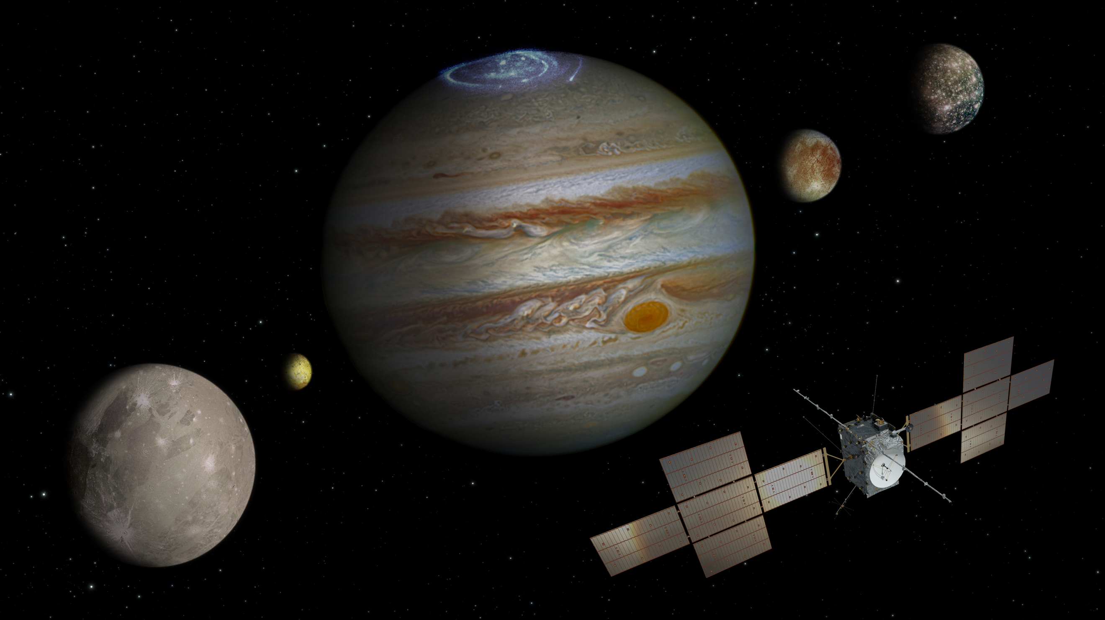On April 13, the journey of Europe's largest scientific space mission ever began - Juice - and the Swedish Institute of Space Physics has two instruments on board. Cred: spacecraft: ESA/ATG medialab; Jupiter: NASA/ESA/J. Nichols (University of Leicester); Ganymede: NASA/JPL; Io: NASA/JPL/University of Arizona; Callisto and Europa: NASA/JPL/DLR

At 14.14, Swedish time, on April 14, the European Juice (JUpiter ICy moons Explorer) spacecraft was launched from French Guiana with the destination Jupiter and its icy moons Europa, Callisto, and Ganymede. The Swedish Institute of Space Physics (IRF) is responsible for two of the ten scientific instruments on board Europe’s largest scientific space mission ever. The main goal is to find out if there are conditions for life on Jupiter’s moons.

After decades of preparation, the eight-year journey has now begun for the European Space Agency's (ESA) Juice spacecraft. In July 2031, Juice will arrive at Jupiter and the moons that consist of oceans beneath layers of ice.

The space instruments that scientists at IRF in Kiruna and Uppsala are responsible for not only participate in the search for the conditions for life but also investigate the complex interplay between Jupiter, its icy moons, and their environment.

Stas Barabash, is a professor at IRF in Kiruna and Principal Investigator for the instrument Particle Environment Package, PEP, which consists of six different instruments measuring various types of neutral and charged particles present in the Jupiter system.

PEP will explore the tenuous atmospheres of the moons and mysterious magnetosphere of Ganymede, search for signatures of life in geysers of Europa and investigate enigmatic Callisto. Flying in the mighty magnetosphere of Jupiter, PEP will study how it works and how it affects the entire Jupiter system.

”Jupiter and its system are so complex and diverse that studying them is like flying in another solar system! A system that may harbor life. After this successful launch, the next big milestone is to switch on PEP for the first time and to see that everything is fine after the launch. If that goes nominal, I will stock up on patience for eight years, and I will wait for great discoveries”, says Stas Barabash.

Jan-Erik Wahlund is an associate professor at IRF in Uppsala and Principal Investigator for the instrument Radio and Plasma Wave Investigation, RPWI, which consists of ten different sensors measuring electric and magnetic fields as well as cold ionized gas.

RPWI will explore the charged and possibly dusty component of the tenuous atmospheres of the icy moons, and investigate the structure of the sub-surface oceans beneath the icy surfaces of Europa, Ganymede, and possibly Callisto. The instrument will investigate the energy and momentum exchange between Jupiter’s magnetosphere and the electrically conductive space and interior environments of the icy moons, mapping all electric currents.

”We scientists want to know how this miniature planetary system works, what processes make it tick. Is it possible to maintain life there? How was it formed and how will it evolve? At the same time, it is kind of a first exploration activity, for future missions to find out how to continue this research. The scientists are always first to new domains reachable by humans. Juice will be one of these missions”, says Jan-Erik Wahlund.

Juice is not only Europe's largest scientific space mission it is also the largest and most complex space project in IRF´s history. IRF was selected in 2013 by ESA to contribute with the instruments PEP and RPWI, which are co-financed by the Swedish National Space Agency (SNSA).

Olle Norberg is Director-General at IRF and together with Stas Barabash and Jan-Erik Wahlund he has followed the launch on-site in French Guiana.

”The selection of IRF to provide two out of ten instruments for this prestigious mission is a clear recognition of IRF as one of the top European space research institutes. IRF will now work with scientists all over the world to explore the exciting icy moons of Jupiter”, says Olle Norberg.

Contact:
Professor Stas Barabash, Swedish Institute of Space Physics, Principal Investigator for Particle Environment Package, PEP.
+46 980 791 22
stas.barabash@irf.se
Associated Prof. Jan-Erik Wahlund, Swedish Institute of Space Physics, Principal Investigator for Radio and Plasma Wave Investigation, RPWI.
+46 767 697 877
jan-erik.wahlund@irfu.se
Olle Norberg, Director-General, Swedish Institute of Space Physics
+46 980 790 78
olle.norberg@irf.se
Press contact:
Martin Eriksson, Information officer, Swedish Institute of Space Physics
072- 581 33 33
martin.eriksson@irf.se
More information:
IRF's participation in Juice:
https://www.irf.se/en/irf-in-space/juice/
Press images – IRF:
https://cloud.irf.se/s/qkySDWAjB97QfD7
Swedish National Space Agency - about Juice:
https://www.rymdstyrelsen.se/upptack-rymden/juice--snart-pa-vag-mot-jupiters-isiga-manar/
ESA - Juice:
https://www.esa.int/Science_Exploration/Space_Science/Juice
ESA media kit - launch:
https://esamultimedia.esa.int/docs/science/Juice-LaunchKit.pdf

