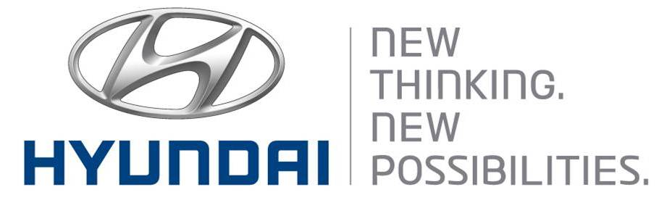  October 27, 2011 | Media Release  For further information contact the  Global Public Relations Team  Tel: +82+2—3464-2153 ~ 60  Fax: +82+2—3464-3497  globalpr@hyundai.com

Hyundai Motor Reports 2011 Third Quarter Earnings

- Hyundai sells 2.95 million units worldwide through third quarter
- Sales revenue and net profit stand at 57.3 trillion won and 6.1 trillion won

Hyundai Motor Company, South Korea’s largest automaker, sold 2,949,914 units (domestic: 510,228 / overseas: 2,439,686) worldwide in the first nine months of the year, up 10.5 percent from the same period a year earlier, led by the launch of new models and strengthened product competitiveness throughout its lineup.

Net profit increased 34.1 percent to 6.1 trillion won as of the end of September from a year earlier, while operating profit rose 27.1 percent to 5.95 trillion won. Improved product mix and sales growth boosted sales revenue by 18.2 percent to 57.28 trillion won. Double-digit sales growth in the overseas markets was a main contributor to the increase in revenue and operating profit.

New models such as Accent (badged as Verna in some markets), Grandeur (Azera), Veloster and i40 drove up sales in all regions. Hyundai’s overseas sales rose 11.2 percent from the same period last year, while its domestic sales increased 7.3 percent.

For the remainder of the year, global demand is expected to be lower than the industry’s original forecast earlier this year, due to unfavorable external factors such as the European financial crisis and slower growth in emerging markets. In order to overcome these hurdles, Hyundai will strengthen its focus on qualitative growth and implementing innovative marketing strategies. Hyundai will also accelerate its efforts to develop more fuel-efficient and eco-friendly models.

Hyundai’s improved brand image attests to such overall efforts: In a survey of Interbrand’s Best Global Brands 2011, the automaker’s brand value surged 19.3 percent to US$6 billion, the biggest jump among all global automakers.

Hyundai will continue to elevate its quality, while widening customers’ choices by providing more regionally exclusive models that cater to local preferences.

* Starting from this year, Hyundai Motor is basing its earnings on the International Financial Reporting Standards (IFRS), replacing K-GAAP.

Established in 1967, Hyundai Motor Co. has grown into the Hyundai Motor Group which has ranked as the world’s fifth-largest automaker since 2007 and includes more than two dozen auto-related subsidiaries and affiliates. Hyundai Motor, which has six manufacturing bases outside of South Korea, sold approximately 3.6 million vehicles globally in 2010. Hyundai vehicles are sold in 186 countries through some 5,300 dealerships and showrooms. Further information about Hyundai Motor and its products is available at www.hyundai.com.

For more press materials, please visit www.cisionwire.com/hyundai-motor-company.

