FOR IMMEDIATE RELEASE

***Best of Glenn Phua***

*With a collection of artworks featuring famous skylines and heritage landmarks,*

*Pathlight School alumni artist Glenn Phua is debuting his solo exhibition.*

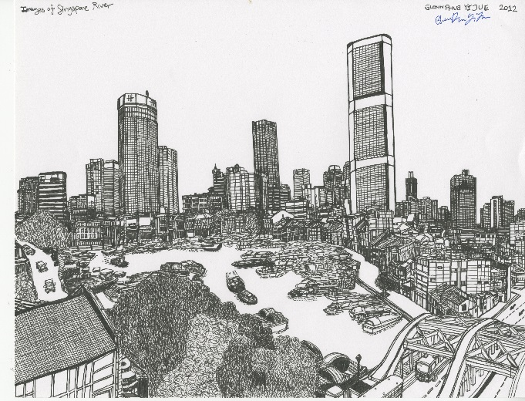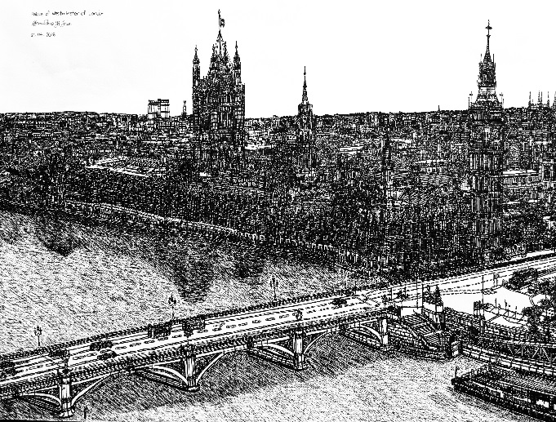

*The Singapore River**The Palace of Westminster of London*

October 2019, Singapore – Pan Pacific Singapore and Pathlight School present ***"Best of Glenn Phua"***, a solo art exhibition by Pathlight alumni artist Glenn Phua.

In this exhibition, Glenn Phua presents 22 remarkable pieces featuring world renowned skylines and heritage landmarks including ‘The Singapore River’ and ‘The Palace of Westminster of London’. Despite the strenuous precision of architectural line drawing which requires up to 30 hours of perseverance, Glenn’s careful attention to detail and stamina is a clear statement of his artistic determination.

Born in 1996, Glenn Phua is a Singaporean artist who was diagnosed to be on the autism spectrum at the age of four. Despite the challenges and struggles, Glenn’s parents never stopped believing in his exceptional gift as an artist. To maximise his potential, he was enrolled in Pathlight School, Singapore’s first autism-focused school that offers mainstream curriculum with life readiness skills.

Glenn Phua’s precise drawing methods allude to the expertise of Stephen Wiltshire, the renowned British artist who is also on the autism spectrum. Glenn’s artworks have been featured at several special occasions, most notably the ‘Opening of Legal Year’ with Singapore’s Chief Justice Sundaresh Menon in January 2015, and the ‘SG50 Living the Singapore Story’ celebration with former President of Singapore Mr. Tony Tan in May 2015. Glenn’s drawing of the Singapore Botanic Gardens was presented to China’s President Xi Jinping in November 2015 as a national gift from Singapore. In August 2016, Glenn’s artwork ‘Supertree’ was presented to former US First Lady Michelle Obama by Prime Minister Lee Hsien Loong’s wife Mdm Ho Ching.

A gifted alumnus of Pathlight School, Glenn Phua was one of the eight students from the pioneering batch of Pathlight School’s Artist Development Programme (ADP), which began in 2011. The Artist Development Programme aims to uncover artistic talents in students, develop their potential and provide an opportunity for students and their families to recognise the value of their talent and acquire a dignified source of income.

Visitors are welcome to view the intricate creations at this complimentary art exhibition. ***Best of Glenn Phua*** is showcasing from 30 October 2019 to 30 January 2020, 11:00am to 8:00 pm daily, at the Public Art Space on Level 2 of Pan Pacific Singapore. For artwork enquiries, please contact Jaslyn Ng from Pathlight School at jaslyn.ng@pathlight.org.sg.

**Name of Exhibition:** Best of Glenn Phua

**Artist:** Glenn Phua Yi Jue

**Exhibition Duration:** From 30 October 2019 until 30 January 2020

**Opening Hours:** 11:00am to 8:00pm daily

**Venue:** Public Art Space (Level 2) at Pan Pacific Singapore

**Address:** Pan Pacific Singapore, 7 Raffles Boulevard, Marina Square, Singapore 039595

[**Download images here**](https://www.dropbox.com/sh/y040c2fwk47zg3r/AAC2Qj72rx8wZ4HpTo3xHXLPa?dl=0)

**ENDS**

**Media Contact**

Annie Choy

Director of Marketing Communications

DID: (65) 6826 8079

E-mail: [annie.choy@panpacific.com](mailto:annie.choy@panpacific.com)

Melissa Ng

Senior Executive, Marketing Communications

DID: (65) 6826 8094

E-mail: [melissa.ng@panpacific.com](mailto:melissa.ng@panpacific.com)

*Pan Pacific Singapore Facebook:* [*https://www.facebook.com/panpacificsingapore*](https://www.facebook.com/panpacificsingapore)

*Twitter:* [*https://twitter.com/panpacificsgp*](https://twitter.com/panpacificsgp)

*Instagram:* [*http://instagram.com/panpacificsingapore*](http://instagram.com/panpacificsingapore)

**About Pathlight School**

Pathlight School is the first autism-focused school in Singapore that offers Singapore's mainstream academic curriculum together with life readiness skills. It caters to students on the autism spectrum and related conditions, aged 7 to 18 years, who are cognitively able to access mainstream academic curriculum but require additional support such as smaller class sizes, special accommodations and teaching staff trained in autism.

**About Public Art Space**

Public Art Space, 220 square metres of dedicated space on level two, Ocean Gallery of Pan Pacific Singapore overlooking the Atrium, is dedicated to showcasing collections by local artists with regularly rotating exhibitions. The decision to create Public Art Space is based on the hotel’s commitment to the local community; particularly supporting local Arts in the most accessible way possible and making it available for public enjoyment.

**Pan Pacific Hotels Group**

Pan Pacific Hotels Group is a wholly-owned hotel subsidiary of Singapore-listed UOL Group Limited, one of Asia’s most established hotel and property companies with an outstanding portfolio of investment and development properties.

Based in Singapore, Pan Pacific Hotels Group owns and/or manages 40 hotels, resorts and serviced suites with more than 12,000 rooms including those under development in Asia, Oceania, North America and Europe.

Voted “Best Regional Hotel Chain” by readers in Asia in 2017, Pan Pacific Hotels Group comprises two acclaimed brands: its signature brand, Pan Pacific and its deluxe brand, PARKROYAL.

Sincerity is the hallmark of Pan Pacific Hotels Group. The Group is known to its guests, partners, associates and owners for its sincerity in people and the sense of confidence which alleviates the stresses of today’s complex world.

**Pan Pacific Hotels and Resorts**

With hotels, resorts and serviced suites across Asia, Oceania and North America, Pan Pacific provides a safe harbour in an ever-changing world. Places with less to worry about because, when you stay with us, rest assured that all will be taken care of. For this is where you will find your balance.