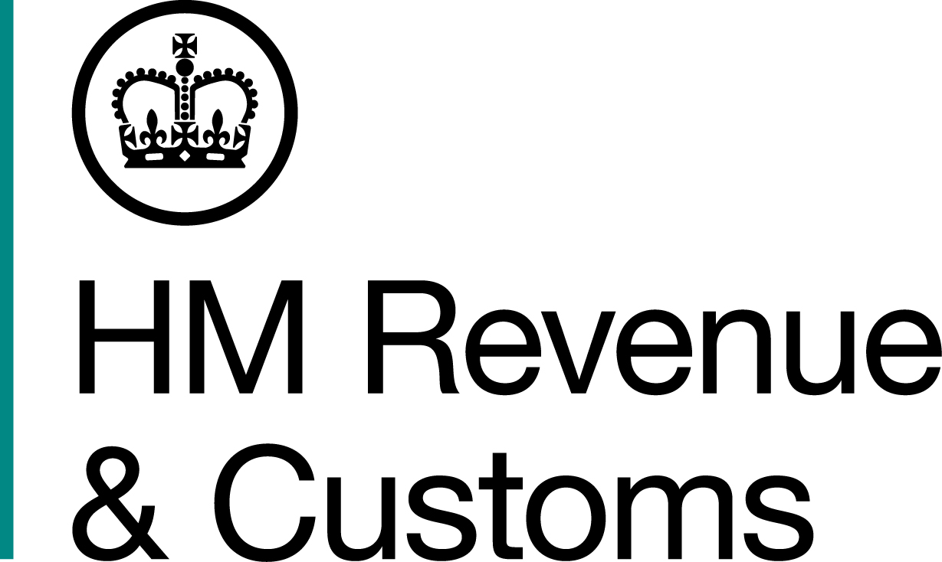
News Release

 | For the attention of News Desks |  | No of pages: |  | 2
 | Date: | 27 December 2014 | Ref: | NAT83/14

Businesses sign up to online tax account

More than half a million businesses have signed up to an online tax account – Your Tax Account – HM Revenue and Customs (HMRC) announced today.

Launched in May 2014, Your Tax Account will, over time, enable small businesses to access everything they need to manage their tax affairs in a single, secure, online space. HMRC has worked with business customers to ensure it reflects their needs and is user-friendly.

The core of the current service is a personalised homepage from which businesses can access:

- links to the key transactions they need to complete (for Self Assessment, Corporation Tax, Pay As You Earn for employers and VAT)
- an overview of their key tax records
- a summary of their current liabilities
- direct links to information and guidance, plus interactive tools
- links to payment information and how to pay.

More services will be added as the product develops.

David Gauke, Financial Secretary to the Treasury, said:
“HMRC is becoming an increasingly digital business. My ambition is for HMRC to offer all
taxpayers – individuals, businesses and agents – their own online tax account.

“Your Tax Account gives businesses easier, quicker and simpler access to the information
and services they need in one place, and is already proving popular with them.”

Notes for Editors

- Follow HMRC Press Office on Twitter @HMRCpressoffice
- HMRC's Flickr channel www.flickr.com/hmrc.gov.uk

Issued by HM Revenue & Customs Press Office

Press enquiries only please contact:

Paul Conroy

Tel: 03000 585 028
Email: paul.conroy1@hmrc.gsi.gov.uk

Or

Jan Marszewski

Tel: 03000 585 021
Email: jan.marszewski@hmrc.gsi.gov.uk

Out of hours
Tel: 07860 359544

Website www.hmrc.gov.uk

