PRESS RELEASE

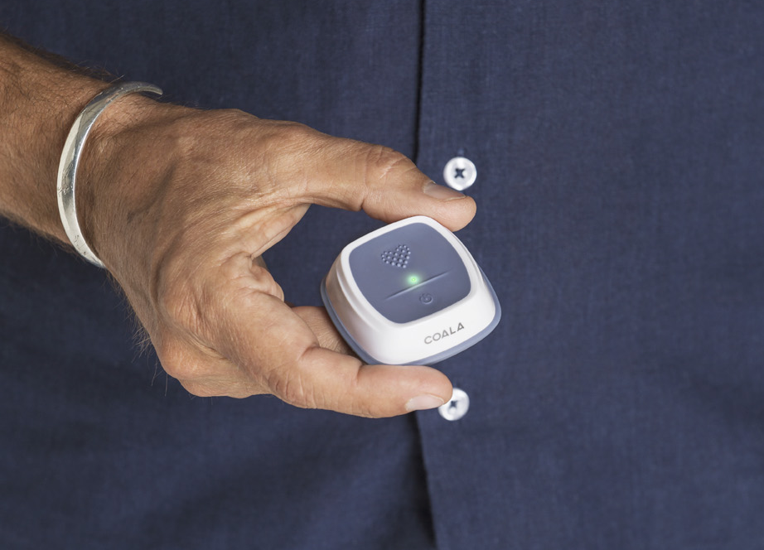

New research confirms Coala's leading detection accuracy

Gothenburg, April 11, 2019 – New research presented today at the 21st Swedish Cardiovascular Spring Meeting in Gothenburg confirms the detection accuracy of the Coala Heart Monitor and it s sequential combination of digital chest- and thumb-ECG. The 2-lead ECG method and instant cloud-based mobile platform proves significantly increased accuracy of detetcing Atrial Fibrillation as compared to single lead thumb-based ECG.

In the research study “Performance evaluation of dual vs. single lead automatic, real-world arrhythmic ECG recordings” the Coala Heart Monitor was evaluated by manual interpretation of 1,000 consecutive anonymous prints of chest- and thumb-ECG recordings. The recordings were compared with Coala’s algorithm-based, automatic analysis of the corresponding measurements. The recordings derived from actual Coala users in Sweden and the blinded recordings were manually interpreted by a trained cardiologist.

“The study confirms the value of our system and how the combination of chest- and thumb-ECG significantly increases the accuracy and reduces the number of false positive indications for Atrial Fibrillation by almost three times as compared to single-lead ECG. Reducing the prevalence of false positive indications is important to reduce the burden on healthcare providers, as well as alleviating worries and reducing anxiety of the individual patient”, comments Magnus Samuelsson, CTO at Coala Life and co-author of the presented research study.

Coala's patent-pending sequential combination of chest- and thumb-ECG concluded a significantly higher positive predictive value (PPV) as compared to thumb-ECG alone. Sequential chest- and thumb-ECG decreased the proportion of false positive indications of Atrial Fibrillation from 35.3% for thumb ECG alone to 12.8% for the sequential combination of chest- and thumb-ECG.

More information about the study:
Performance evaluation of dual vs. single lead automatic, real-world arrhythmic ECG recordings
Ohlsson Å et al., 1895-A-1901. Presented at the 21st Swedish Cardiovascular Spring Meeting.

For more info:
Philip Siberg, CEO, +46 70 790 6734, philip.siberg@coalalife.com
Titti Lundgren, CMO, +46 70 835 3328, titti.lundgren@coalalife.com

About Coala Life:
Coala Life is a Swedish digital health venture focused on cardiac diagnostics and digital health. The company has developed a portfolio of patented medical products and services for user-centered digital remote monitoring and screening of the heart based on advanced and smart algorithms. Coala's solutions enable analysis, remote monitoring, more effective cardiac assessments and integrated care services, all in real time. Coala was named one of five global Cool Vendors within the Health and Wellness market by Gartner Group in 2018 and recognized as of the 100 Global Leaders in Digital Health by the Journal of mHealth. Follow your Heart®. For more information see www.coalalife.com

