WeSpin, part of ComeOn Group, launches new innovative casino streamer platform

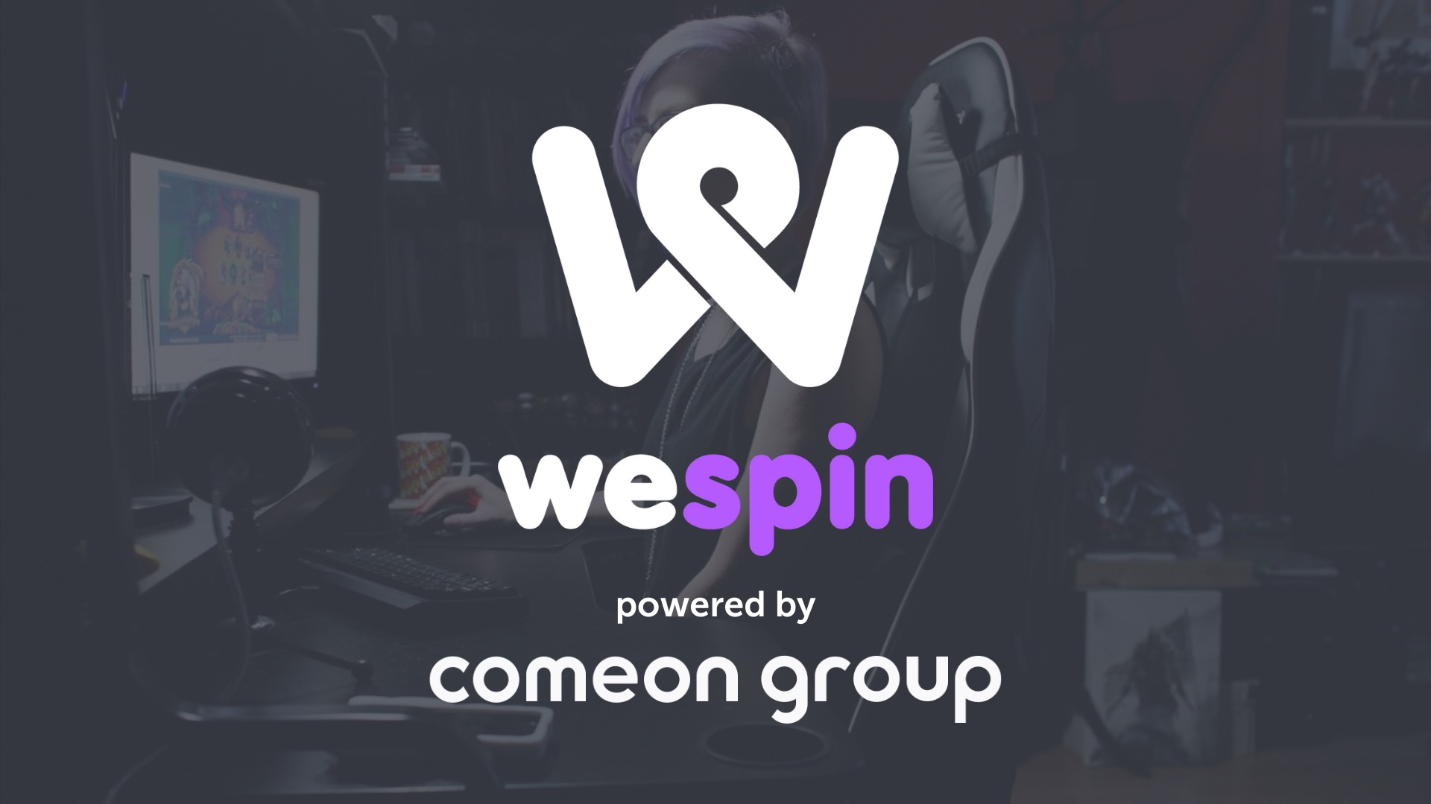

**May 2021** - Gaming operator ComeOn Group announced the launch of their new product WeSpin - an innovative streamer platform aimed to wow the industry. WeSpin is fully developed in-house by dedicated engineering teams and connected to ComeOn's proprietary iGaming platform. WeSpin is a one of a kind product innovation that has its heritage dated all the way back to 2015, inspired by office jackpot hunts between colleagues and the rising trend of passionate casino streamers.

WeSpin has led to the development of a whole new ecosystem with the vision to connect the world of gamblers with online gambling through passionate streamers. The product has taken things to the next level by making online casino a more social, eventful, and entertaining experience.

**Berkay Reyhan, CCO at ComeOn Group, said:** *“The great thing about WeSpin is it is bringing the passive audience of the streamers into the heart of the fun by making them buy-in into the streamers pot. Why watch someone else’s activity behind a screen while you could actually be a part of it? This is what WeSpin solves. We also believe that WeSpin will be taking ComeOn to a leading position within our industry’s new streamer acquisition channel, by the benefits that it offers to all the streamers out there, which goes beyond the standard practices of traditional affiliate marketing.”*

WeSpin is helping ComeOn Group reach players on streaming services in a new and innovative way, directly converting players who want to participate in events that streamers facilitate, tapping directly into a new player demographic of young casino streaming enthusiasts. The product bridges the gap between operator and customer, which leaves room to take part in players winning and having fun.

What’s more to the product is that WeSpin has a boost tool, which enables game providers to sponsor events for exclusivity. This aims to promote new releases but also their existing game portfolio directly to customers in the casino. Sponsored money is added directly to events and streamers can invite their audience to participate in free events and events with add on, increasing affiliate conversion rates and bringing the streamers viewer rates to new all time highs. Streamers can set up events like, bonus hunt, jackpot hunt, bonus buy events and streamers choice - adding to the richness of the product. Game providers like NetEnt, Push Gaming, Yggdrasil and Playtech have joined in to sponsor events through our new boost tool to attract focus on their new releases and get players involved in their most prominent games.

WeSpin has on-boarded some of the biggest streamer profiles in the industry and their reviews have been overwhelmingly positive.

**Anton Jirout, also known as Konnabonus said:** *“I’ve really enjoyed hosting group plays with the WeSpin feature. I've gotten many new viewers to my twitch stream just by working with ComeOn. WeSpin is by far the best place to host group plays as a streamer. What I like the most about comeon and WeSpin is the easy interface, constant improval of the wespin feature and not to forget the fantastic affiliate managers. It’s also been great playing at ComeOn due to their amazing game selection and my viewers absolutely love it! The boost tool is great fun! People really like to participate in groups that also give something extra. What I've noticed works the best is to run a bonus hunt with the new boost feature, that really works with my community as it increases the chances to end up with a positive balance and a cashout”*

**Daniel Natvig, also known as Kongebonus, said:** *“The WeSpin sessions we have had are by far the streams we have with most attention and the biggest audience. It is easy to see that a lot of viewers like the idea that we can all play together. WeSpin has taken streaming and the community-feeling to a whole new level and that is also why we want to keep going with it. The best thing about it is that we actually can have certain events at certain times. We enjoy that we have different and multiple events in one night and the diversity of it”*

**About WeSpin**

Developed by [ComeOn Group](https://www.comeon-group.com/), WeSpin is an innovative product that is breaking new ground in how players interact with casino games. It’s a new community-centred live online casino gaming experience which allows multiple players to buy-in for scheduled casino slots live streaming sessions.

WeSpin is fully developed in-house by dedicated engineering teams and connected to ComeOn's proprietary iGaming platform.

The future of Casino is together - WeSpin together, we win together!

Read more about WeSpin on [www.wespin.com](http://www.wespin.com)

------------------------------------------------ END ------------------------------------------------

**About ComeOn Group**

Founded in 2008, ComeOn Group is a leading global player in the rapidly growing iGaming market. Having launched its first online brand already in 2010, ComeOn Group is running a wide range of exciting brands across multiple markets. Operating more than 20 brands on it's proprietary platform which provides a secure, innovative and entertainment-led player experience across casino and sports betting.

ComeOn Group’s extensive brand portfolio includes brands as: [www.casinostugan.com/](http://www.casinostugan.com/), [www.cherrycasino.com/](http://www.cherrycasino.com/), [www.comeon.com/](http://www.comeon.com/), [www.eurolotto.com/](http://www.eurolotto.com/), [www.euroslots.com/](http://www.euroslots.com/), [www.folkeriket.com/](http://www.folkeriket.com/), [www.galaksino.com/](http://www.galaksino.com/), [www.getlucky.com/](http://www.getlucky.com/), [www.hajper.com/](http://www.hajper.com/), [www.mobilautomaten.com/](http://www.mobilautomaten.com/), [www.mobilebet.com/](http://www.mobilebet.com/), [www.nopeampi.com/](http://www.nopeampi.com/), [www.norgesspill.com/](http://www.norgesspill.com/), [www.pzbuk.pl/](http://www.pzbuk.pl/), [www.snabbare.com/](http://www.snabbare.com/), [www.sunmaker.com/](http://www.sunmaker.com/), [www.sunnyplayer.com/](http://www.sunnyplayer.com/), [www.suomikasino.com/](http://www.suomikasino.com/)

ComeOn Group is an international employer with over 500 talented employees across 7 main locations.

Read more about ComeOn Group on [www.comeon-group.com](http://www.comeon-group.com)

For further information, please contact:

[pr@comeon.com](mailto:pr@comeon.com)