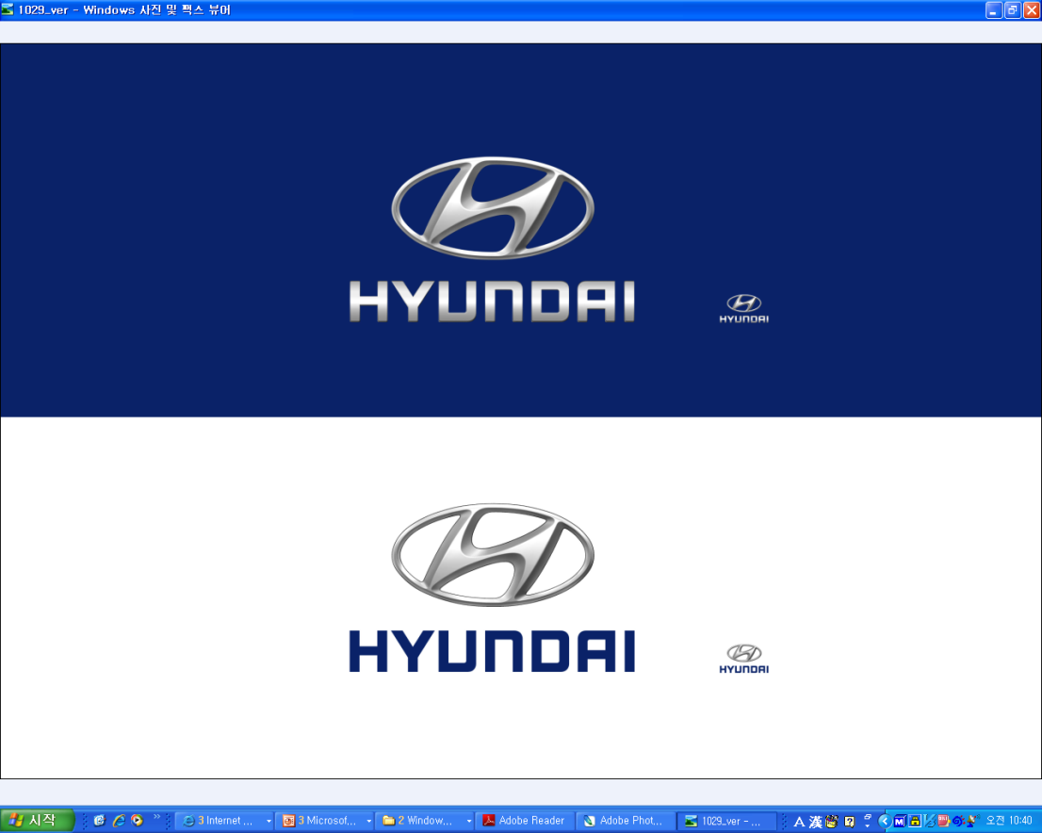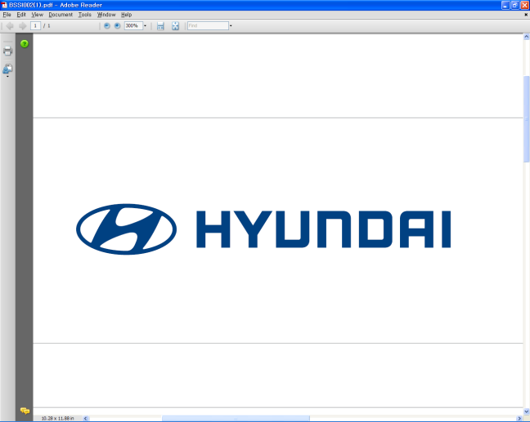  Feb. 28, 2011 | Media Release  For further information contact the  Global Public Relations Team  Tel: +82+2—3464-2153 ~ 60  Fax: +82+2—3464-3497  globalpr@hyundai.com

Hyundai Signs Agreement with Vodafone To Develop Telematics Opportunities in Europe

- Hyundai to partner with Vodafone, one of the world’s largest mobile communications companies, to explore opportunities in telematics
- Combination of automotive and IT technologies to produce a new range of automotive services
- Expected to raise Hyundai’s business capabilities

(Feb. 28, 2011) Hyundai Motor Group signed an agreement with Vodafone Global Enterprise, the business within Vodafone which manages the communications needs of its largest multinational customers, to explore business opportunities in telematics services in Europe. The initial agreement, which was signed today, is expected to boost Hyundai’s competitiveness in vehicle IT systems and reach out to a wider customer base in Europe.

Under the agreement, Hyundai will focus on creating new business opportunities based on automotive IT systems and Vodafone’s existing communications network in Europe. As well as collaborating on the development of new telematics services, Hyundai will develop new automotive IT solutions by using the telematics infrastructure to build a new customer-oriented telematics business models.

“Through collaboration with the world-renowned mobile communications operator
Vodafone, the Hyundai Motor Group looks forward to providing advanced automotive IT services to its European customers as part of its ongoing commitment to become increasingly competitive in this market,” said Hyundai Motor Vice-Chairman Hyun-Soon Lee.

“Vodafone’s high-performance mobile networks and simple solutions for managing wireless connectivity on a global basis, mean we are ideally placed to help the Hyundai Motor Group develop a whole range of new services,” said Nick Jeffery, Chief Executive Officer, Vodafone Global Enterprise. “This collaboration is set to deliver an even better driving experience for drivers across Europe.”

Hyundai introduced the BlueLink® telematics system at the 2011 Consumer Electronics Show (CES) in Las Vegas, presenting its advanced vehicle information technology systems to the world.

About Hyundai Motor Co
Established in 1967, Hyundai Motor Co. has grown into the Hyundai Motor Group which has ranked as the world’s fifth-largest automaker since 2007 and includes more than two dozen auto-related subsidiaries and affiliates. Hyundai
Motor, which has six manufacturing bases outside of South Korea, sold approximately 3.6 million vehicles globally in
2010. Hyundai vehicles are sold in 186 countries through some 5,300 dealerships and showrooms.
Further information about Hyundai Motor and its products is available at www.hyundai.com.

About Vodafone
Vodafone is one of the world's largest mobile communications companies by revenue with approximately 358 million customers in its controlled and jointly controlled markets as at 31 December 2010. Vodafone currently has equity interests in over 30 countries across five continents and more than 40 partner networks worldwide. Vodafone Global Enterprise is an organization that is part of the Vodafone Group, providing managed communications services across five regions : Northern Europe; Central Europe; Southern Europe; the Americas; Asia Pacific and Africa.

