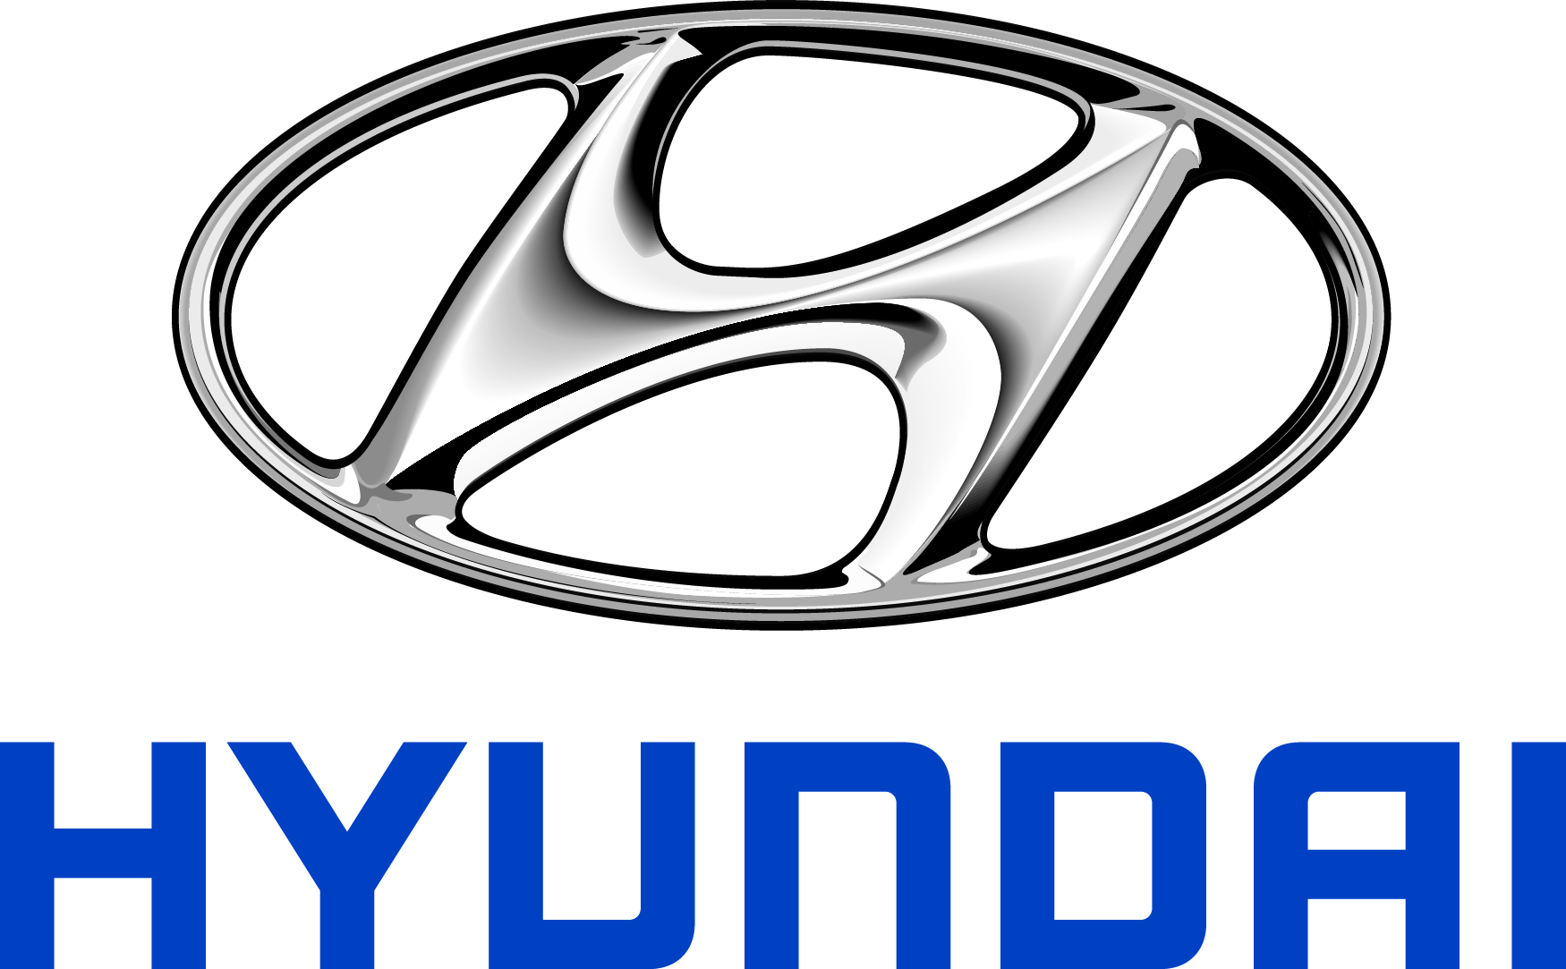 | Hyundai Motor America  10550 Talbert Ave, Fountain Valley, CA 92708  TEL: 714-965-3000 FAX: 714-378-1008  MEDIA WEBSITE: HyundaiNews.com CORPORATE WEBSITE: HyundaiUSA.com

Contact:
Jim Trainor
jtrainor@hmausa.com
714-316-6421

HYUNDAI FUEL CELL HYDROGEN-POWERED ELECTRIC ENGINE NAMED TO WARD’S 10 BEST ENGINES LIST
First Time a FCEV Engine is Honored in Annual Accolade

FOUNTAIN VALLEY, Calif., Dec. 10, 2014 – Hyundai Motor’s zero-emission fuel cell engine, which debuted on the 2015 Tucson, has been recognized as the first engine of its kind in the annual Ward’s 10 Best Engines by WardsAuto World. The WardsAuto World editors tested and named the most sophisticated engines available on the market today.
Hyundai Motor’s Tucson Fuel Cell, the world’s first mass-produced fuel cell electric vehicle, has been available in Southern California since June 10th, 2014, when the first retail customer delivery took place. Outside the U.S., the fuel cell program is currently operating in about a dozen European countries, where the vehicle is known as the ix35.
“Hyundai engineers did a stunning job of slipping the most advanced automotive technology imaginable into a roomy family vehicle and making it all very consumer friendly,” said Drew Winter, editor-in-chief of WardsAuto World magazine. “The powertrain is exceptionally quiet and has a range of 265 miles. Plus, it can be refueled in minutes instead of hours like a battery-electric vehicle. The Hyundai Tucson Fuel Cell is a great engineering achievement and a giant leap for zero-emissions vehicles.”
Hyundai’s fuel cell effectively replaces the battery pack used in an electric vehicle by generating electricity from hydrogen through an electrochemical process that does not involve hydrogen combustion, with no moving parts within the fuel cell stack. The Tucson Fuel Cell maintains the day-to-day flexibility of the gasoline-powered Tucson so that its driver is able to immediately enjoy the next generation of electric vehicles without range or recharge-time compromises to their lifestyle.
“Being included in the prestigious Ward’s 10 Best Engines list validates Hyundai Motor’s powertrain technology leadership as the fuel cell was the first engine of its kind to be honored,” said Dr. Woong-Chul Yang, Vice Chairman of Hyundai Motor’s R&D Headquarters in Korea. “Hyundai Motor will continue to utilize its global R&D resources to develop innovative and game-changing powertrains and technologies, to offer customers more choices when making environment-conscious decisions.”
“It’s an honor to have our most advanced eco-friendly powertrain included in the Ward’s 10 Best Engines List, the industry’s barometer in recognizing outstanding powertrains,” said Dave Zuchowski, president and chief executive officer of Hyundai Motor America. “This award validates our belief that hydrogen-powered fuel cells are the next-generation of zero-emission vehicle technology.”
Ward’s 10 Best Engines, announced every December, is the ultimate list that defines the industry’s outstanding powertrains. Since the list began in 1995, Hyundai Motor has been included four times: the Tau V-8 was honored in 2009, 2010 and 2011 and the Gamma I-4 in 2012. The award ceremony takes place at a banquet during the North American International Auto Show on January 14, in Detroit.

HYUNDAI MOTOR AMERICA
Hyundai Motor America, headquartered in Fountain Valley, Calif., is a subsidiary of Hyundai Motor Co. of Korea. Hyundai vehicles are distributed throughout the United States by Hyundai Motor America and are sold and serviced through more than 820 dealerships nationwide. All Hyundai vehicles sold in the U.S. are covered by the Hyundai Assurance program, which includes the 5-year/60,000-mile fully transferable new vehicle limited warranty, Hyundai’s 10-year/100,000-mile powertrain limited warranty and five years of complimentary Roadside Assistance. Hyundai Blue Link Connected Care provides owners of Hyundai models equipped with the Blue Link telematics system with proactive safety and car care services complimentary for one year with enrollment. These services include Automatic Collision Notification, Enhanced Roadside Assistance, Vehicle Diagnostic Alert, Monthly Vehicle Health Report and in-vehicle service scheduling.
For more details on Hyundai Assurance, please visit www.HyundaiAssurance.com

Please visit our media website at www.hyundainews.com and our blog at www.hyundailikesunday.com

Hyundai Motor America on Twitter | YouTube | Facebook

###

