


News Release June 9th, 2020
YANMAR HOLDINGS CO. LTD.

YANMAR Supports AFF Suzuki Cup 2020

OSAKA, Japan (June 9th, 2020)- Yanmar has renewed its sponsorship of the AFF Suzuki Cup for the 2020 edition of the tournament making this the company’s third consecutive partnership with Southeast Asia’s biggest football tournament. Following successful events in 2016 and again in 2018, YANMAR will again sponsor the event as 11 ASEAN countries compete for AFF Suzuki Cup from November to December 2020.
Held biennially, the AFF Suzuki Cup is the region’s premiere football tournament, and is closely followed by millions of football fans across the region.

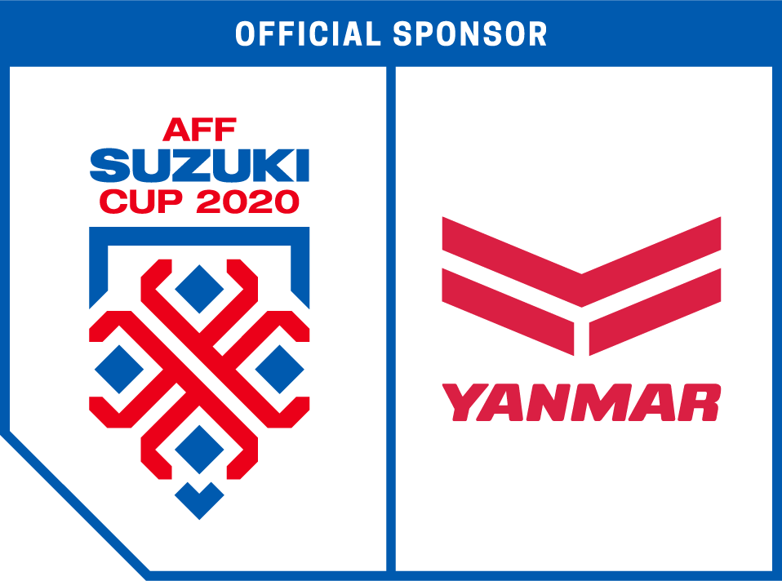
The Yanmar AFF Suzuki Cup logo.

Together with the AFF Suzuki Cup 2020 sponsorship, Yanmar groups its cooperative activities in the region under the banner of “WE ASSIST HOPE”. This message highlights the company’s different assistance and community building activities: assistance in society and agriculture; building excitement, lifestyles and opportunity through football, and technological assistance with the company’s advanced SMARTASSIST geolocation and agricultural management platform.

“As partners with the AFF Suzuki Cup 2020, we will to showcase our commitment to furthering Southeast Asian society through technology, and a shared love of sport,” said Sota Harayama, head of the Sports Business Promotion Office of YANMAR HOLDINGS Co., Ltd. “Football unites people across language and national borders, and Yanmar wants to contribute to a society charged with the shared passion that sport provides.”

Malcolm Thorpe, Managing Director, South East Asia, at SPORTFIVE, the exclusive commercial partner of the AFF Suzuki Cup, said, “Yanmar’s remarkable success from its association with the preceding tournaments is testament to the AFF Suzuki Cup’s prowess in elevating the status of brands among fans in the region. We look forward to continue supporting international brands like Yanmar to harness the passion points of fans as well as grow their brand equity.”

Yanmar will host event spaces at selected matches, where it will present the company’s agricultural solutions and demonstrate its ongoing commitment to Southeast Asia.


Yanmar’s support activities under the WE ASSIST HOPE message.

Yanmar’s support of the AFF Suzuki Cup 2020 is part of its goal to create exciting experiences and realize a society in Southeast Asia that offers an exciting life through football.

About the AFF Suzuki Cup
The AFF Suzuki Cup is a biennial football competition organised by the ASEAN Football Federation (AFF), accredited by FIFA, and contested by the national ‘A’ teams of Southeast Asia.

In 2020, the 13th edition of the AFF Suzuki Cup will continue the format where 10 qualified teams will be split into two groups of five and play a round robin system, with each team playing two home and two away fixtures. The format of the knockout round remains unchanged, with semi-finals and the final played on a home and away format.
For more information, please visit:
www.affsuzukicup.com

About Yanmar
With beginnings in Osaka, Japan in 1912, Yanmar was the first ever to succeed in making a compact diesel engine of a practical size in 1933. Moving on, with industrial diesel engines as the cornerstone of the enterprise, Yanmar has continued to expand its product range, services, and expertise to deliver total solutions as an industrial equipment manufacturer. As a provider of small and large engines, agricultural machinery and facilities, construction equipment, energy systems, marine, machine tools, and components — Yanmar’s global business operations span seven domains.
On land, at sea, and in the city, Yanmar’s Mission of “providing sustainable solutions focused on the challenges customers face, in food production and harnessing power, thereby enriching people’s lives for all our tomorrows,” stands testament to Yanmar’s determination to provide us with “A Sustainable Future”.
For more details, please check out the official website of Yanmar Co., Ltd.
https://www.yanmar.com/global/

＜NOTE＞
The contents of this news release reflect what was mentioned in the press announcement. Please be aware that the contents of this release may differ with new information and developments.

Inquiries
Corporate Communications, Yanmar Global Expert Co., Ltd.
newsroom@yanmar.com

