February 18, 2013

PRESS RELEASE

Flying sailboats at Allt för sjön,
the Stockholm International Boat Show

When the Stockholm International Boat Show opens at Stockholmsmässan on March 1, the sailboat dock will be packed with exciting sailboat models – large, small and very new. Everything from the Show's largest boat, the 17-meter-long Beneteau Sense 55 luxury yacht, to the six-meter Fabola 650 day sailer. Among the many interesting new items it may well be the "flying" sailboats that attract the most attention.

For many people, the Stockholm International Boat Show marks the kick-off of summer. Outdoors, the sun is starting to warm up, while inside the three exhibition halls this year's boating innovations are on display news and soon it will be time to see to your own boat, or maybe buy a new one!

For some it may be this year’s biggest boat, the Beneteau Sense 55, (16.80 m - 55'1")
that is most the Show’s most interesting. It is a dream-come-true for those who love comfort, luxury and smooth sailing, both out on the open water and among the islands of the archipelago. The boat boasts two "owner’s cabins" with large double bunks and separate shower compartments. With the glass doors between the salon and the spacious aft deck open, a large cocktail area is created with room for 10–15 guests. “Extra everything” can be found on board this splendid boat.

Another find on the sailboat dock is the new Dufour 310 GL, whose bright oak decor and well-appointed galley should arouse great interest. Inside there are two cabins, a large dining area and one head. The cockpit is exceptionally large, and despite its short length, the boat is equipped with equipped with dual wheels.

"It is notable that so many sailboat exhibitors have chosen the Stockholm International Boat Show to show off their boats this year. The economy has not been so great over the past few years; given that, we are really excited to be able to offer a fully stocked sailboat dock with such fantastic new showpieces that all sailing aficionados will be able to discover treasures”, says Thomas Sandberg, the Show’s project manager, at Stockholmsmässan.

The Haber 660 is a different type of boat, which comes from Poland. It is a motor-sailer that despite its 6.6 meter length offers everything a family could want. It has full standing headroom inside, separate head, a galley and berths for four people. The Haber 660 also features a centerboard and folding mast, allowing to easily go onto a trailer.

Other interesting sailing boats moored at the dock include the Najad 440 CC, a genuine Orust creation with traditional teak wood furnishings and classic lines. In addition to Sense 55, France’s Beneteau is showing two other boats: the Oceanis 44 and Oceanis 38. Dufour is exhibiting two Grand Large models, the 380 GL and 410 GL, and Finland will be represented by the high-performance Finn Flyer 34 GT, among others. Hanse is showing two cruisers, the Hanse 375 and Hanse 345.

But the most innovative vessels are probably those that fly. They are of course found in the Flying Boats booth, just below the sail boat dock, where one will find four types of boat types that actually go-ride-fly over the water – with the help of hydrofoils. The world's first mass-produced hydrofoil catamaran, the Flying Phantom is making its Nordic premiere. It has hydrofoils/wings on the centerboard like America's Cup boats, and when riding high on the foils it is good for over 30 knots. Also to be seen is the Mothjollen, which sails up to one meter above the water surface at its centerboard, with wings. The booth will also display the Foil Twister motor boat, a Swedish innovation which when on the foils only draws some 4 oz of fuel per nautical mile.

For more information, please contact:
- Thomas Sandberg, project manager, thomas.sandberg@stockholmsmassan.se, tel: 08-749 44 94
- Mats Hagman, press officer, mats.hagman@informedia.se, tel: 070-628 12 10

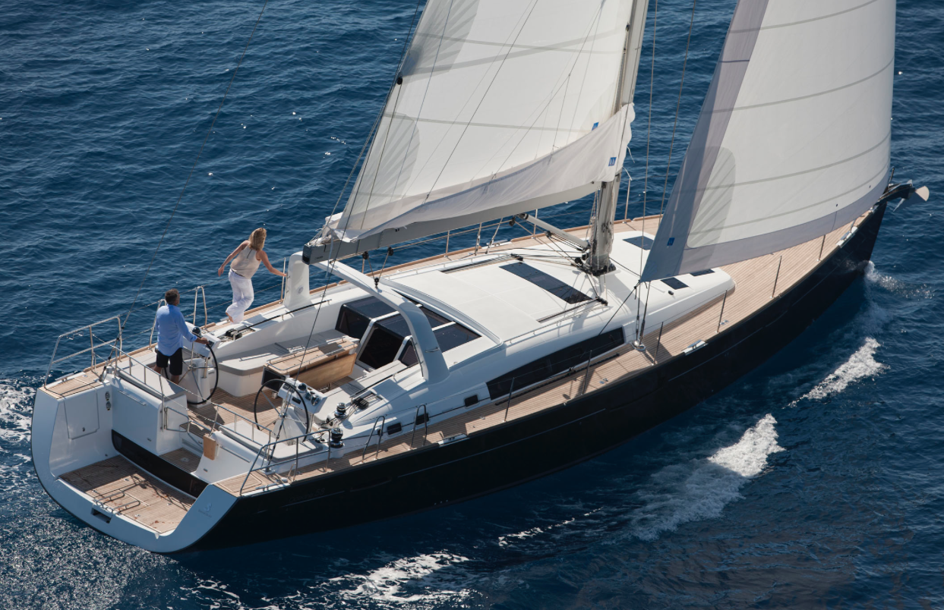
Beneteau Sense 55
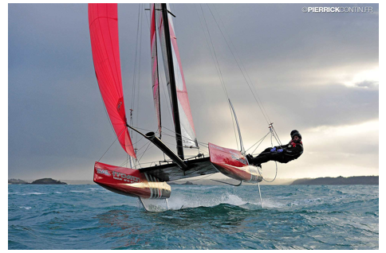
Flying Phantom

