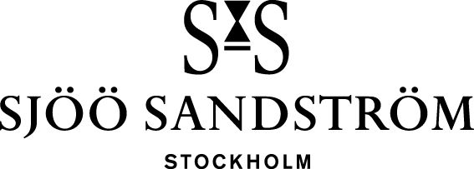

Press release, Stockholm, 2024

Adding steel bracelet to the Landsort 459m collection.

Unveiling the latest upgrade to the Landsort 459m collection: the steel bracelet. Engineered for enduring durability and timeless elegance, this sleek addition boasts micro-adjustment functionality with 6 steps and totally 8mm, guaranteeing a custom fit with unparalleled comfort.

Sjöö Sandström will continue developing the Landsort 459m collection. True to its heritage, Sjöö Sandström are sure that the Landsort 459m have many more years to come and will keep on pushing limits.

**Specification:**

Material: Stainless Steel

Size: Tapered 22/18mm

Buckle type: Folding buckle with micro adjustment (8mm)

Buckle size: 18mm

RRP: 7.900:- SEK

<https://www.sjoosandstrom.com/collection/landsort-459m>

**For more information, please contact:**   
Kristofer Johansson

Press contact, Sjöö Sandström AB   
[kristofer.johansson@sjoosandstrom.se](mailto:kristofer.johansson@sjoosandstrom.se)   
Telephone: +46 768 06 12 55