**MEDIA RELEASE**

**Pan Pacific Manila earns**

**2019 Tripadvisor Certificate of Excellence**

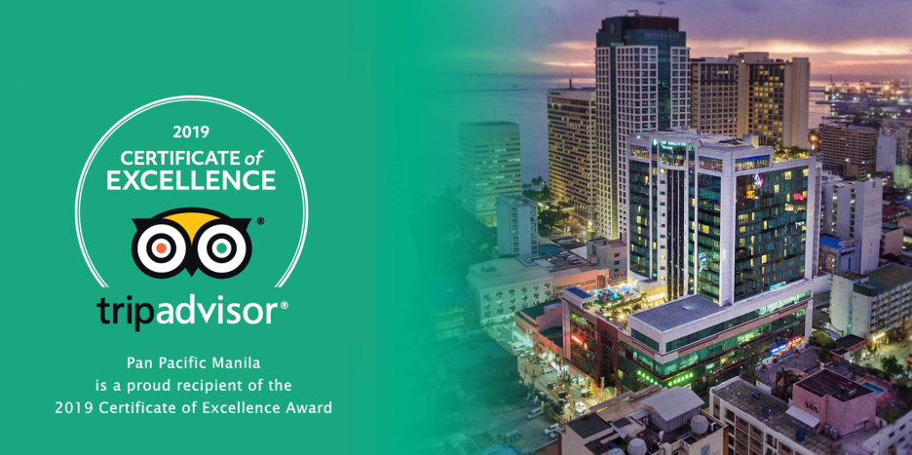

6 June 2019, Manila– Pan Pacific Manila has once again joined the ranks of the country’s best hotels as it received this year’s TripAdvisor® Certificate of Excellence. Now in its ninth year, the achievement celebrates businesses that are consistently excellent – having earned great traveler reviews on TripAdvisor over the past year. Certificate of Excellence recipients include restaurants, accommodations and attractions located all over the world that have continually delivered a quality customer experience.

“TripAdvisor is excited to announce the recipients of the 2019 Certificate of Excellence, which for nearly a decade has celebrated businesses that have consistently received positive ratings from travelers and diners on the world’s largest travel platform,” said Neela Pal, Vice President of Brand, TripAdvisor. “This recognition allows us to publicly recognize businesses that are actively taking into account customer feedback to help travelers confidently experience the most highly reviewed places to eat, stay, and explore.”

The Certificate of Excellence accounts for the quality, quantity and recency of reviews submitted by travelers on TripAdvisor over a 12-month period. To qualify, a business must maintain an overall TripAdvisor bubble rating of at least four out of five, have a minimum number of reviews and must have been listed on TripAdvisor for at least 12 months.

Pan Pacific Manila is located at M. Adriatico cor. Gen Malvar Sts. Malate. For reservations, please contact (02) 318 0788 or email [dining.ppmnl@panpacific.com](mailto:dining.ppmnl@panpacific.com). Price is subject to change without prior notice.

For more information on Pan Pacific Manila, please visit:

<https://www.panpacific.com/en/hotels-resorts/philippines/manila>

**ENDS**

**Media Contact**

Stephanie Cabrejas

Assistant Marketing Manager

Pan Pacific Manila

Email: [stephanie.cabrejas@panpacific.com](mailto:stephanie.cabrejas@panpacific.com)

Tel: +63 2 917 595 1479/ +63 2 318 0788

**About Pan Pacific Manila**

The first and finest Butler hotel in the Philippines – ranked among the recommended hotel at the 2017, 2018 and 2019 Forbes Travel Guide, named one of the best places to stay in the TripAdvisor Travellers Choice Award, and also recognised among the Philippines’ Leading Business Hotels at the World Travel Awards, is conveniently located at the heart of the historical and cultural district of Malate in the Manila Bay area. Pan Pacific Manila is a short drive to the city’s convention, exhibition and business centres and a walk away from shopping, food and entertainment establishments. A business hotel, designed to offer a comfortable abode to business and leisure travellers with its excellent facilities and service, the hotel has 236 all-executive rooms and suites and 7 spacious function rooms.

**About Pan Pacific Hotels and Resorts**

With hotels, resorts and serviced suites across Asia, Oceania and North America, Pan Pacific provides a safe harbour in an ever-changing world. Places with less to worry about because, when you stay with us, rest assured that all will be taken care of. For this is where you will find your balance.

**About Pan Pacific Hotels Group**

Pan Pacific Hotels Group is a wholly-owned hotel subsidiary of Singapore-listed UOL Group Limited, one of Asia’s most established hotel and property companies with an outstanding portfolio of investment and development properties.

Based in Singapore, Pan Pacific Hotels Group owns and/or managers more than 40 hotels, resorts and serviced suites including those under development in 24 cities across Asia, Oceania, North America and Europe.

Voted “Best Regional Hotel Chain” by readers in Asia in 2017 and 2018, Pan Pacific Hotels Group comprises two acclaimed brands: its signature brand, Pan Pacific and its deluxe brand, PARKROYAL.

Sincerity is the hallmark of Pan Pacific Hotels Group. The Group is known to its guest’s partners, associates and owners for its sincerity in people and the sense of confidence which alleviates the stresses of today’s complex world.