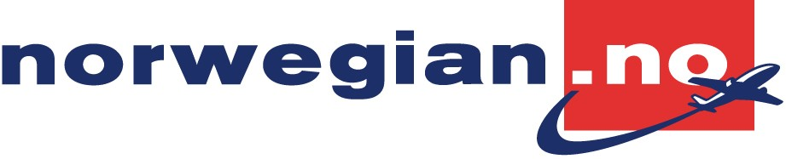
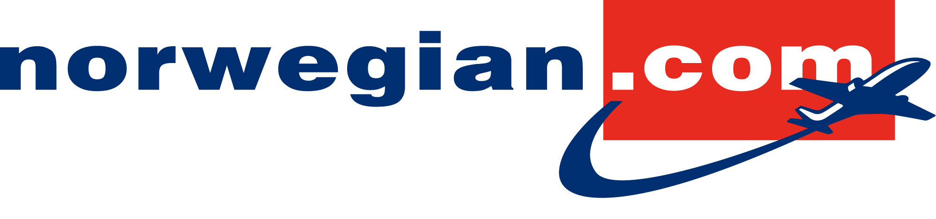

Oslo/Fornebu, 18 November 2009

Norwegian launches new frequent flyer program

Norwegian is today launching an entirely new frequent flyer program which will benefit both leisure and business travellers in all three Scandinavian countries. The frequent flyer program offers all travellers the possibility to earn CashPoints, up to 10 percent on Full flex tickets. The frequent flyer program is a stand alone program which is entirely independent from credit card solutions and other programs.

Norwegian Reward is the name of the frequent flyer program which is being launched today, 18 November. Travellers will receive a total of 10 percent CashPoints on Full flex tickets and 2 percent CashPoints on Low fare tickets. 1 CashPoint is equivalent to 1 NOK.

Travellers can earn CashPoints from the very first trip and use them as full or partial payment for new flights, check-in luggage or seat reservations. The points can be used at any time, and you do not need to save up a certain number of points before use.

Important to listen to the customers

-The frequent flyer program is part of our continuous work to provide our customers with a constantly improved offering. We know that our customers appreciate our low fares, improving route network, new airplanes and new seats with enhanced passenger legroom. This frequent flyer program is a further confirmation that we listen to our customers and provide a good and straightforward offer to all customer groups, says Daniel Skjeldam, Commercial Director in Norwegian.

My Reward and Corporate Reward

My Reward is for individuals – both for leisure and business travellers. Membership in the frequent flyer program will not be attached to a specific card. The customers will receive an electronic membership without a physical card, and can choose to pay their trip with any kind of credit card.

My Reward applies to both domestic and international travel. Due to Norwegian legislation it is not possible to earn points on domestic flights in Norway, however, it is possible to earn points on all international flights, also out of Norway.

Corporate Reward is an electronic corporate agreement, where it is the company that earns CashPoints.

The two programs My Reward and Corporate Reward may be combined – so that both the company and the employees can earn points on the same trip.

Contacts:
Commercial Director, Daniel Skjeldam, phone +47 907 42 073
Senior Vice President, Corporate Communications, Anne-Sissel Skånvik, phone +47 489 9 44 40

