

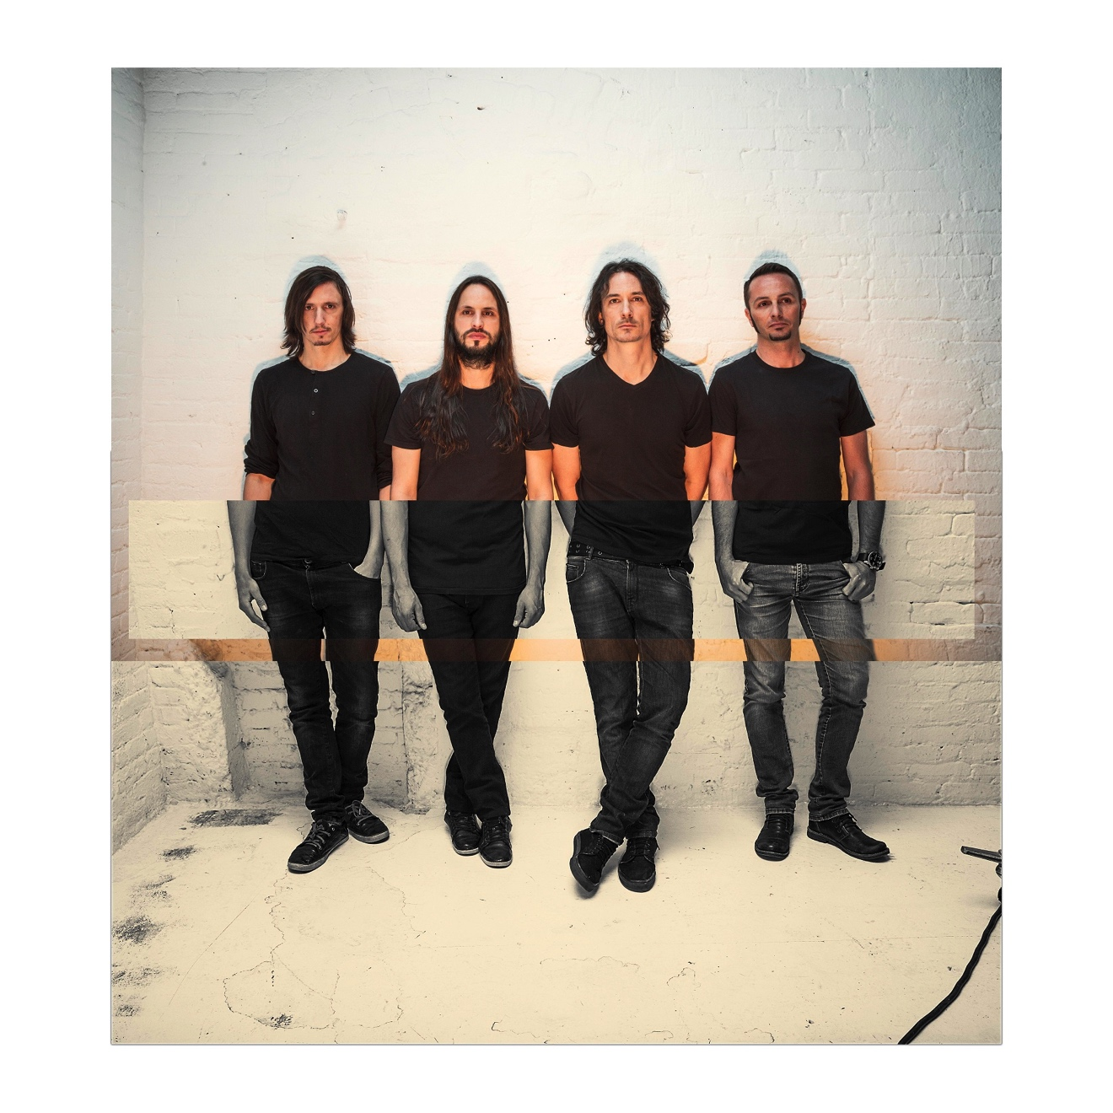

**GOJIRA RETURN WITH NEW LP *MAGMA***

**LEAD TRACK “STRANDED” STREAMING WITH OFFICIAL VIDEO AT** [**WWW.GOJIRA-MUSIC.COM**](http://WWW.GOJIRA-MUSIC.COM)

**PRE-ORDERS FOR *MAGMA* AVAILABLE TODAY**

***MAGMA* ARRIVES JUNE 17TH**

**WATCH THE OFFICIAL VIDEO FOR GOJIRA’S NEW TRACK “STRANDED”**

**(**[**https://youtu.be/FNdC_3LR2AI**](https://youtu.be/FNdC_3LR2AI)

EMBED CODE: <iframe width="580" height="323" src="<https://www.youtube.com/embed/FNdC_3LR2AI>" frameborder="0" allowfullscreen></iframe>

April 22, 2016 - Roadrunner Records group Gojira have announced details of their anticipated new LP *MAGMA*. The follow up album to 2012’s widely acclaimed *L’ENFANT SAUVAGE*, *MAGMA* is heralded by the new single “Stranded,” which is streaming now accompanied by an official music video directed by Vincent Caldoni at [www.Gojira-Music.com](http://www.Gojira-Music.com). Pre-orders for *MAGMA* are available today at [www.Gojira-Music.com](http://www.Gojira-Music.com), with all orders receiving an instant grat download of “Stranded” (album art below). Exclusive bundles are also available, which include a limited edition 52 page hardcover book with exclusive photos, sketches and artwork from the creation of *MAGMA*. Additionally, all bundles also include a DVD and HD digital download of Gojira’s 2015 Rock In Rio performance featuring newly mixed audio done by the band themselves. *MAGMA* arrives everywhere June 17th.

Frontman Joe Duplantier commented, “We are very excited to release our new album *MAGMA*. We put everything we had into these songs. This album is our flesh and blood.”

Recorded at the band’s own Silver Cord Studio in Ridgewood, Queens, *MAGMA* is produced, mixed and engineered by Gojira. It is the first of Gojira’s albums to be recorded at Silver Cord, their new NYC headquarters which brothers Joe and Mario Duplantier began building out by hand in 2014 as detailed by [*Rolling Stone*](http://www.rollingstone.com/music/news/gojira-preview-emotional-epic-new-album-20160330?page=2). *MAGMA* is already garnering “Most Anticipated” accolades from the press with [*Rolling Stone*](http://www.rollingstone.com/music/pictures/25-most-anticipated-metal-albums-of-2016-20160112/gojira-20160109) featuring it in their ‘25 Most Anticipated Metal Albums of 2016’ round-up. Additionally, *Decibel Magazine* placed the new LP in their ‘Top 20 Anticipated Albums Of 2016’ while [*Consequence of Sound*](http://consequenceofsound.net/2016/01/the-20-most-anticipated-metal-albums-of-2016-mm/3/) included it in their ‘20 Most Anticipated Metal Albums of 2016’ preview.

Gojira - brothers Joe Duplantier [vocals, guitar] and Mario Duplantier [drums], Christian Andreu [guitar], and Jean-Michel Labadie [bass] – will tour Europe and North America in the months ahead, with additional dates to be announced. For more information visit, [www.Gojira-Music.com](http://www.Gojira-Music.com).

Gojira made a stunning international impact with the release of their 2012 album *L’ENFANT SAUVAGE*, earning the four-piece unanimous critical praise and numerous “Best Of” honors. “…One of the most riveting and challenging metal records of the year. This quartet's nothing if not an adroit and agile rock band, prone to acrobatic guitar lines and rhythmic shifts capable of inducing whiplash,” stated *Pitchfork*. *Entertainment Weekly* placed *L’ENFANT SAUVAGE* in their “Six Best Metal Albums of the Year” round-up, while *SPIN* raved “…every nanosecond of (their) proggy death metal is masterfully erected.”

(ALBUM ART / TRACK LISTING / TOUR ITINERARY BELOW)

**GOJIRA**

***MAGMA***

RELEASE DATE: JUNE 17TH

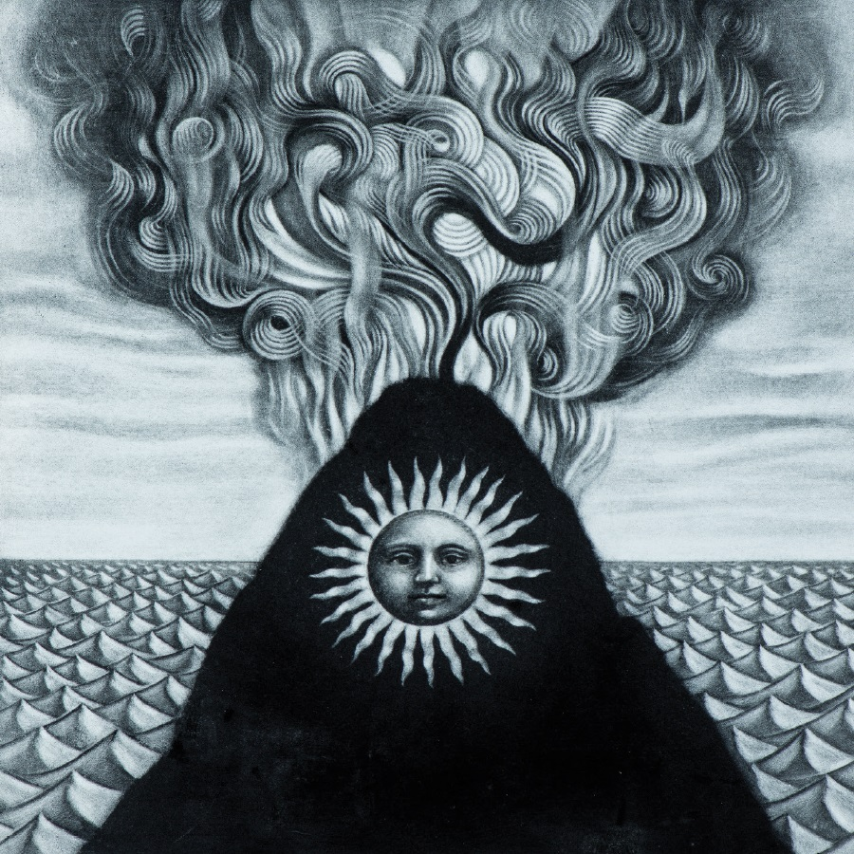

**TRACKLISTING**

1. The Shooting Star
2. Silvera
3. The Cell
4. Stranded
5. Yellow Stone
6. Magma
7. Pray
8. Only Pain
9. Low Lands
10. Liberation

**GOJIRA**

***ON TOUR 2016***

***5/28 – 8/13 – EUROPEAN FESTIVAL DATES***

May-28 Dortmund, GER Rock Im Revier/Westfalenhalle

May-29 Munich, GER Rockavaria

May-31 Warsaw, POL Stodola

June-1 Krakow, POL Kwadrat Klub

June-3 Luzern, SWI Sonisphere

June-4 Nijmegen, HOL Fortarock

June-5 Vienna, AUT Rock In Vienna

June-7 Roncade, ITA New Age Club

June-8 Milan, ITA Alcatraz

June-10 Paris, FRA Download

June-12 Donnington, ENG Download

June-14 Grenoble, FRA La Belle Electrique

June-15 Geneva, SWI L’Usine

June-17 Pratteln, SWI Konzertfabrik

June-18 Hasselt, BEL Graspop

June-19 Clisson, FRA Hellfest

July-2 Roskilde, DEN Roskilde

July-3 Helsinki, FIN Tuska Open Air

July-8 Viveiro, SPA Resurrection

July-10 Biarittz, FRA Atabal

July-17 Quebec, QUE Festival D’Ete De Quebec

July-22 Tromso, NOR Bukta Open Air Festival

July-23 Malakoff, NOR Malakoff Rock

Aug-11 Jaromer, CZE Brutal Assault Festival

Aug-13 Walton, ENG Bloodstock

For more information, visit [www.Gojira-Music.com](http://www.Gojira-Music.com)