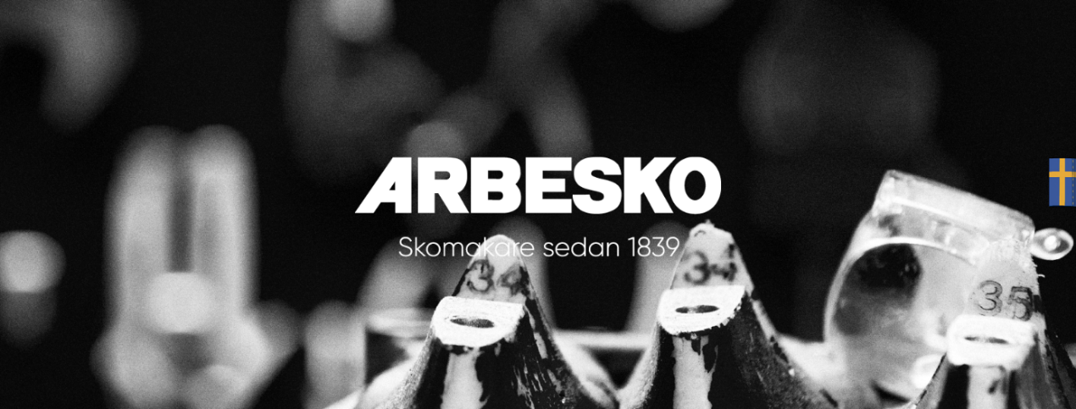

**ARBESKO APPOINTS A NEW HEAD OF SALES**

**The Swedish shoemakers Arbesko strengthens their organization by appointing Jonny Ljungberg as Head of Sales. Jonny is not a brand-new addition to the Arbesko family, he has worked as Key Account Manager since august 2017 and for the past four months he has had the role of acting Head of Sales. His inhouse experience will be a great asset in his new role where he will lead the sales crew forward.**

“Jonny has been the acting Head of Sales for the past four months and despite tough conditions, with both a lack of winter here in the Nordics and now a world-wide virus outbreak that makes the market uncertain, he has shown that he is the right person to lead our sales organization forward. We have a challenging period ahead of us, but with his experience and personality, I am convinced that Jonny will be a great asset to both the company and our customers”, says Karin Lidman, CEO at Arbesko.



“It feels great and exciting to have been given this opportunity. It's a troubled time we live in, but I have strong confidence in what we do as a company and what we will do going forward. We have a tremendous amount of knowledge within the team, the company and the Bergman & Beving Group, which feels really good. Even though we have a tough period right now, I know that we have a bright future with both our existing products and new product launches ahead”, says Jonny Ljungberg, Head of Sales at Arbesko.

Jonny Ljungberg has previously worked in the footwear industry and with professional clothing. He spends much of his free time as sports manager for Warberg IC. Jonny starts his new job as Head of Sales at Arbesko April 1st, 2020.

**For further information, please contact:**Karin Lidman Jonny Ljungberg  
CEO Head of Sales  
[karin.lidman@arbesko.se](mailto:karin.lidman@arbesko.se) jonny.ljungberg@arbesko.se  
+46 730783641 +46 706379264