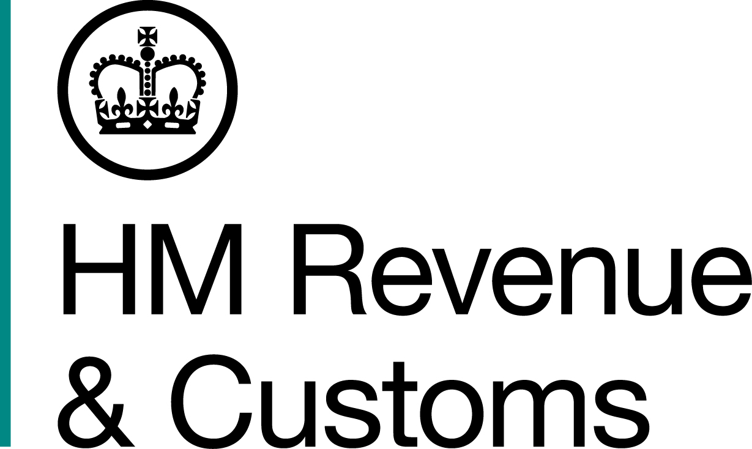
News Release

 | For the attention of News Desks |  | No of pages: 4
 | Date: | 01 March 2019 | Ref: | WM NR 11 18

VAT fraudster fails to dodge justice with forged hospital report

A crooked accountant who tried to escape justice by forging a medical report from a Cypriot hospital has been jailed for a £400,000 VAT scam.

Rakesh Sidhpara, of Wheatmoor Road, Sutton Coldfield, claimed more than 100 fraudulent repayments through hijacked businesses and fake firms, an investigation by HM Revenue and Customs (HMRC) found.

Sidhpara tried to delay his own trial in September last year by sending the court a forged five-page medical report from Cyprus, which claimed he couldn’t attend because of kidney stones.

But a HMRC officer raised suspicions about the stamp and signature on the medical report and went on to prove it was a fake. During the trial Sidhpara also sent several emails directly to the judge.

Sidhpara returned to the UK during the three-week trial and admitted the three-year VAT fraud. He was jailed for five-and-a-half years in December, 2018. He also admitted attempting to pervert the course of justice yesterday, 28 February, and was sentenced to an extra year in prison.

The 35-year-old acted as an accountant for a number of small firms and had the fraudulent VAT repayments paid into various bank accounts, which included some belonging to him and his wife, who helped him launder more than £80,000.

The cash was used to lease expensive Mercedes cars and to buy a large detached home for him and his 32-year-old wife, Ritu Sidhpara, who was also jailed for 23 months after admitting money laundering offences. The couple also enjoyed more than a dozen holidays between 2010 and 2013, which included trips to Las Vegas, Mexico, India, Dubai and even a VIP studio tour of the CNN headquarters in Atlanta.

Tanveer Akram, 35, from Handsworth, also received cash from the fake VAT returns and passed the proceeds of crime back to Sidhpara. He was convicted of VAT fraud during the same trial at Birmingham Crown Court and was also jailed two-and-a-half years.

Nick Stone, Assistant Director, Fraud Investigation Service, HMRC, said:

“Sidhpara thought he could lie to us and to the courts. He was wrong. He will now spend even more time behind bars thanks to our eagle eyed officer.

“This was a significant and sustained attack on the public purse, orchestrated by Sidhpara, along with his wife and business partner. The Sidhparas spent money on a lifestyle they could not legitimately afford and bought a large house with the proceeds of the crime.

“VAT fraud will not and should not be tolerated. If you know of anyone who is committing this type of crime you can report them to HMRC online or call our Fraud Hotline on 0800 788 887.”

Sidhpara, his wife Ritu and Akram were arrested in July 2013.

The trio, led by Sidhpara, claimed £407,587.56 between January 2010 and July 2013 through several companies – some did not exist while others were small taxi, recruitment and car wash firms.

Sidhpara used the bank accounts of some traders and hijacked others so payments were diverted into his own accounts without the knowledge of the businesses.

Sidhpara and his wife left the UK before the trial started. His wife returned for their trial on September 17 and admitted money laundering offences. But he stayed in Cyprus and then emailed the forged medical report to the judge.

He was arrested on October 3 after arriving at Birmingham Airport on a flight from Dubai.

Sidhpara was sentenced to five-and-a-half years in prison for VAT fraud and a further 12 months for attempting to pervert the course of justice. Ritu Sidhpara was sentenced to 23 months in prison for money laundering and Akram was jailed for two-and-a-half years for VAT fraud.

During sentencing, at Birmingham Crown Court, Judge Richard Bond QC, described Rakesh Sidhpara as “thoroughly dishonest” and “a conman” who was the “controlling mind of the fraud.”

During sentencing of his wife, he added:

“Ritu Sidhpara returned to the UK in September. She sat in the dock knowing that a completely false medical report had been handed over.

“Rakesh Sidhpara almost got away with it, but enquiries revealed that the report was utterly false from start to finish.

“Photos from the defendants Facebook page demonstrate that Ritu Sidhpara was, from 2010 until 2013, living a lifestyle that was far beyond that of an ordinary human being.

“As well as the holidays there was a lavish engagement party in 2011 and in 2012 there was a lavish Indian wedding ceremony. This would have cost tens of thousands of pounds over those years.

“The couple also bought a property together in Sutton Coldfield’s Wheatmoor Road, which cost £338,000. I am told there was a £100,000 mortgage and £238,000 was paid in cash.

“This was a money laundering arrangement and Ritu Sidhpara was aware of it from the outset. She entered into this with her eyes wide open.”

HMRC will now seek to recover the proceeds of the trio’s crimes.

Notes for editors

- Rakesh Sidhpara admitted making false claims to HMRC for VAT repayments with intent to prejudice or defraud HMRC. He was also convicted of attempting to pervert the course of justice. Tanveer Akram was convicted of making false claims to HMRC for VAT repayments with intent to prejudice or defraud HMRC. Ritu Sidhpara was convicted of money laundering offences contrary to Section 328 of the Proceeds of Crime Act (2002).

- Rakesh Sidhpara (DOB 07/01/1983) of Wheatmoor Road, Sutton Coldfield, was sentenced to five-and-a-half years at Birmingham Crown Court on 14 December 2018. He was also sentenced to 12 months for attempting to pervert the course of justice at the same court on 28 February, 2019.

- Ritu Sidhpara (DOB 24/02/1986) of Wheatmoor Road, Sutton Coldfield, was sentenced to 23 months in prison at Birmingham Crown Court on 28 January, 2019.

- Tanveer Akram (DOB 22/03/1983) of Colebourne Road, Moseley, Birmingham, B13, was sentenced to five-and-a-half years in prison at Birmingham Crown Court on 14 December, 2018.

- Follow HMRC’s Press Office on Twitter @HMRCpressoffice

Issued by HM Revenue & Customs Press Office

Press enquiries only please contact:

Nick McCarthy
Tel: 03000 589 546 or 07741 615 634
Email: nick.mccarthy@hmrc.gsi.gov.uk

Out of hours
Tel: 07860 359544
Website: www.gov.uk/hmrc

