**Swedish superstar Otto Knows joins American violin star Lindsey Stirling on latest single “Dying For You” also featuring Alex Aris out today via Warner Music!**

**Stream/Buy:** [**https://lnk.to/DyingForYou**](https://lnk.to/DyingForYou)

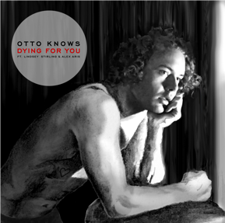

Picking up where **‘Next To Me’** left off, which to date has streamed more than **50 million** times on Spotify, **Otto Knows**’ second single signed to **Warner Music Group** continues to demonstrate where the Swedish heavyweight is pushing beyond the comfort zones of his craft. Calling upon the talents of viral YouTube violin star **Lindsey Stirling**, **‘Dying For You’** - which she’s a feature, alongside **Alex Aris** - seamlessly fuses Otto’s finely tuned melodic dance sound with Stirling’s renowned instrumental skills. Together, the duo forges an emotionally charged landmark in the young Swede’s already impressive discography. With more than **150 million streams** **globally** to his name, 2015 was another marker year for Stockholm-based talent **Otto Jettman**. Garnering **triple platinum** status in Sweden and gold in all Nordic countries for his single **‘Next To Me,’** (<https://youtu.be/VD9zmaX4ez8>) the summer saw Otto make landmark appearances at Tomorrowland, Creamfields, Summerburst Festival and Ushuaia Ibiza, adding to the announcement of his signing to At Night Management in a co-management deal alongside **Sebastian Ingrosso**. Propelled into the spotlight by breakthrough smash hit **‘Million Voices’** back in 2012, Otto would go on to co-write and produce **Britney Spear**’s returning hit ‘Work Bitch,’ marking an early indicator of where dance music’s next generation were naturally finding a voice among pop music’s elite. 2014’s **‘Parachute’** (Cheryl Cole) and **‘Can’t Stop Drinking About You’** (Bebe Rexha) continued to spotlight Otto’s unique hold on electronic music, paving the way for his on-going stand of quality dance music with mass appeal.

**FOR MORE INFORMATION:**

<https://www.facebook.com/OttoKnows>

<https://twitter.com/ottoknows>