PRESS PACK

23 May 2016

New PEUGEOT 3008
Advanced SUV

The new Peugeot 3008 has at last been unveiled. This long-awaited vehicle takes the C-SUV segment by storm, in a class of vehicles in full expansion across all regions of the globe. It takes on demanding customers looking for new and different experiences with a very strong hand. Whether by its spectacular latest-generation PEUGEOT i-Cockpit, by its exceptionally inspired design, by its optimised architectural efficiency or by its high-tech equipment, the new PEUGEOT 3008 SUV aims to assert itself from the off as a major player. It inaugurates for PEUGEOT a new SUV range for which it will be the worldwide emblem. The new PEUGEOT 3008 SUV will be the star of the PEUGEOT stand at the next Paris Motorshow where it will at last be presented to the public ahead of its worldwide launch.

When the new PEUGEOT 3008 arrives in the C SUV segment

For several years, across all segments, the SUV market is booming. In the European C-segment, still the biggest and most diverse, SUV sales have increased two and a half-fold since 2009 – the launch-date of the first generation of PEUGEOT 3008. Now, in Europe, all segments considered, one car in ten belongs to the SUV family.

A true incarnation of the modern automobile, stately, technological, creator of emotions and personal pleasure, the SUV enhances the standing of its driver and embodies values in keeping with its time. It is not only the realisation of a desire for personal expression but also a desire to demonstrate success, the looks from others reflecting ones own values. Lastly, it shows a desire for escapism and new experiences, even if the imagined excursion into the wilderness with this vehicles remains strictly fantasy!

Because today’s drivers want a renewed driving experience from their cars. For travelling time, all too often these days seen as a chore, to become a time enriched by experiences, emotions and sharing. An intuitive and sensory interaction with their machine, as if the vehicle understands the needs of its occupants and could mould itself to them. A welcoming cabin that they can personalise to be as relaxing as their own home. And which vehicle best meets these desires? The “Sport Utility Vehicle” the SUV, the concept of which has even surpassed its title to forge its own myth.

All vehicle manufacturers have understood this, and a plethora of models is available worldwide. However, the experience of driving an SUV rarely comes up to expectations. The challenge facing PEUGEOT is therefore a major one: not only to incorporate all the characteristics of the segment but above all to deliver an incredibly consistent, modern, sleek and intelligent package. With the new PEUGEOT 3008, the brand wants to position itself from the off in the C SUV segment with an eminently desirable product consistent with its best know-how and its strategy of moving up-market. And this move up-market is confirmed first and foremost by the fitment as standard of the new PEUGEOT i-Cockpit®.

Breath-taking interior design

Getting into the new PEUGEOT 3008 SUV is to enter another world, surprising, original and oozing quality. A spectacular, almost futuristic dashboard immediately catches the eye. This coherent and highly technological ensemble is the latest generation PEUGEOT i-Cockpit®, a novel concept that has rewritten the book on the car cockpit. Here, everything seems to be at the service of the pleasure and concentration of the driver in a pronouncedly high-tech niche.

The steering wheel is even more compact and has been redesigned with two flats to make it easier to grip and to afford the driver maximum visibility and legroom. The close attention paid to material choices and attention to detail – full hide leather from level 2, chrome inserts, gloss black trims – deliver a high level of perceived quality and attractiveness.

The large 8” touch-screen resembles a tablet installed in the centre of the dashboard and is equipped with capacitive technology for greater reactivity and practicality. It is accompanied by six elegant piano-key “toggle switches” - giving direct and permanent access to the main control functions: radio, climate control, navigation, vehicle parameters, telephone and mobile applications.
The heads-up instrument unit unveils in series production a high-resolution 12.3” screen with futuristic graphics. It can be completely configured and personalised, and brings together all that the driver could want in his field of view. Five different display modes – controlled from a knob on the steering wheel – allow the driver to configure the instrument unit “a la carte”. The « Personal » mode in particular, configured from the touch-screen, allows the driver to display a wide choice of information: copy of navigation instructions, driver aids, engine parameters, trip computer, route information etc. The visual impact of each setting is highlighted by a series of animations and transitions which are a treat for the eyes.

But this enhancement of the PEUGEOT i-Cockpit® doesn’t end there. Because pleasure is still one of PEUGEOT’s core values, it pushes the sensory boundaries even further. So, by a simple press of a special switch – next to the toggle switches – the new PEUGEOT 3008 SUV calls up a true Master of Ceremonies to enhance the driving experience: the i-Cockpit® Amplify. In this way, almost all the senses are immediately aroused:
- Sight, by varying the brightness of the ambient lighting and the colour of the screens;
- Hearing, via the musical equaliser settings;
- Touch, via the multipoint massage embedded in the seats (up to five programmes);
- Smell, via a fragrance diffuser.
(see detailed description on page 13)

Furthermore, as in the PEUGEOT 308, sight, touch and hearing can further enjoy the stunning features of the Driver Sport Pack.
(see detailed description on page 13)

So there is a veritable feast of sensations for the driver to experience, letting him go to the limit of his driving pleasure. Occupants get the immediate choice of two themes: the “Boost” theme aimed at a dynamic driving style, and the “Relax” theme for gentler driving. These two themes are entirely configurable so that the driver and passengers exceed the limits of pleasure, and make travelling on board truly unique and unforgettable.

This on-board experience is equally well served by the richness of the interior, actively contributing to the excellent sense of perceived quality and modernity felt in the cabin. Material choices are inspired and their appearance uncompromising. Here we will find leather, numerous touches of brushed chrome, large expanses of carbon or cloth decoration…. Textiles inspired by “home design” cover the door-card inserts, the headlining, the windscreen pillars and even some areas less commonly found in cars, such as the dashboard inlay….it’s all very modern and warm.

Inspired exterior design

The interior design of the new PEUGEOT 3008 is unique to the market. The design is successful and rich, and the on-board technology promises much.
This feeling is carried over to the outside. At first glance, the new PEUGEOT 3008 is striking and surprises by the strength of its character. The effect is strong, clear and self-evident: this is an SUV. The new PEUGEOT 3008 has adopted all the characteristics of this type of silhouette:
- A vertical front end,
- A long flat bonnet,
- A high waist line,
- Wide protective bands (bumper skirts, wheel arches, bottom of doors),
- Large wheels,
- Raised ground clearance,
- Shaped roof bars,

But the new PEUGEOT 3008 SUV doesn’t just settle for incorporating these characteristics. It adds meaning and emotion whilst keeping in mind consistency. Because what you notice first about the vehicle is a sense of harmony, of well-balanced proportions, of just the right quantity of everything. A shape inspired by the boundless creativity of its designers.

The front end is certainly vertical, but also very powerful, giving off a feeling of strength, even of animal aggression. Its lines are clear, bold and balanced. The wide chrome-trimmed grille sets the tone. In its centre the Lion, correctly in proportion, neither too shy nor ostentatious, takes pride of place. A piercing feline look comes from the narrow halogen headlamps. It becomes sharper still when they are take on the (optional) full LED lamps. There are numerous wide open air intakes. The expressionism of this front end characterises the self-assurance of the owner and the sense of belonging to the brand. A true PEUGEOT!

The bonnet is certainly long and flat, but its styling lines convey a sense of strength. Beyond it the windscreen is more upright and positioned behind the line of the front axle, and it is flanked by chrome inserts sweeping back from the line of the headlamps. A nod to the HX1 concept car, this body-side design language lends a dynamic feel to the front end and further increases the standing and modernity of the vehicle.

The waist line is certainly raised, and there is a marked increase in the sheet metal/glass ratio, but the line is highlighted with elegance and fluidity, producing a slimmer profile. The upper surface of the bonnet flows into a crease incorporating the door handles and stretching out the line of the vehicle with finesse and style. It’s a superbly styled vehicle whose proportions give it a look less heavy and tall than the majority of its competitors. And how were the PEUGEOT styling team able to achieve this feat? Partly because they included – as an option from level 2 – a gloss black roof, highlighted by standard-fit stainless steel trims which stretches to the rear spoiler. This “Black Diamond” roof is a key styling feature in the design of the vehicle, lending it increased personality, dynamism, modernity and status.

The protection around the vehicle, its large wheels, roof bars, are certainly all there! – but executed with a canny mixture of character and sophistication. It all leads to a creative result that is extremely modern, even futuristic whilst avoiding pompous and torturous styling compromises.

The surprise continues at the rear, where again we find a clear and very modern design. Beneath the inclined rear window, a gloss black band incorporates the opalescent LED tail lamps. These feature the three essential claw-marks that make the PEUGEOT visual signature so clearly identifiable – at night as in daytime.

Whatever angle it is approached from, whoever sees the new SUV PEUGEOT 3008 for the first time is struck by the feeling of top-quality execution and of a high level of perceived quality. A multitude of factors contribute to this overall impression: the fine tolerance of gaps and fits, touches of chrome cleverly distributed all around the vehicle, two-tone bodywork etc. It’s attractive, well thought-out and tasteful. This “look” makes for the most fashionable SUV on the market.

A jubilant driving experience …

The reputation of the Lion brand in terms of driving experience is already well-established, the skill of the in-house development engineers is in repeatedly producing the most satisfying vehicles to drive, whatever their size. In the case of an SUV, the challenge is considerable: raised ride-height, high driving position, raised centre of gravity…In this class of vehicle, styling choices are often made to the detriment of driveability.
But in this case, right from the start, you can feel the magic. Irreproachable road-holding, precise steering, ride, a feeling of agility and safety, everything is there as it should be. Is it really magic? Of course not. This result is the product of long experience and of the most efficient and modern technology.

Thanks to the new EMP2 platform and to its renowned dynamic qualities, the new PEUGEOT 3008 achieves a balance between comfort and road holding hitherto completely unknown in the C SUV segment. Its suspension is tuned to each power-plant to achieve a ride fitting to the reputation of the Lion. Finally, it contributes to the virtuous circle of weight reduction giving improved fuel consumption, passive safety and performance.

The new PEUGEOT 3008 is a true SUV, but above all it’s a PEUGEOT! And like any true SUV it has genuine off-road capability, especially thanks to Advanced Grip Control.
This enhanced traction system utilises the following equipment:
- optimised traction control with five grip levels (Normal, Snow, Mud, Sand, ESP OFF) controlled from a knob on the centre console;
- specific tyre fitment 18’’ M+S (Mud & Snow);
- Hill Assist Descent Control (HADC), a new descent assist function giving perfect and completely safe control over the vehicle and its path on steep slopes. The innovation in the system is that it can keep the vehicle to a very low speed (3 kph) bringing control and safety in supposedly anxiety-provoking situations. This function is controlled by a special button on the centre console.

The driver and passengers just have to sit back and enjoy the ride! Journeys on board, even the shortest and most day-to-day trips, are enriched with new discoveries. This new PEUGEOT is a true invitation to travel, first-class, aided by excellent sound-insulation and numerous comfort features, most of which are above normal market levels:
- body-hugging front seats both of which can receive as an option an 8-pocket pneumatic massage system
- a large panoramic sunroof fitted with a blind and illuminated rails
- a Premium FOCAL® Hi-Fi system from the major French audio brand

In an exclusive partnership with the top-end brand FOCAL®, PEUGEOT is able to offer as a world first on any vehicle a factory-fitted Hi-Fi incorporating FOCAL® technology.
(see detailed description on page 14)

… supported by an arsenal of driver aids…

It is a joy to drive, a feeling amplified by the compact steering wheel, and the driver can make the most of the dynamic abilities of this SUV, especially thanks to the support of the numerous driver aids available to him. These latest generation ADAS (Advanced Driver Assistance Systems) minimise any source of danger on the road through an arsenal of safety features:
- Active Safety Brake and Distance Alert;
- Active lane departure warning;
- Driver attention warning
- Automatic adaptive headlamp main-beam
- Speed limit sign recognition and recommendation
- Adaptive Cruise Control with Stop function (automatic gearboxes)
- Active blind-spot monitoring

For city driving, the driver is also assisted with certain manoeuvers, by Visio Park (360° all-around vision) and the latest generation Park Assist.
(see detailed description on pages 14 to 17)

… and permanent connectivity

The new PEUGEOT 3008 is like its driver – it moves with the times. So it meets the need to stay connected at the wheel and to be able to navigate calmly and peacefully, thanks to features like Mirror Screen, induction Smartphone recharging (for equipment compatible with the Qi standard) and 3D connected navigation.

The 3D navigation stretches realism even further by displaying images of buildings and monuments, whilst taking into account the contours of the terrain. With a simple touch of a knob on the wheel, it can be copied from the touch-screen to the digital instrument unit for easier viewing. With TomTom® Traffic its connectivity gives real-time visibility of events essential to the journey and access to various information: local weather, car-parks, service stations etc. There is also an option to subscribe to TomTom® risk areas and to receive reliable information on permanent danger areas and temporary risk areas reported by the community.

With the Mirror Screen function, a Smartphone screen can be reproduced on the touch-screen to make best use of its applications. It is compatible with MirrorLink protocols (Android smartphones), Android Auto and Apple CarplayTM (iPhone 5 onwards). And with a simple touch of a button on the steering wheel, there is a remote voice recognition function through the smartphone (Android S-Voice and Apple Siri). Without taking his eyes off the road, and in complete safety, new possibilities are opened up to the driver: make calls, choose music, read and send text messages, get route information…permanent connectivity in operation!

With the PEUGEOT Connect pack, even greater possibilities are opened up in three areas: navigation, safety (Peugeot Connect SOS & Assistance) and maintenance (PEUGEOT Connect pack teleservices).
All this information is served up to the driver in the simplest and most intuitive way possible. The interfaces provided by the new PEUGEOT 3008 at last allow these functions to be used in peace!

Design intelligence for practical use

This design intelligence does not end at providing vehicle occupants with the best comfort and safety features available on the market. The new PEUGEOT 3008 encourages its occupants to share unforgettable moments in it and so has to ensure maximum versatility. This wide-ranging modularity, together with its clever features have been thought out to meet all expectations and handle all situations. An unusual load? The 2/3-1/3 split-folding “Magic Flat” rear seat produces a flat load-floor. Need to keep your things separate? Want easy loading or to make the most of you leisure activities? The innovative two-position sliding floor makes for easy use of the boot space and you can even sit on it comfortably without getting dirty. An especially long load? The fold-flat passenger seat gives a load-space 3 metres long! And on all versions, the rear seat centre armrest is fitted with a ski-flap….. To this clever versatility you can add a hands-free tailgate, where with a simple movement of the foot beneath the rear bumper the motorised tailgate can be opened or closed. In fact, the ingenuity of the new PEUGEOT 3008 lends itself to all configurations!

It also benefits from an optimised architecture, opening the way for dimensions at the heart of the market but among the largest interior space!
(see detailed description on pages 10 and 11)

Thus, as for the interior cabin space, the boot capacity is markedly improved over the previous generation. As well as a capacity of 520 l VDA 210, it also has one of the lowest loading heights in its class.
(see detailed description on page 12)

This optimised architecture also brings a step-change in weight. The beneficial effects of the new EMP2 platform, coupled with a genuine optimisation of the weight/volume/equipment ratio at all levels give an average weight gain of 100kg over the previous generation. The new PEUGEOT 3008 starts from kerb weights of only 1325kg for petrol and 1375kg for diesel versions.
(see detailed description on page 12)

An engine range which is powerful…and parsimonious!

All this effort expended on vehicle architecture and weight reduction is a major factor in the never-ending search for reduction in fuel consumption and CO₂ emissions. But that is not all. Aerodynamic design and optimised external dimensions lead to an excellent CxA of 0.76 m² (on the best versions). And the use of Ultra Low Rolling Resistance (ULRR) tyres in 17” and 18” or even a stretched 19’’(205 55 R19) fitment also contribute to the efficiency of the new PEUGEOT 3008.

Finally, whether petrol or Diesel, the new PEUGEOT 3008 SUV in Europe benefits from a range of Euro6.1 engines which are powerful….yet give ultra-low consumption.
Hence, all petrol versions are best in Class in their power range! The 1,2L PureTech 130 S&S engine posts from 115g CO₂ / km whilst the 1.6L THP 165 S&S 6-speed auto emits only 129 g/km of CO₂. There are 4 power-plants in the range:
- 1.2L PureTech 130 S&S 6SMT (6-speed manual transmission) in standard and very-low consumption versions
- 1.2L PureTech 130 S&S 6-speed auto
- 1.6L THP 165 S&S 6-speed auto

For Diesels, BlueHDi technology keeps emissions for the range between 100 and 121 g/km of CO₂ for power outputs of 100, 120 and 150 hp. The 1.6L BlueHDi and 2.0L BlueHDi installations are also among the best on the market:
- 1.6L BlueHDi 100 S&S BVM5
- 1.6L BlueHDi 120 S&S 6SMT (6-speed manual transmission) in standard and very-low consumption versions
- 1.6L BlueHDi 120 S&S 6-speed auto
- 2.0L BlueHDi 150 S&S 6SMT (6-speed manual transmission)
- 2.0L BlueHDi 180 S&S 6-speed auto

Extended mobility – innovation at work!

In a context where access to town centres has become more and more difficult, PEUGEOT has positioned itself as a supplier of innovative solutions to today’s mobility problems. It is still the only brand offering two, three and four-wheeled solutions and is using the launch of the new PEUGEOT 3008 to offer its customers a new personal mobility solution:
- An electrically assisted folding scooter (e-Kick) by MICRO
- An electrically assisted folding bicycle (e-Bike) by PEUGEOT

This unique offer is aimed at customers looking for complementary solutions to their vehicle to complete the last part of their journey. The daily life of the city-dweller has been transformed: no more limitations! Long live freedom!
Moreover, to ensure perfect integration into the boot and immediate availability, “dockstations” hold the e-Kick or e-Bike in place in the boot and recharge the batteries whilst the vehicle is running.

Made in France

The new PEUGEOT 3008 is produced in the Sochaux plant, and the French Trémery and Douvrin factories supply all the power-plants. It will therefore carry from the outset the “Origine France Garantie” label.

The new PEUGEOT 3008 will be presented to the public for the first time at the 2016 Paris Motorshow and will go on sale worldwide from October.

Follow all the latest at #SUVPeugeot3008
The new PEUGEOT 3008 in detail

1 - Optimised architecture

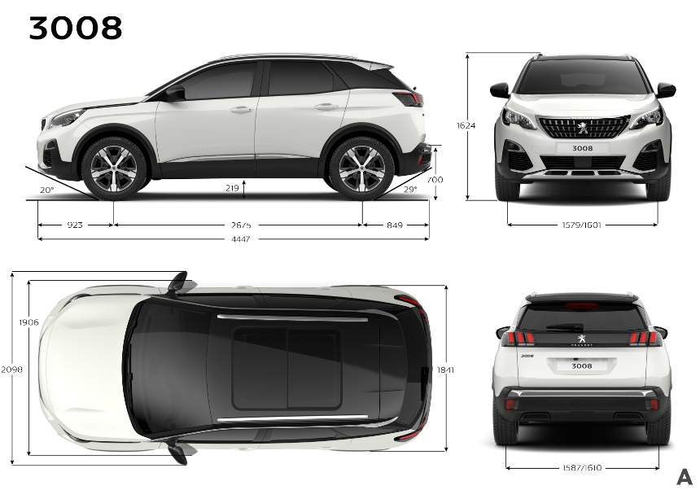

The new PEUGEOT 3008 SUV is not only attractive to look at, it is also well thought-out, enjoying performance and features are in line with the best in the segment and up to the reputation of the brand.
At 4.45m in length it is positioned at the heart of the segment. And although it is 8cm longer than the previous generation, this extra length can be found in the wheelbase - and thus in the passenger space – which at 2 675 mm, increases by 62mm over the old 3008. This wheelbase is one of the longest on the market. With a width of 1.84m (the same as the previous generation but with enhanced interior space) the height of the new PEUGEOT 3008 has been kept to 1.62 m (including roof bars), a key factor in a remarkable aerodynamic performance whilst affording its occupants excellent head-room.
It is imposing, with its large wheels and 22cm ground clearance.

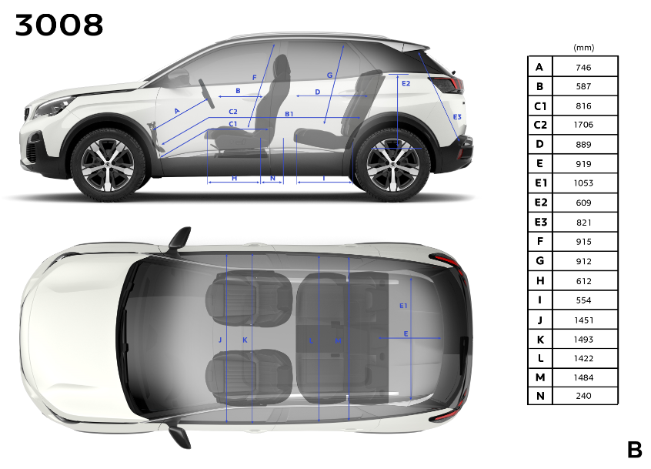
Inside, all key passenger dimensions are improved over the previous generation:
- Rear legroom +24 mm
- Front elbow room: + 17 mm
- Rear elbow room: +4 mm
- Rear headroom: + 36 mm (steel roof)…

Similarly boot capacity is greatly increased: with 520 litres VDA 210 under the luggage cover it is almost 90 litres bigger than on the previous generation (432 l VDA). Its versatility even allows the load capacity to be increased to 1580 litres!
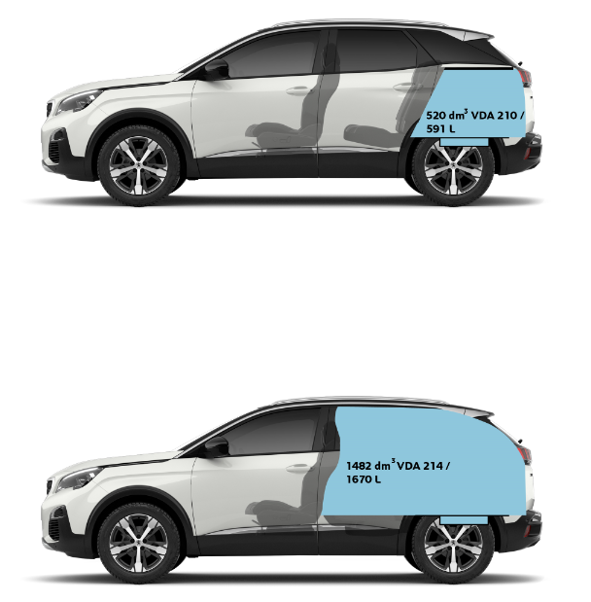

This optimised architecture is accompanied by a step-change in weight, as an average of 100kg have been saved over the previous generation. To achieve this performance, each part made, each process employed has been subjected to a virtuous design cycle leading to a maximum weight gain in the name of fuel consumption, passive safety and dynamic performance of the vehicle. The key features are:
- VHSS and UHSS steels (Very High Strength Steel and Ultra High Strength Steel)
- Thermoplastic boot floor and tailgate
- Wings, front suspension arms and rear seat frames in aluminium
- Improved engine noise levels allowing reduction in sound-deadening materials …

2- The new PEUGEOT i-Cockpit: sensation amplifier!

The new PEUGEOT i-Cockpit® is a step forward in all areas. Higher quality visually, more technical in its design, better connected, more intuitive, it goes further still by playing on the pleasure and personalisation in its use.
It can also be accompanied by the optional i-Cockpit® Amplify where by the touch of a button on the central console, almost all senses are immediately aroused:
- Sight, by varying the brightness of the lighting and the ability to select the colour themes of the screens;
- Hearing, via the musical equaliser and sound settings;
- Touch, via the multipoint massage system embedded in the seats;
- Smell, via a fragrance diffuser (see below)

Occupants get the immediate choice of two themes: the « Boost » theme aimed at a dynamic driving style, and the « Relax » theme for gentler driving. These two themes are entirely configurable so that the driver and passengers exceed the limits of pleasure and make travelling on board unique and unforgettable.

Quality can also be seen in the fragrances offered by the i-Cockpit® Amplify. In fact they have been developed with Scentys and Antoine Lie, an internationally renowned perfumer, for a top of the range olfactive experience.

Each of the 3 fragrances on offer has its own characteristics:
- ‘Cosmic Cuir’: a vibrant and sensual fragrance, and a genuine olfactive signature of the brand;
- ‘Aerodrive’: a lively and stimulating fragrance (the default setting for the ‘Boost’ atmosphere);
- ‘Harmony Wood’: an authentic and relaxing fragrance (the default setting for the ‘Relax’ atmosphere);
There are also 3 intensity settings available.

Moreover, as in the PEUGEOT 308, sight, touch and hearing can further benefit from the stunning features of the Driver Sport Pack, which influences the following settings:
- firmer and more responsive power steering;
- more responsive accelerator pedal mapping;
- enhanced engine and gearbox response (on automatic versions, where paddle-shifters are also fitted to the steering wheel);
- engine sound amplified with a sporty note (via a digital amplifier which enhances the sound in the cabin);
- enhanced colour display on the various screens (instrument unit and touch-screen) with additional vehicle dynamics information displayed on the instrument unit: power output, boost pressure, longitudinal and lateral g-force.

3 - FOCAL® Premium Hi-Fi system for a top of the range acoustic voyage

The new PEUGEOT 3008 is able to offer as an option and a world first on any vehicle a factory-fitted Hi-Fi audio system developed by the French brand FOCAL®. As a specialist in the audio field for more than 35 years, FOCAL® is renowned worldwide for its patented innovations and its unique sound.

This system is fitted with 10 speakers using exclusive FOCAL® technology, bringing the pleasure of pure and defined sound on board the vehicle:

- High fidelity Woofers / mid-range: Polyglass technology for balanced and clear sound
- TNF Tweeters: Inverted aluminium dome technology for optimal sound output and clear high-pitched notes
- Subwoofer: 200 mm Power FlowerTM triple coil technology, for clear and dynamic reproduction of low frequencies
- Active 12-channel amplification – 515 Watts: Class AB / Class D hybrid technology, giving rich and fine high frequencies and genuinely powerful bass notes.

The speakers are fitted with metallic grilles, carrying the FOCAL® logo on front and rear tweeters.

4 - Numerous state-of-the-art driver aids

Ably assisted by the numerous electronic aids, the driver of the new PEUGEOT 3008 can fully enjoy the dynamic capabilities of his SUV. All these functions can be switched on and off at will using the “Vehicle parameters” menu.

Active Safety Brake and Distance Alert

The Distance Alert function (collision warning) warns the driver that the vehicle is about to collide with the vehicle in front or a pedestrian on the carriageway.
Active Safety Brake (emergency brake assist) comes into play after the warning if the driver does not react quickly enough and apply the brakes. In this way it helps, without any action from the driver, to avoid a collision or to mitigate its severity by reducing the vehicle speed. The system detects registered vehicles which are travelling in the same direction or stationary, as well as pedestrians on the road (cycles, motorcycles, animals and other objects on the carriageway are not detected).
Active Safety Brake operates if:
- Vehicle speed is between 5 kph and 140 kph when a moving vehicle is detected;
- Vehicle speed does not exceed 80 kph when a stationary vehicle is detected;
- Vehicle speed must not exceed 60 kph when a pedestrian is detected

(Active) Lane Departure Warning

Lane Departure Warning is a system using camera recognition of continuous or broken lines on the road surface that senses when the vehicle accidentally crosses lane markings. For maximum safety the camera processes the image and triggers a visual and audible warning if the vehicles goes off course when driver concentration lapses at speeds over 80 kph.

Between 65 and 180 kph, Active Lane Departure Warning also corrects the course of the vehicle: as soon as the system observes that the vehicle is likely to stray over a lane-marking line, the steering applies opposite lock progressively to keep the vehicle in its original lane. If the driver wishes to stay on the current path, he can override the correction by holding the steering wheel firmly (for instance during an avoidance manoeuvre). Correction will be halted if the direction indicator is activated.

Driver Attention Warning

The new 3008 is fitted as standard with Driving Time Warning: a warning is given if the system detects that the driver has not taken a break after driving for more than two hours at speeds above
65 kph. This warning takes the form of a message encouraging him to take a break, along with a warning chime.
Alongside this function is Driver Attention Warning. The vehicle has a camera fitted at the top of the windscreen which tracks its course. The system monitors the state of alertness of the driver by analysing any deviations from the path between road markings. It can then trigger various levels of audible and visual warning (“Stay alert!” or “Take a break!”)

Automatic adaptive headlamp main beam

The vehicle has a camera fitted at the top of the windscreen which monitors light sources. This system automatically switches between main and dipped beam according to lighting and traffic conditions. It thus maximises time spent on main beam for greater safety.

Speed Limit recognition and recommendation

The camera fitted at the top of the windscreen can detect and read speed limit and derestriction signs, and cause them to be displayed on the instrument unit. The system also uses speed limit information taken from the navigation system mapping. Individual speed limits such as those applicable to HGVs are not displayed. This feature is fitted as standard from the first trim level.
Speed recommendation complements this device: the driver can choose to modify the vehicle speed setting to that read by the camera, by pressing the ‘MEM’ button on the cruise control/speed limiter control.

Adaptive Cruise Control with Stop Function (Automatic gearboxes)

The vehicle is fitted with a radar unit at the centre of the front bumper having a range of 150 metres. Between 30 and 180kph, the Adaptive Cruise Control with Stop Function has two functions:
- To automatically maintain vehicle speed to that set by the driver
- To automatically keep the distance from the vehicle in front (3 pre-set levels: distant, normal and close)

The system detects any preceding vehicle moving in the same direction. It automatically adjusts the vehicle speed to that of the vehicle in front using engine braking and the main brakes (in which case the brake lights come on), to keep a constant distance from the vehicle in front, right up to when the vehicle comes to a complete stop.
This feature is available as standard fitment or an option on automatic gearbox vehicles only (except 1,2L PureTech 130 S&S 6-speed auto).

Active Blind-spot Monitoring

Between 12 kph and 140 kph, this system warns the driver of the presence of another vehicle in his vehicle’s blind-spots, whenever it presents any potential danger. The warning takes the form of a tell-tale lamp that lights up in the door mirror on the relevant side, whenever a vehicle (car, lorry, cycle) is detected.
The system works in conjunction with the Active Lane Departure Warning system: as well as the tell-tale lamp in the door mirror on the relevant side lighting up, a path correction will be felt if a lane marking is crossed with the direction indication activated, to help the driver to avoid a collision.

Visiopark 1 & 2

The vehicle is fitted with 180° video cameras on the tailgate (Visiopark 1) and in the front grille (Visiopark 2). The system shows the area surrounding the vehicle on the touch screen via the cameras. The parking aid sensors add further information to project a view from above the vehicle. A view from above the vehicle is shown in real time as the vehicle manoeuvres, giving an all-round 360° view.
This view helps to position the vehicle when parking and to see all obstacles nearby.

Park Assist
.
Using side-facing ultrasonic sensors, this system provides active parking assistance:
- it identifies a parking space suitable for the size of the vehicle using sensors installed in the front and rear bumpers
- then it controls the steering to park the vehicle in the space

The driver controls acceleration, braking, gear selection and clutch (manual gearboxes). During the entry and exit phases to and from the parking space, the system gives visual and audible signals to the driver so that he can manoeuvre in safety. The driver can resume control of the steering at any time simply by gripping the steering wheel.
Park Assist will facilitate « parallel » (entry and exit) and « perpendicular » parking manoeuvres.

Press contacts
www.peugeot-pressepro.com
Edouard BERGEVIN \ +33(0) 1 40 66 36 51
edouard.bergevin@peugeot.com

PEUGEOT
Stimulating and involving driving, sleek design, uncompromising quality, these make up the commitment of the brand towards its customers and contribute to the pleasure that each PEUGEOT brings.
Present in nearly 160 countries with more than 10 000 sales outlets, PEUGEOT grew in 2015 by 4.6% to 1 710 000 vehicles sold worldwide. Everywhere, PEUGEOT combines Rigour, Attractiveness and Pleasure with the ambition to be the up-market generalist brand with a global remit.
Begun in 1889, the automotive heritage of the brand has been further enhanced this year by the victory of the 2008 DKR on the tracks of the Dakar.

