


News Release February XX, 2021
Yanmar Holdings Co., Ltd.

Yanmar Powers Award-winning Norwegian Hybrid Fishing Vessel

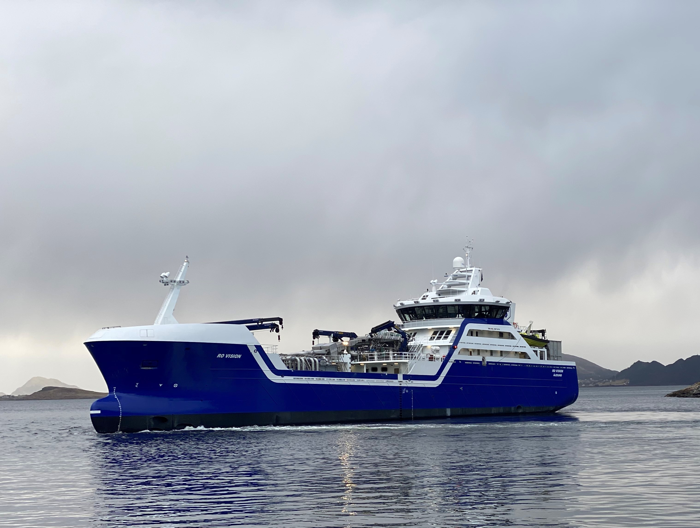
The Ro Vision hybrid live fish carrier.

Yanmar has delivered engines for an innovative hybrid power solution for the live fish carrier, Ro Vision, the winner of Norway’s Boat of the Year Award. Built by Norwegian shipyard Larsnes Mek. Verksted AS., the The Ro Vision is powered by three of Yanmar’s 6EY22ALW diesel generators integrated with a 600kW battery pack from Siemens which together provide power for onboard systems and the electric propulsion system. The ground-breaking vessel was awarded Norway’s prestigious Ship of the Year Award for 2020 for its outstanding technology and design.
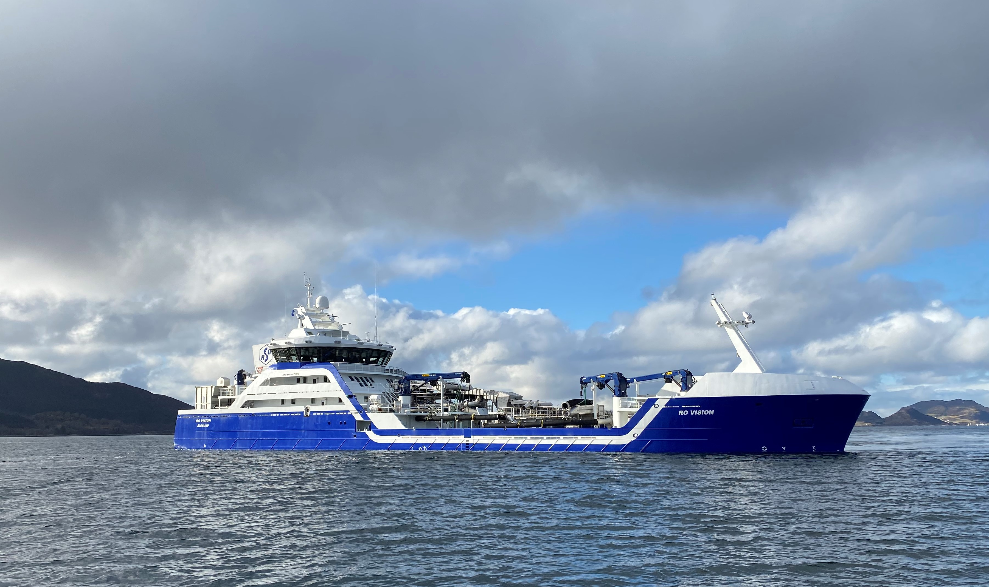
Ro Vision is winner of Norway's prestigious Ship of the Year Award for 2020.

With the Norwegian aquaculture and fishing industry setting its sights on the future, new boats are being built with increasing concern for the condition of the live fish, the welfare of the crew and the environment. This first ever hybrid propulsion live fish carrier is developed with a strong focus on increased safety and lower emissions. Equipped with a selective catalytic reduction (SCR) system to reduce nitrogen oxide (NOx) emissions, the Yanmar engines deliver safe and reliable power that is cleaner than ever.
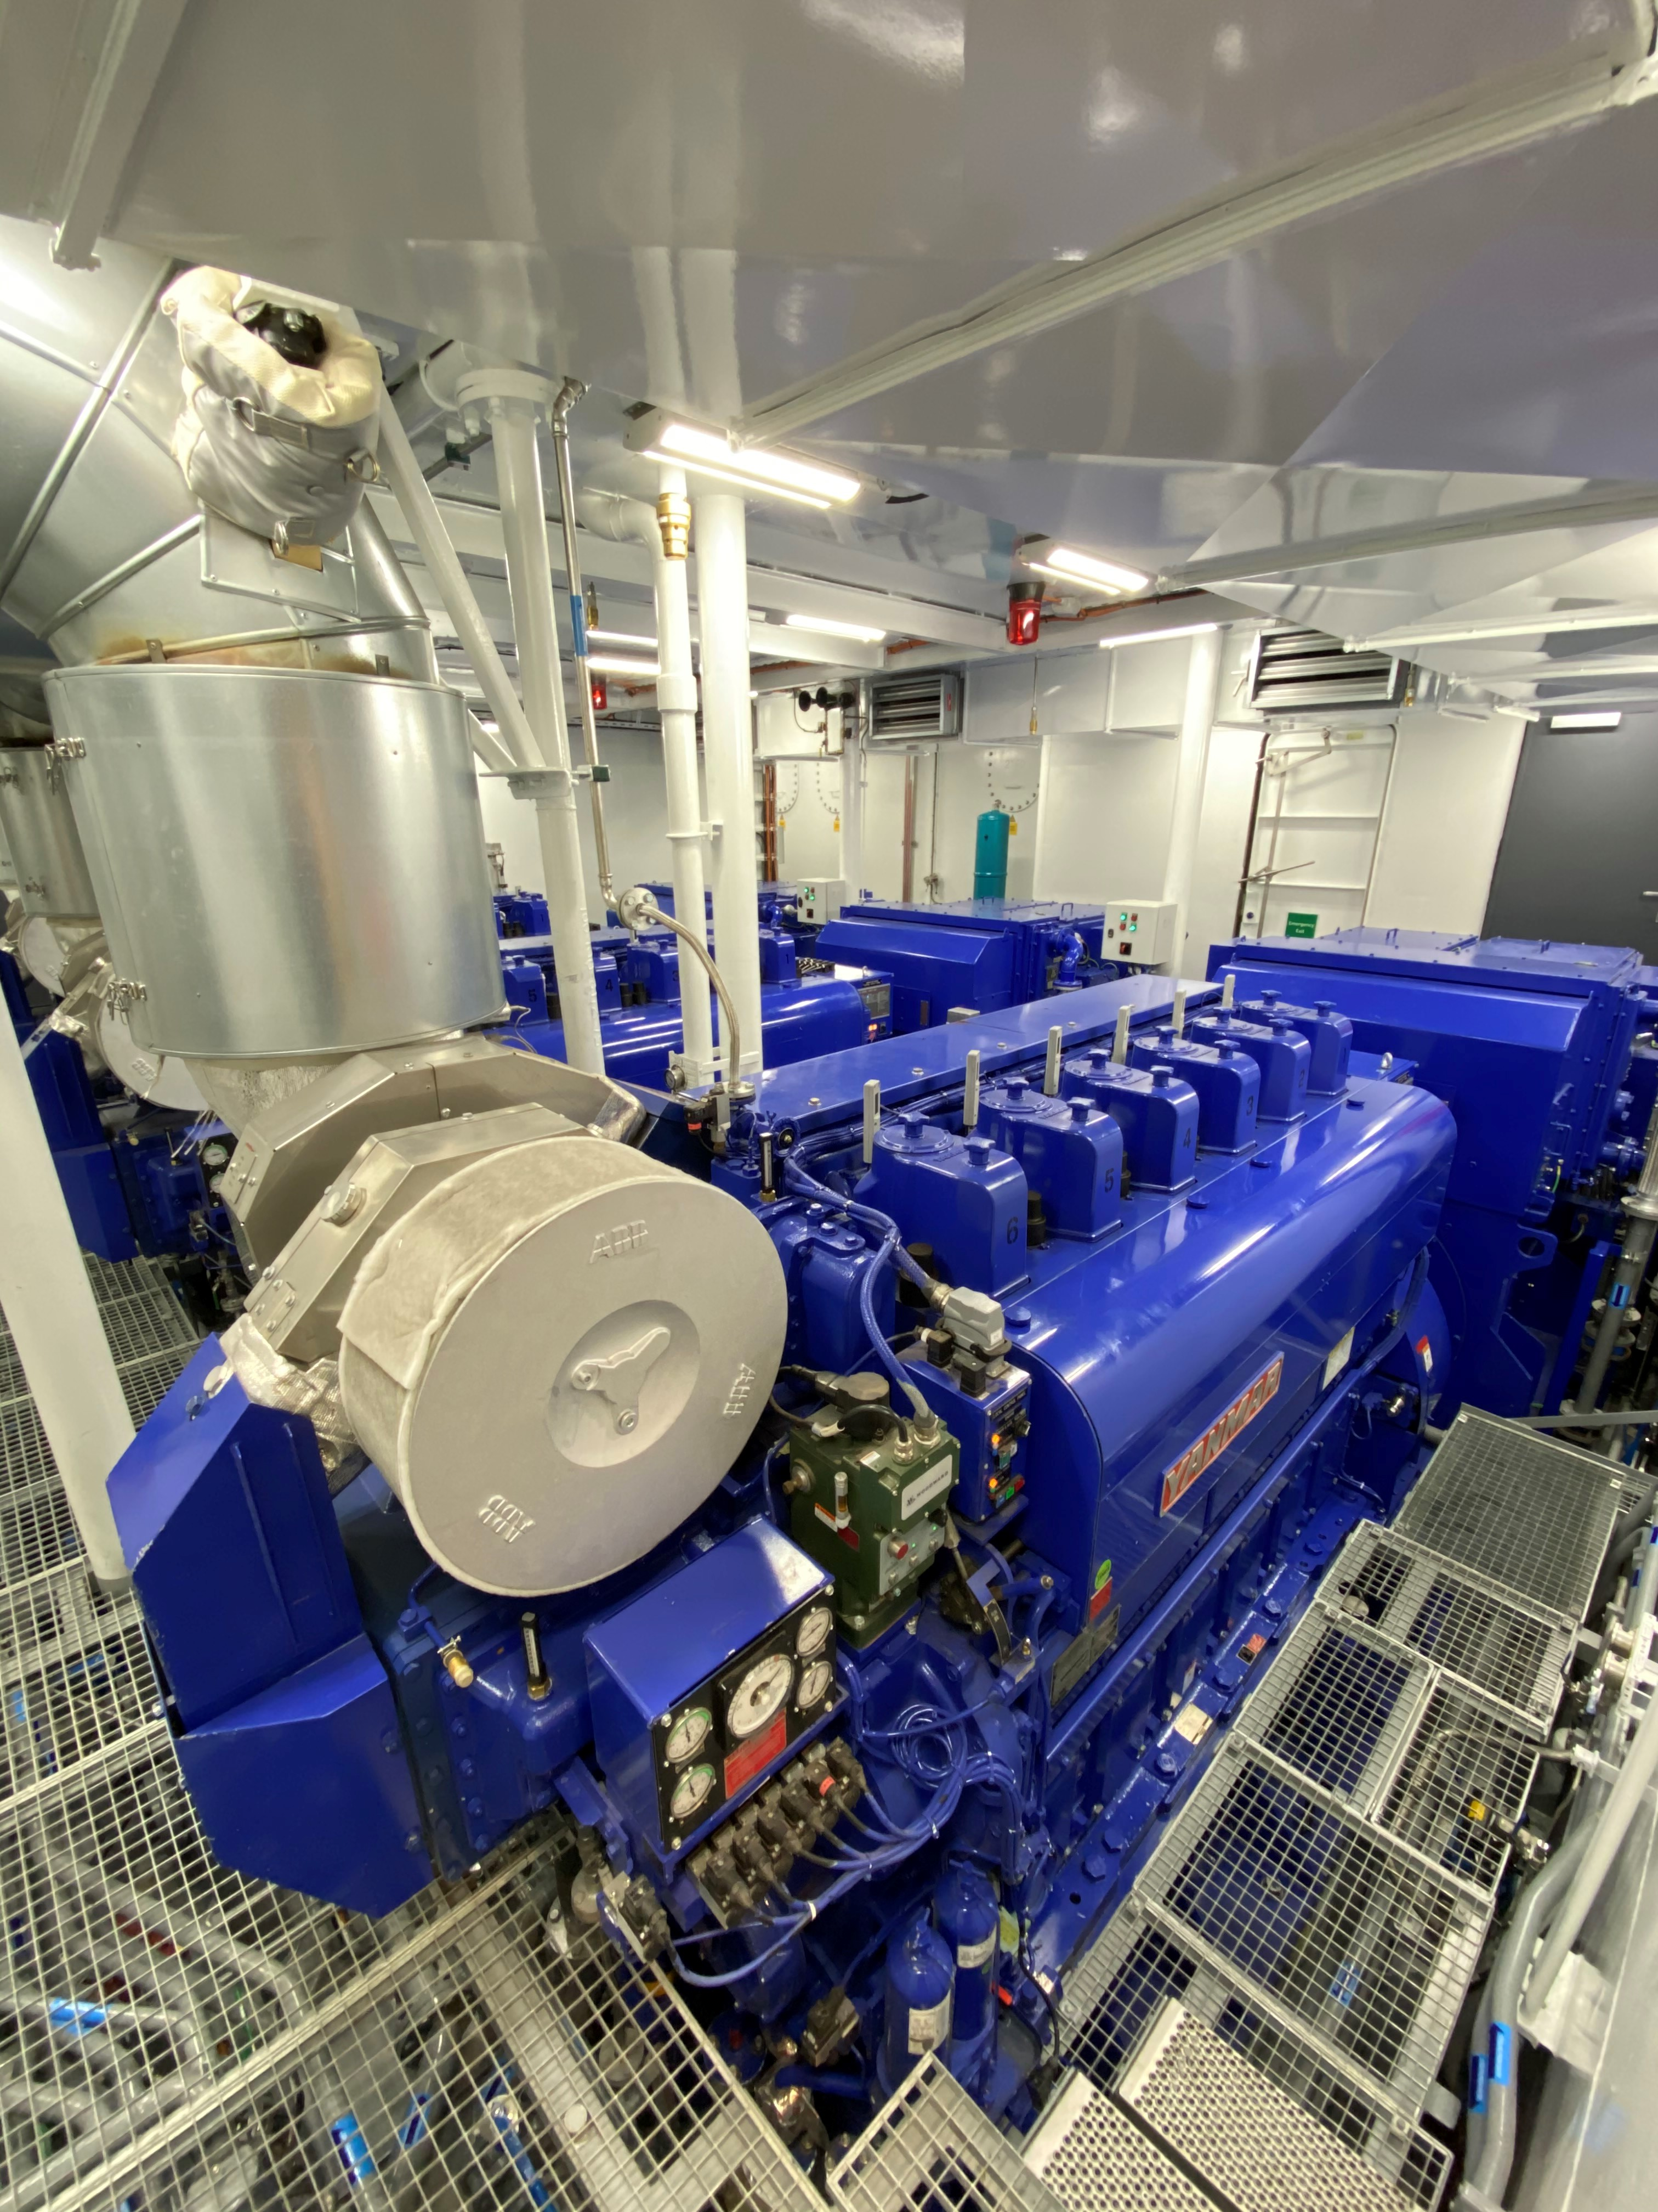
Three 6EY22ALW diesel generators power the Ro Vision's industry leading hybrid solution.
Jarle Gunnarstein, CEO of shipbuilder Larsnes Mek Verksted, gave credit to the powerplant: “YANMAR engines are easy to install and accessible for maintenance. Moreover, they are economical, have low emissions and a long lifespan, which is often a decisive factor for our customers, such as ship owners and designers.”
As the Norway’s fisheries embrace new challenges, Yanmar will continue to support the industry with solutions for the vessels of tomorrow.

■Ro Vision
Name: MS "Ro Vision"
Design: Skipskompetanse AS
Shipyard: Larsnes Mek. Verksted AS.
Type of Vessel: Live Fish Carrier
Length: 84.2 m
Beam: 15.5 m
Hybrid/battery-package: Siemens
Diesel generators: 3 x Yanmar 6EY22-ALW

About Yanmar
With beginnings in Osaka, Japan in 1912, Yanmar was the first ever to succeed in making a compact diesel engine of a practical size in 1933. Moving on, with industrial diesel engines as the cornerstone of the enterprise, Yanmar has continued to expand its product range, services, and expertise to deliver total solutions as an industrial equipment manufacturer. As a provider of small and large engines, agricultural machinery and facilities, construction equipment, energy systems, marine, machine tools, and components — Yanmar’s global business operations span seven domains.
On land, at sea, and in the city, Yanmar’s Mission of “providing sustainable solutions focused on the challenges customers face, in food production and harnessing power, thereby enriching people’s lives for all our tomorrows,” stands testament to Yanmar’s determination to providing us with “A Sustainable Future.” For more information, visit Yanmar Co., Ltd. at its global website at https://www.yanmar.com/global/about/

＜NOTE＞
The contents of this news release reflect what was mentioned in the press announcement. Please be aware that the contents of this release may differ with new information and developments.

【Media inquiries】
Yanmar Public Relations
E-mail: newsroom@yanmar.com

