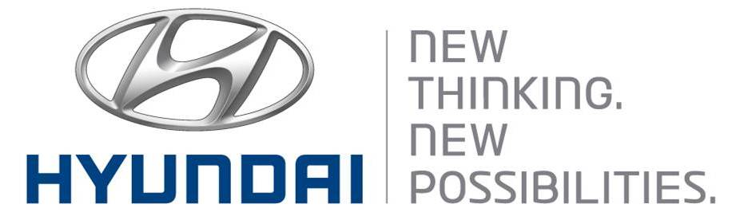  July 29, 2011 | Media Release  For further information contact the  Global Public Relations Team  Tel: +82+2—3464-2153 ~ 60  Fax: +82+2—3464-3497  globalpr@hyundai.com

Hyundai Motor Named One of World’s Top
Global Green Brands of 2011
- No. 4 among automakers, beating BMW, Ford and Mercedes

Interbrand, the global brand consultancy, ranked Hyundai as one of the world’s greenest brands, citing the automaker’s Blue Drive eco-friendly strategy and its industry leadership in zero-emissions hydrogen fuel-cell vehicle development.

Interbrand ranked Hyundai 11th among the agency’s 50 Best Global Green Brands, a new global report by the agency. Hyundai placed fourth among the seven automotive brands that made the survey.

“The company is so confident in its fuel efficiency that starting this year it is reporting monthly fleet fuel efficiency figures in the U.S.,” Interbrand wrote in the survey. “Hyundai has recently seen strong improvements in energy, GHG emissions, water, waste, and toxic emissions.”

The survey, which questioned more than 10,000 respondents in 10 countries, examined each company’s environmental record and how the company is perceived by consumers. Companies were judged based on their performance, their environmental impact, their sustainable growth strategy and their corporate social responsibility programs.

Hyundai’s Blue Drive sub-brand, launched in 2008, encompasses all of the company’s eco-friendly technologies and products that contribute to higher fuel efficiency and lower emissions, including gasoline, diesel, electric, hybrid and hydrogen fuel-cell engines.

Hyundai rolled out the Avante LPi hybrid in 2009 and the Sonata hybrid in 2011.
Hyundai plans to bring plug-in hybrid vehicles to market soon, while the company is currently operating test fleets of its hydrogen fuel-cell electric vehicles and pure-electric vehicles, called BlueOn.

Established in 1967, Hyundai Motor Co. has grown into the Hyundai Motor Group which has ranked as the world’s fifth-largest automaker since 2007 and includes more than two dozen auto-related subsidiaries and affiliates. Hyundai Motor, which has six manufacturing bases outside of South Korea, sold approximately 3.6 million vehicles globally in 2010. Hyundai vehicles are sold in 186 countries through some 5,300 dealerships and showrooms. Further information about Hyundai Motor and its products is available at www.hyundai.com.

