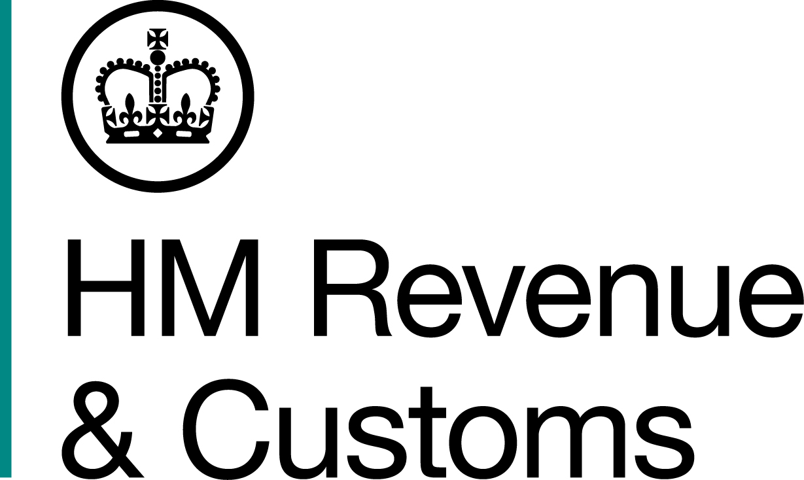
News Release

 | For the attention of News Desks |  | No of pages: 3
 | Date: | 25 September 2020 | Ref: | SE 02 20

Restaurant owner must pay £1.2m or face 7 years behind bars

A restaurant owner who laundered cash stolen by his VAT fraudster wife has been ordered to hand over £1.2 million within three months or face an extra seven-and-a-half years in jail.

Yong Hong Lu, 52, of Farnham, Surrey, was jailed for two years last May after a HM Revenue and Customs (HMRC) investigation found he had laundered more than £1m.

His wife Huey Jun Khoo, 51, and business partner Jing Fu, 50, of Crondall, Hampshire, were sentenced for VAT fraud in May 2019, after they used an off-the-books card machine at the Bon East Chinese restaurant in Farnham to pocket £180,000 in VAT.

Lu and Khoo used the stolen money from their four-year fraud to pay for school fees, designer clothes and holidays.

Lu was jailed for two years, Khoo was jailed for three years and 9 months, and Fu was sentenced to seven months imprisonment, suspended for two years.

All three have now been ordered to pay back money at a confiscation hearing at Southwark Crown Court earlier this month.

Lu must pay £1.2m within three months or face seven-and-a-half years longer in jail. Fu has three months to pay £50,000 and Khoo has been ordered to pay £15,000 within three months. If they fail to do so, they will be jailed for nine months respectively and still owe the money.

Nicola Dunk Assistant Director, Fraud Investigation Service, HMRC, said:
“Our work doesn’t stop when someone is convicted, we will always seek to reclaim criminal money and assets.

“Confiscated proceeds of crime are redistributed into the public purse which helps fund vital services such as schools and hospitals.

“If you know anyone who is committing tax fraud or laundering money, you can report them to HMRC on gov.uk or call our Fraud Hotline on 0800 788 887.”

The VAT fraud and money laundering was discovered after a surprise visit from HMRC at the Bon East Chinese restaurant in 2015. Officers found two card reading machines – one linked to a business bank account and the other to a bank account which Khoo had opened in the name of one of the restaurant’s chefs.

Customer payments made into the ‘chef’ account were never declared to HMRC, to evade paying VAT.

After the HMRC visit, Khoo and Fu destroyed the business records in a failed bid to hide their crimes. Two documents which Khoo kept were later discovered at her home. Investigators also found £12,000 in cash hidden in a wardrobe in the couple’s home.

Khoo admitted evading VAT, money laundering and perverting the course of justice. Fu, admitted money laundering and perverting the course of justice. Lu was convicted of money laundering after a trial at Southwark Crown Court.

Notes to Editors

- Yong Hong LU, DOB 17/02/1968, of Weydon Lane, Farnham, Surrey, GU9 was convicted of money laundering on 20 March 2019 and sentenced to two years in jail on 10 May 2019. On 8 September 2020, at Southwark Crown Court, Lu was ordered to pay £1,253,000, plus £7,000 costs to the court within three months, or face a default sentence of seven and a half years in jail.

- Huey Jun KHOO, DOB 15/03/1969, formerly of Old Compton Lane, Farnham, Surrey, GU9 admitted the fraudulent evasion of VAT, money laundering and perverting the course of justice. She was sentenced to three years and nine months on 10 May 2019. On 8 September 2020, at Southwark Crown Court, Khoo was ordered to pay £15,000 within three months or faces a default sentence of nine months in prison.

- Jing FU, DOB 27/11/1969, of Ashley Close, Crondall, Hampshire, GU10 admitted the fraudulent evasion of VAT and perverting the course of justice. She was sentenced to seven months in jail, suspended for two years on 10 May 2019. She was also ordered to serve 120 hours of unpaid community work. On 8 September 2020, at Southwark Crown Court, Fu was ordered to pay £50,000 within three months or face a default sentence of nine months in prison.

- Follow HMRC Press Office on Twitter @HMRCpressoffice.

Issued by HM Revenue & Customs Press Office

Press enquiries only please contact:

Will Lyon
Tel: 07469 023 331
Email: william.lyon@hmrc.gov.uk

Out of hours: Tel: 07860 359544

Website www.gov.uk/hmrc

