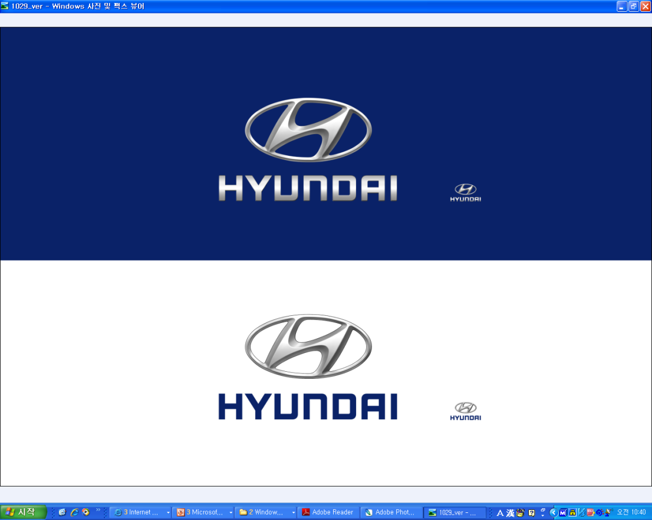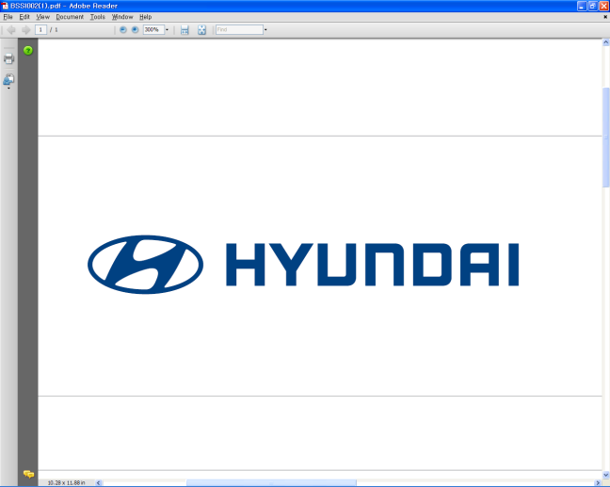  Embargoed until Jan. 10 at 14:55 ET (U.S.)  (or Jan. 11 at 04:55 Seoul time) | Media Release  For further information contact the  Global Public Relations Team  Tel: +82+2—3464-2153 ~ 60  Fax: +82+2—3464-3497  globalpr@hyundai.com

Hyundai Reveals New Brand Direction & Statement
At the 2011 Detroit Motor Show

- Hyundai defines new brand concept as ‘Modern Premium’
- 3-door coupe Veloster and Curb concept vehicle embrace new attitude
- Hyundai to “satisfy new values by creating new possibilities with new thinking about our customers and our cars,” says Vice Chairman Chung

Hyundai Motor Company, the world’s fastest-growing automotive company by brand, officially announced its new brand direction and statement today at the 2011 North American International Auto Show in Detroit.

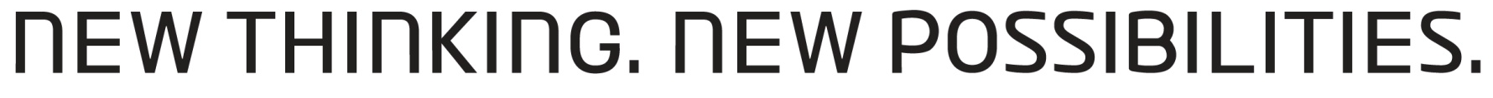

Hyundai’ new brand statement will be “New Thinking. New Possibilities.” This encompasses Hyundai’s new brand concept, “Modern Premium,” which aims to provide customers with emotional value and experiences beyond expectations through new thinking and new possibilities. The new brand direction also captures the spirit of change at the automaker, which has shown dramatic growth in all areas of business.
“Today, customers do not believe that expensive cars with unnecessary technology are premium,” Euisun Chung, Vice Chairman of Hyundai Motor said during a speech at the Detroit motor show. “Instead, they want their core needs fulfilled at an accessible price and with a car that exceeds their expectations; a car that reflects their values and the times in which they live.”

“Hyundai is not just a company that makes cars. Hyundai is a company that creates new possibilities. Our goal is not to become the biggest car company. Our goal is to become the most-loved car company and a trusted lifetime partner of our owners,” said Vice Chairman Chung.

While traditional premium is usually linked with high prices for the privileged few, Hyundai’s `Modern Premium’ concept is based on the idea that high quality does not necessarily require a high price for a limited class. Hyundai will offer high-end, high-quality values at a surprisingly attainable price and values that customers never experienced or expected. This will not be limited to just the product, but throughout Hyundai’s entire business, operations and services.

Hyundai’s new thinking and change in attitude has already been applied in various areas with proven results, such as the highly-successful `Hyundai Assurance Program’ launched in the U.S. market last year and the 2011 Sonata, which shook up the mid-size family sedan segment with its dynamic `fluidic sculpture’ designs and unrivalled powertrain package. Genesis, which won the prestigious North American Car of The Year award in 2009, also redefined luxury with its attainable price compared to its award-winning powertrain and advanced audio and convenience features.

Now, at the 2011 North American International Auto Show in Detroit, Hyundai unveils its latest creations that capture this spirit: Veloster, a three-door compact coupe that brings innovation to the segment. Veloster offers a coupe design with the functionality of a hatch and a unique third door on the passenger-side for easy rear-seat access.

Hyundai will also display its HCD-12 Curb concept vehicle in Detroit, while at the recent 2011 Consumer Electronics Show (CES) in Las Vegas, the automaker launched its global telematics brand Blue Link® and other independently developed in-vehicle technologies, presenting its advanced vehicle information technology systems to the world.

* More detailed press releases on Veloster, Curb and Blue Link® available.

Established in 1967, Hyundai Motor Co. has grown into the Hyundai Motor Group which has ranked as the world’s fifth-largest automaker since 2007 and includes more than two dozen auto-related subsidiaries and affiliates. Hyundai Motor, which has six manufacturing bases outside of South Korea, sold approximately 3.6 million vehicles globally in 2010. Hyundai vehicles are sold in 186 countries through some 5,300 dealerships and showrooms. Further information about Hyundai Motor and its products is available at www.hyundai.com.

