**BACKSTREET BOYS ÄR TILLBAKA MED NYTT ALBUM OCH GER SIG UT PÅ STOR ARENATURNÉ**

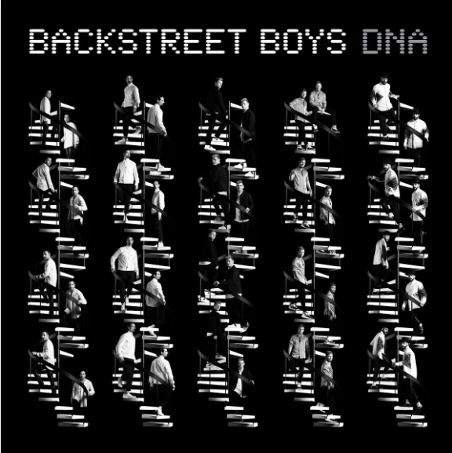

**Backstreet Boys släpper idag nyheten om kommande albumet “DNA”, som släpps 25 januari 2019 via RCA Records. Samtidigt avslöjar de att de ger sig ut på stor arenaturné, där inte mindre än två Sverigestopp är inplanerade!**

Albumet **“DNA”,** som finns tillgängligt för förbeställning redan nu, är gruppens tionde studioalbum och innehåller låtar skrivna av **Lauv** (Charli XCX), **Andy Grammer, Stuart Crichton** (DNCE) och **Mike Sabbath** (J Balvin).

Idag släpps också nya singeln [**“Chances”,**](https://open.spotify.com/track/5J783SDlyitqvLFAzTm0jU?si=nC1y76gKRzypUBii_k7JCA) som är första singeln från kommande albumet. [Se den officiella videon för “Chances” här.](https://www.youtube.com/watch?time_continue=4&v=W5kM5wAwRug)

Med start den 11 maj kommer Backstreet Boys ge sig ut på **“DNA World Tour”,** som blir deras största arenaturné på 18 år. Under tre månader kommer gruppen att spela över hela Europa och Nordamerika, och headlinea stora arenor som Staples Center i Los Angeles, Barclays Center i Brooklyn och Bridgestone Arena i Nashville. Till vår glädje kommer de även att göra två stopp i Sverige. Fredagen den 31 maj spelar BSB på Scandinavium i Göteborg, och den 2 juni kommer “DNA World Tour” till Stockholm och Ericsson Globe. Biljetter släpps fredag 16 november kl. 09.00 via LiveNation.se.

*“When this group started 26 years ago – and through all the highs and lows of our career – we’ve had to learn it wasn’t about us as individuals but about what’s best for the group,”* säger **Howie D**.

*“That’s what I love about this album.”* fortsätter **Kevin Richardson***. “We were able to bring all of our influences and styles into one coherent piece of work. These songs are a great representation of who we are as individuals and who we are as a group. It's our DNA. We’re really proud of that.”*

*“The journey is ongoing with us and there is so much left to do.”* säger **Brian Littrell**. *“We’re living the next chapter that hasn’t been told yet, and that's exciting.”*

Backstreet Boys succéshow i Las Vegas**, “Backstreet Boys: Larger Than Life”**, avslutas i april 2019 efter 14 månaders speltid. Då blir det dags att ge sig ut i världen och möta fansen.

*“Vegas has been amazing and these next set of dates are going to be a party”* säger Howie. *“Then it’s time for us to visit our fans all over the world.”*

[**Backstreet Boys**](x-apple-data-detectors://108)**- Chances**

Multi-retailer - [http://smarturl.it/bsbxChances](https://emea01.safelinks.protection.outlook.com/?url=http%3A%2F%2Fsmarturl.it%2FbsbxChances&data=02%7C01%7Ckazzandra.tarnowsky%40sonymusic.com%7C3cf5b3c3353244c942c608d645cd40b0%7Cf0aff3b791a54aaeaf71c63e1dda2049%7C0%7C0%7C636773145178778026&sdata=TWskp8fc8nqDDfrpfKNy44yurXRRxbcOkePbVXSQjxs%3D&reserved=0)

[**Backstreet Boys**](x-apple-data-detectors://116)**- DNA Pre-Order**

Multi-retailer - [http://smarturl.it/BSBxDNA](https://emea01.safelinks.protection.outlook.com/?url=http%3A%2F%2Fsmarturl.it%2FBSBxDNA&data=02%7C01%7Ckazzandra.tarnowsky%40sonymusic.com%7C3cf5b3c3353244c942c608d645cd40b0%7Cf0aff3b791a54aaeaf71c63e1dda2049%7C0%7C0%7C636773145178818059&sdata=HuzkJ2Jhn1cIrbVy886n3lQXFsYU14sgRQNurcChOEw%3D&reserved=0)

**Turnédatum Europa:**

11 May 2019       Portugal               Lisbon                   Altice Arena

13 May 2019       Spain                     Madrid                 Wizink Arena

15 May 2019       Italy                       Milan                     Mediolanum Forum

17 May 2019       Spain                     Barcelona            Palau Sant Jordi

19 May 2019       France                  Paris                      Accorhotels Arena

21 May 2019       Germany             Hannover            TUI Arena

22 May 2019       Belgium               Antwerp              Sportpaleis

23 May 2019       Netherlands       Amsterdam        Ziggo Dome

25 May 2019       Germany             Mannheim          SAP Arena

27 May 2019       Germany             Munich                 Olympiahalle

28 May 2019       Austria                Vienna                  Stadthalle

29 May 2019       Germany             Berlin                   Mercedes-Benz Arena

31 May 2019       Sweden               Gothenburg       Scandinavium

01 June 2019      Norway                Oslo                       Spektrum

02 June 2019      Sweden                Stockholm           Ericsson Globe

05 June 2019      Finland                Helsinki                Hartwall Arena

08 June 2019      Denmark             Copenhagen      Royal Arena

10 June 2019       UK                        Manchester       Manchester Arena

11 June 2019      Ireland                 Dublin                   3Arena

14 June 2019      UK                         Glasgow               SSE Hydro

15 June 2019      UK                         Birmingham        Birmingham Arena

17 June 2019      UK                         London                 O2 Arena

20 June 2019      Germany             Cologne               Lanxness Arena

21 June 2019      Switzerland        Zurich                    Hallenstadion

22 June 2019      Czech Republic Prague                  O2 Arena

24 June 2019      Poland                 Warsaw                Torwar Arena

25 June 2019      Hungary              Budapest             Budapest Arena

**North American Tour Dates:**

July 12th Capital One Arena Washington, DC

July 15th Bell Centre Montreal

July 17th ScotiaBank Arena Toronto

July 20th Xcel Energy Center Minneapolis, MN

July 22nd Bell MTS Place Winnipeg

July 24th ScotiaBank Saddedome Calgary

July 25th Rogers Place Edmonton

July 27th Pepsi Live at Rogers Arena Vancouver

July 29th Angels of the Winds Arena Seattle, WA

July 30th Moda Center Portland, OR

August 1st Golden 1 Center Sacramento, CA

August 3rd  Staples Center Los Angeles

August 4th SAP Center San Jose, CA

August 5th Honda Center Anaheim, CA

August 7th Vivint Smart Home Arena Salt Lake City, UT

August 8th Pepsi Center Arena Denver, CO

August 10th United Center Chicago, IL

August 12th Little Caesars Arena Detroit, MI

August 14th TD Garden Boston, MA

August 15th Barclays Center New York, NY

August 17th Wells Fargo Center Philadelphia, PA

August 18th Hersheypark Stadium Hershey, PA

August 20th PNC Arena Raleigh, NC

August 21st State Farm Arena Atlanta, GA

August 23rd BB&T Center Ft. Lauderdale, FL

August 24th Amway Center Orlando, FL

August 26th Bridgestone Arena Nashville, TN

August 27th Fed Ex Forum Memphis, TN

August 28th BOK Center Tulsa, OK

August 30th Smoothie King Center New Orleans, LA

August 31st Toyota Center Houston, TX

September 1st  American Airlines Arena Dallas, TX

September 3rd Cajundome Lafayette, LA

September 4th The Legacy Arena at the BJCC Birmingham, AL

September 6th Enterprise Center St. Louis, MO

September 7th Sprint Center Kansas City, MO

September 8th CHI Health Center Omaha, NE

September 10th Bankers Life Fieldhouse Indianapolis, IN

September 11th Fiserv Forum Milwaukee, WI

September 13th KFC Yum! Center Louisville, KY

September 14th PPG Paints Arena Pittsburgh, PA

September 15th Prudential Center Newark, NJ

**Följ Backstreet Boys här:**

[Hemsida](https://www.backstreetboys.com/)

[Facebook](https://facebook.com/backstreetboys)

[Twitter](https://twitter.com/backstreetboys)

[Instagram](https://www.instagram.com/backstreetboys/)

**Presskontakt**

Moa Egonson

[moa.egonson@sonymusic.com](mailto:moa.egonson@sonymusic.com)