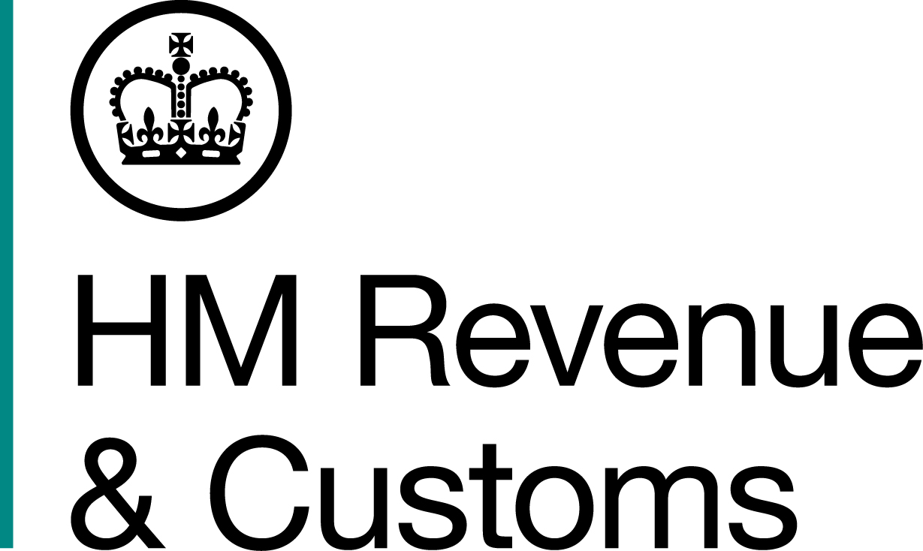
News Release

 | For the attention of News Desks |  | No of pages: |  | 3
 | Date: | 27 March 2015 | Ref: | NAT 17/15

HMRC scores hat trick of avoidance wins

HM Revenue and Customs (HMRC) has secured three tribunal wins against tax avoidance schemes, protecting over £260 million in tax.

All three rulings uphold earlier judgments in HMRC's favour at the First-Tier Tribunal.

The Upper Tribunal dismissed an appeal brought by users of a scheme promoted by NT Advisors. This is HMRC’s ninth recent win against schemes promoted by NT Advisors. This scheme sought to create artificial losses by using a combination of the employment income and capital gains tax rules on share options. The judges dismissed the appeal without needing to hear substantive arguments from HMRC, and indicated that written reasons would follow. There were 420 users of this scheme.

The Upper Tribunal also dismissed two other cases. These bespoke schemes were designed by banks to provide the users with a much higher tax-free return on their cash deposits than they could have obtained by placing funds in a normal deposit account. Both of these schemes were marketed and sold by banks some years ago for substantial fees. The court joined these two separate cases because of similarities between the schemes.

The Financial Secretary to the Treasury, David Gauke, said:

"The overwhelming majority of people pay the taxes they owe. These latest cases show that HMRC will effectively tackle those who try to get around their legal responsibilities. Users of avoidance schemes should think twice before trying to abuse tax reliefs to avoid paying their fair share of tax.”

Notes to Editors

- The three cases are:
- Steve Price, John Myers and James Lucas v HMRC
- Malcolm Healey v HMRC
- Philip Savva, Andrew Savva, Mario Savva, Savva Savva and Kalliopi Pericleous v HMRC
- The Healey decision concerns the tax year 2003/4, while the Savva decision concerns the tax year 2005/6.
- Other successes against NT Advisor schemes can be found here:
http://www.mynewsdesk.com/uk/hm-revenue-customs-hmrc/pressreleases/hmrc-clocks-up-another-win-over-nt-advisors-1035698

http://www.mynewsdesk.com/uk/hm-revenue-customs-hmrc/pressreleases/hmrc-defeats-nt-advisors-again-at-a-tax-tribunal-995314

http://www.mynewsdesk.com/uk/hm-revenue-customs-hmrc/pressreleases/second-hand-car-dealer-tax-scheme-scrapped-964268

http://www.mynewsdesk.com/uk/hm-revenue-customs-hmrc/pressreleases/nt-advisors-loses-ps100m-offshore-tax-avoidance-bid-955616

http://www.mynewsdesk.com/uk/hm-revenue-customs-hmrc/pressreleases/hmrc-tax-tribunal-victory-saves-ps190m-871801

- HMRC has a dedicated helpline – 03000 530435 – for those who have engaged in tax avoidance schemes but now want to settle their affairs.
- Further information can also be found at www.hmrc.gov.uk/avoidance/tempted.htm
- Follow HMRC Press Office on Twitter @HMRCpressoffice
- HMRC's Flickr channel www.flickr.com/hmrc.gov.uk

Issued by HM Revenue & Customs Press Office

Press enquiries only please contact:
Patrick O’Brien
Tel: 03000 585024
Email: patrick.o’brien@hmrc.gsi.gov.uk

Out of hours
Tel: 07860 359544

Website www.gov.uk/hmrc

