MELANIE MARTINEZ’S ACCLAIMED DEBUT ALBUM CRY BABY
MAKES INCREDIBLE CHART DEBUT, PREMIERING AT #5 ON THE TOP ALBUMS CHART AND #6 ON THE BILLBOARD 200

MAJOR US HEADLINE TOUR GETS UNDERWAY THIS WEEK WITH
WIDE-RANGING ITINERARY APPROACHING COMPLETE SELL-OUT,

“CRY BABY” AVAILABLE EVERYWHERE NOW

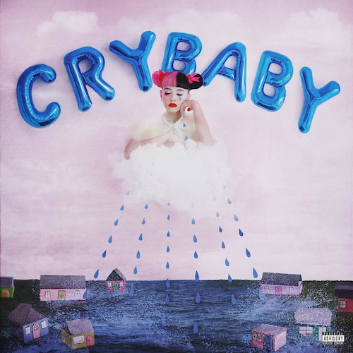

Atlantic recording artist Melanie Martinez has made an extraordinary entry onto the charts with her acclaimed debut album. “CRY BABY” arrives on this week’s Billboard 200 at #6, while also coming at #5 on the “Top Albums” chart.

“CRY BABY” – which follows the 20-year-old Long Island native’s 2014 breakthrough, “THE DOLLHOUSE EP” – had an explosive first week ascending to #1 on the Billboard “Current Alternative Album” chart. The album’s success follows a remarkable pre-sale in which “CRY BABY” pre-orders reached #1 on iTunes “Top Alternative Albums.”

“CRY BABY” is highlighted by “Pity Party,” which debuted at #2 on the iTunes Store’s “Top Alternative Songs” before becoming a worldwide Spotify success, reaching #10 on the US Viral 50 and #13 on the Global Viral chart. In addition, the “Pity Party” companion video was recently tagged #hitoftheweek by MTV Hits, guaranteeing the week’s most plays on the network. The clip – conceived and directed by Martinez herself – has now drawn more than 5.5 million views and counting at her official YouTube channel, www.youtube.com/watch?v=6bAPlojfgO0.

“CRY BABY” features five tracks currently among the iTunes Store’s “Top 200 Alternative Songs,” including lead single “Soap” which debuted in the chart’s top 10 prior to the album’s release. “SOAP” is set to impact Alternative radio outlets nationwide this month. Also following suit, “Sippy Cup” premiered TOP 10 on the iTunes Alternative Songs chart while provocative companion videos for both songs – once again, conceived and directed by Martinez – are now streaming at the acclaimed singer/songwriter’s official YouTube channel, https://www.youtube.com/user/Melmartinezx3, which now approaching 50 million views.
“CRY BABY” is among the most inventive and striking debut albums in recent memory, an unforgettable collection of provocative pop framed as a modern fairy tale, complete with storybook illustrations and a dramatic structure that takes listeners on a dark journey through the life of its title character. Both the album and Martinez herself are proving critical sensations, with New York Newsday praising the talented young singer/songwriter’s “mix of pop melodies and spare, trap instrumentation.” “CRY BABY” is “a distinctly 21st century twist of pop, spikily honest and occasionally barbed words served up in cinnamon-dusted melodies,” declared Noisey, “a swirl of R&B curves, stuttering beats, and ratatat hi-hats.” (Martinez) possesses and arrestingly innocent voice that just barely hides its true power,” noted SPIN, “the bend-over-backwards ability to go for the jugular.” The juxtaposition of promiscuous parents, complicated love, and substances with carnival pop is haunting,” applauded NYLON, but infectious enough to keep you coming back for more…like candy.”

Hailed as a stunning singer, performer, and visual presence, Martinez is currently poised to start her upcoming fall tour. “The Cry Baby Tour” gets underway August 26th at Charlotte, NC’s Amos’ Southend and then travels the US through the end of October (see attached itinerary). Much of the trek is already sold out, including such major markets as Atlanta, Orlando, Boston, New York, Los Angeles, and Dallas. More sell outs are expected, as are upgrades to larger venues– for complete information and remaining ticket availability, please visit melaniemartinezmusic.com/#tour.

“CRY BABY” also includes the hit singles, “Carousel” and “Dollhouse,” both first released in May 2014 on Martinez’s stunning debut, “THE DOLLHOUSE EP,” which debuted among the TOP 5 on Billboard’s “Heatseekers” chart. The compelling “Dollhouse” companion video – conceived, co-directed, and co-produced by Martinez – has proven an online phenomenon, with individual views now exceeding 21 million at www.youtube.com/watch?v=HcVv9R1ZR84. “Carousel,” matched the success of its predecessor, after soundtracking the first extended trailer for FX Networks’ hugely popular American Horror Story: Freak Show. In addition, the haunting “Carousel” companion video – filmed on Martinez’s native Long Island, NY – is a YouTube favorite with more than 9 million views at www.youtube.com/watch?v=zAB5AC9yhY0.

For more, please visit melaniemartinezmusic.com, twitter.com/MelanieLBBH, www.facebook.com/melaniemartinezmusic, instagram.com/littlebodybigheart, and www.atlanticrecords.com.

(TOUR ITINERARY ATTACHED)
MELANIE MARTINEZ
THE CRY BABY TOUR – FALL 2015

AUGUST
26 Charlotte, NC Amos’ Southend
27 Nashville, TN High Watt
29 Atlanta, GA Vinyl – SOLD OUT
30 Orlando, FL The Social – SOLD OUT

SEPTEMBER
1 Raleigh, NC Lincoln Hall
2 Freehold, NJ Gamechanger World
3 Boston, MA Sinclair – SOLD OUT
9 Philadelphia, PA World Café
10 Hamden, CT College Street Music Hall
11 New York, NY Highline Ballroom – SOLD OUT
13 Washington, DC U Street Music Hall – SOLD OUT
14 Cleveland, OH House of Blues (Cambridge) – SOLD OUT
15 Pittsburgh, PA Stage AE
16 Columbus, OH A&R Club
18 Detroit, MI Shelter – SOLD OUT
20 Chicago, IL Lincoln Hall – SOLD OUT
21 Minneapolis, MN Triple Rock Social Club
25 Tuscon, AZ The Rock
27 Santa Ana, CA The Observatory
28 Los Angeles, CA The Troubadour – SOLD OUT
29 Santa Cruz, CA The Catalyst
30 San Francisco, CA Great American Music Hall

OCTOBER
2 Vancouver, BC The Media Club
3 Portland, OR Hawthorne Theatre
4 Seattle, WA Chop Suey – SOLD OUT
6 Denver, CO Larimer Lounge
7 Denver, CO Larimer Lounge
9 Kansas City, MO Record Bar
10 St. Louis, MO Off Broadway
12 Dallas, TX House of Blues– SOLD OUT
15 New Orleans, LA House of Blues
16 Birmingham, AL Saturn
18 Greensboro, NC Blind Tiger
21 Milwaukee, WI Turner Hall Ballroom
23 Grand Rapids, MI The Stache
26 Toronto, ON Mod Club Theatre

