PRESS RELEASE
Indulge in Exquisite Handcrafted Rice Dumplings from Hai Tien Lo
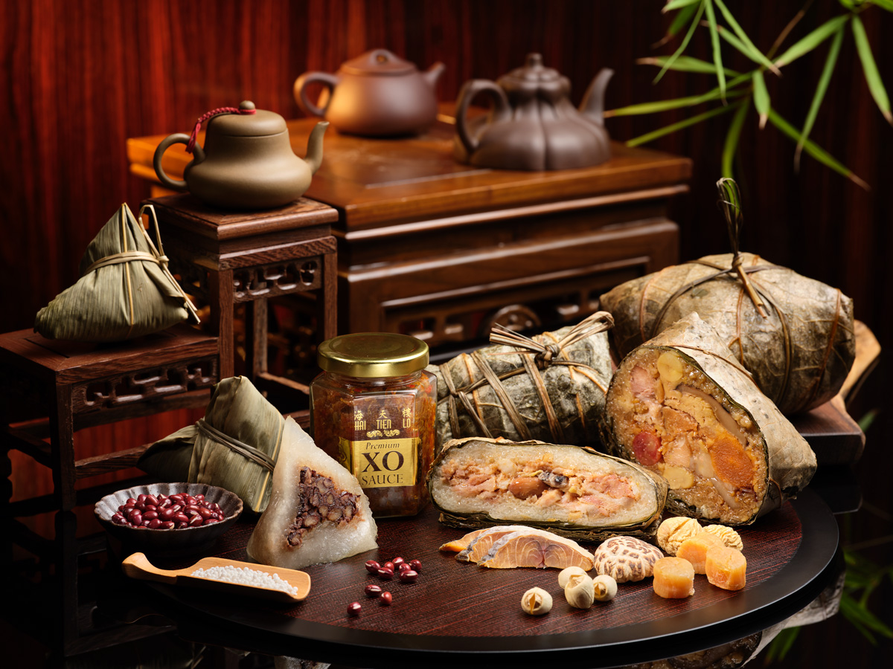Premium Rice Dumpling Gift Set
Singapore, 10 April 2019 – Celebrating the traditional Dragon Boat Festival (端午节) in epicurean style, Hai Tien Lo (海天楼) presents an exquisite ensemble of handcrafted rice dumplings including perennial favourites and new creations. Available from 6 May to 7 June 2019, savour the luxurious treats made up of premium glutinous rice and superb ingredients, meticulously hand-wrapped in bamboo leaves.
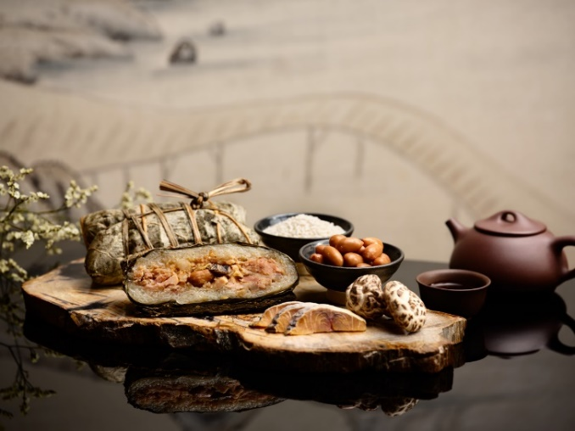
^{NEW!} Classic Pork Belly and Salted Fish Dumpling, 咸鱼花腩粽 (SGD18.80 per piece)
A tasty highlight this Dragon Boat Festival is Hai Tien Lo’s Classic Pork Belly and Salted Fish Dumpling. This irresistible delicacy was inspired by the well-loved classic Cantonese dish of “Steamed Pork Belly with Salted Fish” originating from Guangdong Province, and conjures up nostalgic feelings of home for Executive Chef Ben Zeng. The delicious rice dumpling is packed with tender pork belly, salted fish, mushrooms, peanuts and premium glutinous rice.
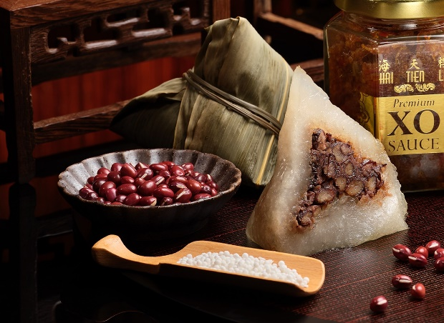
^{NEW!} Crystal Dumpling with Red Bean and Sago, 红豆水晶西米粽 (SGD8.80 per piece)
Those revelers with a sweet tooth will love this delicate crystal beauty that’s generously packed with sweet red beans and chewy sago, two familiar flavours that combine perfectly together. This creation was inspired by the traditional dessert “Red Bean Soup with Sago”, often served at the end of a meal in Cantonese households.
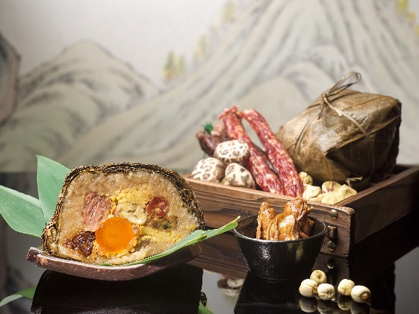
^{SIGNATURE!} Traditional Jumbo Rice Dumpling 五香腩肉、燒鴨、腊肠、润肠、日本花菇、瑤柱、咸蛋黄、甘香粟子、暹逻绿豆、湖南湘莲子、顶级糯米 (SGD33.80 per piece)
Back by popular demand, Hai Tien Lo’s Traditional Jumbo Rice Dumpling returns this dumpling festival with a new ingredient addition - roasted duck. A perfect sharing size for joyous gatherings with friends and loved ones, this sumptuous treat also contains exceptional ingredients of succulent pork belly, assorted preserved meat, Japanese mushrooms, dried scallops, salted egg yolk, chestnuts, green beans, lotus seeds and premium glutinous rice.
Other handcrafted flavours include Cantonese Pork Dumpling with Salted Egg Yolk 廣東咸蛋鮮肉粽 (SGD13.80 per piece) featuring pork belly, salted egg yolk and green beans as well as Traditional Nyonya Dumpling 南洋娘惹粽 (SGD9.80 per piece) filled with pork, candied melon, Japanese mushrooms, shallots and garlic.
Exquisite Rice Dumpling Gift Sets (SGD68.90 or SGD88.90)
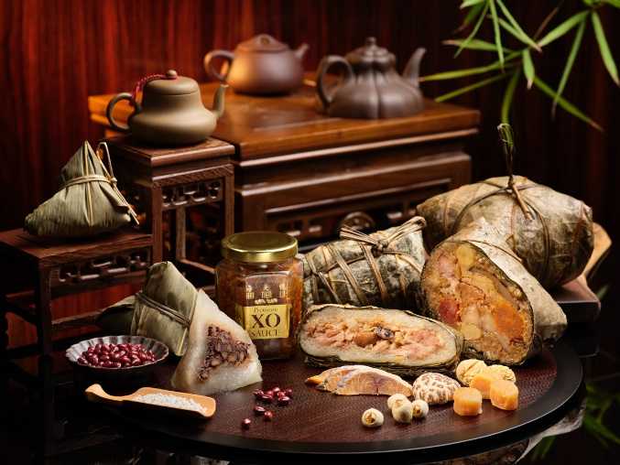
Perfect gift sets to commemorate the treasured Chinese festival, Hai Tien Lo presents the Classic Rice Dumpling Gift Set 端午套装 and Premium Rice Dumpling Gift Set 端午金装, comprising three delectable flavours exquisitely packaged with a bottle of Hai Tien Lo’s Signature Homemade XO Chilli Sauce or Fragrant Spicy Dried Shrimp Sauce. Upholding the timeless tradition, guests may look forward to gastronomic gatherings with their loved ones and have fun exploring different rice dumpling flavours in the process.
Available from 6 May to 7 June 2019, enjoy these flavourful rice dumplings while dining at Hai Tien Lo, or purchase as them takeaways from the restaurant. Alternatively, orders can be placed by emailing dining.ppsin@panpacific.com or calling 6826 8240, or via online orders at pacificmarketplace.sg from 6 May 2019. Rice Dumplings are to be collected at Hai Tien Lo. Guests can enjoy complimentary delivery to one location in Singapore with orders of SGD500 and above. For all other orders, a delivery charge of SGD50 per location applies.

Dragon Boat Festival – Exquisite Handcrafted Rice Dumplings Promotion
Date: 6 May to 7 June 2019
Price: From SGD8.80 to SGD33.80 (per piece), SGD68.90 or SGD88.90 (per set)
Venue: Hai Tien Lo (Level 3), 7 Raffles Boulevard, Singapore 039595
Opening Hours: 11:30am to 2:30pm; 6:30pm to 10:30pm
Items | Price
^{New!} Classic Rice Dumpling Gift Set端午套装  - Cantonese Pork Dumpling with Salted Egg Yolk  - Traditional Nyonya Dumpling  - Crystal Red Bean with Sago Dumpling  - Fragrant Spicy Dried Shrimps Sauce | SGD68.90 per set
Premium Rice Dumpling Gift Set端午金装  - Traditional Jumbo Rice Dumpling  - Classic Pork Belly and Salted Fish Dumpling  - Crystal Red Bean with Sago Dumpling  - Hai Tien Lo’s Signature Homemade XO Chilli Sauce (Bottle) | SGD88.90 per set
^{SIGNATURE!} Traditional Jumbo Rice Dumpling 一品粽  Pork Belly, Roasted Duck, Assorted Preserved Meat, Japanese Mushroom, Dried Scallops, Salted Egg Yolk, Chestnuts, Green Beans, Lotus Seeds and Premium Glutinous Rice | SGD33.80 per piece  Serves four to six
^{New!} Classic Pork Belly and Salted Fish Dumpling咸鱼花腩粽  Pork Belly, Salted Fish, Mushroom, Peanuts and Premium Glutinous Rice | SGD18.80 per piece  Serves up to three
^{New!} Crystal Dumpling with Red Bean and Sago 红豆水晶西米粽  Red Bean and Sago | SGD8.80 per piece  Serves one
Traditional Nyonya Pork Dumpling 南洋娘惹粽  Pork, Candied Melon, Japanese Mushroom, Shallots, Garlic and Premium Glutinous Rice | SGD9.80 per piece  Serves one
Cantonese Pork Dumpling with Salted Egg Yolk 廣東咸蛋鮮肉粽  Pork Belly, Salted Egg Yolk, Green Beans and Premium Glutinous Rice | SGD13.80 per piece  Serves one
Prices quoted are subject to prevailing Goods & Services tax for takeaway, as well as 10% service charge and prevailing Goods & Services tax for dine-in.
For dining reservations and enquiries, please speak with us at +65 6826 8240 or email dining.ppsin@panpacific.com.

High-resolution Images can be downloaded here.

Media Contact
Ms. Gillian Teo
Assistant Director
Pan Pacific Singapore
E-mail: gillian.teo@panpacific.com
Tel: +65 6826 8095

Melissa Ng
Senior Marketing Communications Executive
Pan Pacific Singapore
Email: melissa.ng@panpacific.com
Tel: +65 6826 8094
Hotel Facebook: https://www.facebook.com/panpacificsingapore
Hai Tien Lo Facebook: https://www.facebook.com/HaiTienLo.Singapore
Twitter: https://twitter.com/panpacificsgp
Instagram: http://instagram.com/panpacificsingapore

Pan Pacific Hotels and Resorts
With hotels, resorts and serviced suites across Asia, Oceania and North America, Pan Pacific provides a safe harbour in an ever-changing world. Places with less to worry about because, when you stay with us, rest assured that all will be taken care of. For this is where you will find your balance.

Pan Pacific Hotels Group
Pan Pacific Hotels Group is a wholly-owned hotel subsidiary of Singapore-listed UOL Group Limited, one of Asia’s most established hotel and property companies with an outstanding portfolio of investment and development properties.
Based in Singapore, Pan Pacific Hotels Group owns and/or manages 40 hotels, resorts and serviced suites with more than 12,000 rooms including those under development in Asia, Oceania, North America and Europe.

Voted “Best Regional Hotel Chain” by readers in Asia in 2017, Pan Pacific Hotels Group comprises two acclaimed brands: its signature brand, Pan Pacific and its deluxe brand, PARKROYAL.

Sincerity is the hallmark of Pan Pacific Hotels Group. The Group is known to its guests, partners, associates and owners for its sincerity in people and the sense of confidence which alleviates the stresses of today’s complex world.

About Hai Tien Lo
Helmed by Executive Chef Ben Zeng, Hai Tien Lo epitomises traditional Cantonese dining with a contemporary twist. Enjoy exquisite dim sum, double boiled soups, Peking duck and classic braised dishes, in addition to modern interpretations like the “Australian Abalone with Japanese Mushrooms and Black Truffles” or “Double-boiled Chicken Soup with Abalone, Dried Scallops, Fresh Prawns and Chinese Mushrooms served in Young Coconut”.

