2020-11-25

PRESS RELEASE

Unique tests available at Sweden's IRF SpaceLab

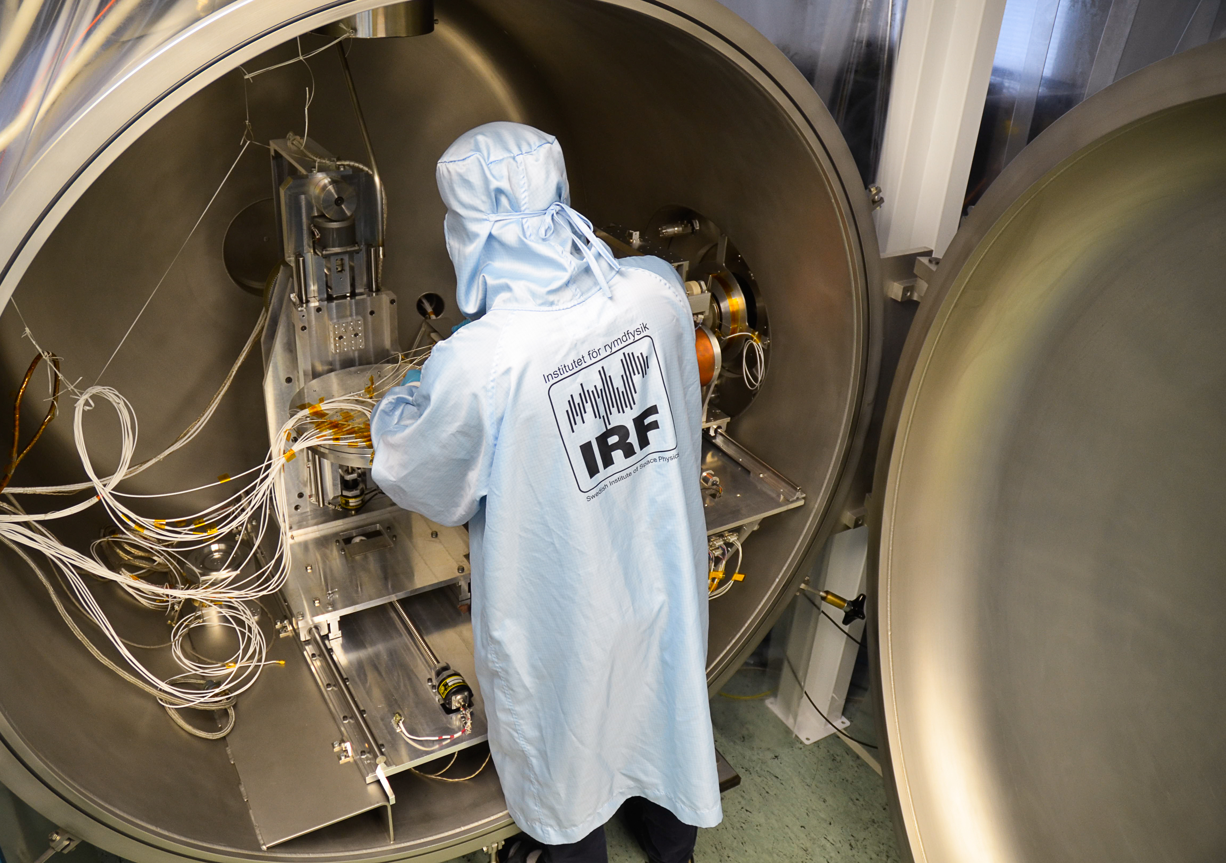
The unique facility IRF SpaceLab in Kiruna, Sweden, tests hardware for space projects and is available to external users. The facility is now presented in a film and on a website. Photo: Annelie Klint Nilsson, IRF

The SpaceLab test facility at the Swedish Institute of Space Physics (IRF) in Kiruna, Sweden, offers industry and research groups an extensive opportunity to test and qualify space-related hardware for satellites, rockets, balloons and ground-based technology. A film and a website are now being launched to present the test capabilities within IRF SpaceLab.

”IRF has been developing instruments for satellites, rockets and balloons since the 1960s and has all the necessary equipment to simulate the harsh environment these instruments face. We are opening our facility at the head office in Kiruna for external customers so that they can benefit from our facilities and our expertise,”says Mate Kerenyi, IRF research engineer and IRF SpaceLab project manager.

The website provides a complete overview of IRF SpaceLab's various current facilities and the film aims to make the test facility's capacity visible and increase the interest of external customers.

IRF Director Stas Barabash comments on SpaceLab:

"SpaceLab clearly shows the path of knowledge - from basic research to societal development! The infrastructure that IRF has created to test and develop instruments for the purpose of exploring the solar system will be used to improve space technology for, among other things, earth observations and communication," says Stas Barabash.

The ambitious plans to develop space technology at IRF SpaceLab are made in collaboration with strong partners: the regional project Space for Innovation and Growth, RIT2021, and Kvarken Space Eco at the University of Vaasa in Finland.

Contact:
Mate Kerenyi, research engineer, project manager, IRF SpaceLab, Swedish Institute of Space Physics
mate.kerenyi@irf.se , +46 980 790 02

Websites:
spacelab.irf.se
www.irf.se

Link to the film: https://youtu.be/mIE-N5aVXVo

