PRESS RELEASE | NOVEMBER 2020

12 000 KM—a climate-conscious journey in search of deep powder and an adventure of a lifetime.

The Haglöfs-sponsored documentary 12 000 KM follows a group of Swedish freeride skiers and snowboarders on a climate-conscious journey from Sweden to Japan via the Trans-Siberian Railway—with a great deal of humor, cultural meetings, and world-class riding along the way.

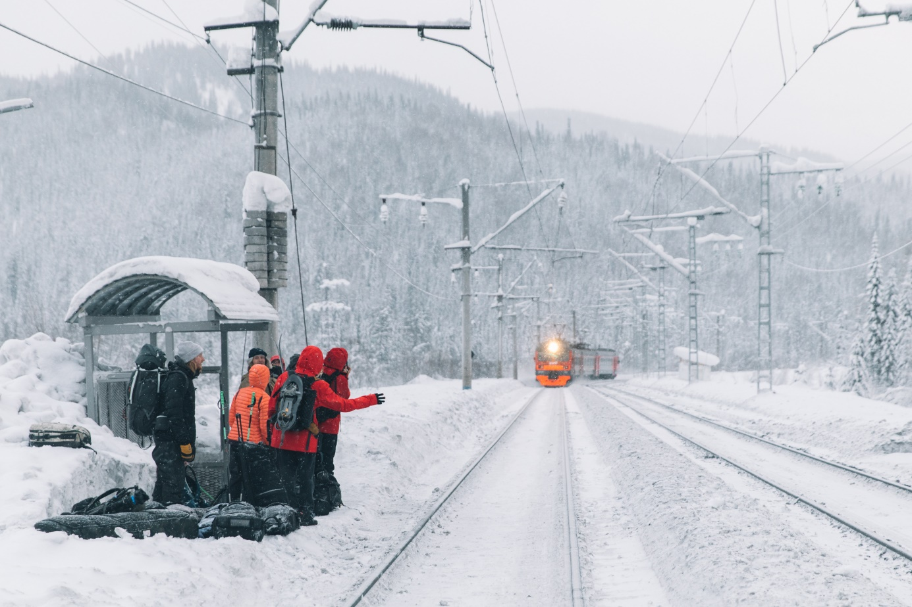

In 2019, a bunch of freeride snowboarders and skiers embarked on an epic journey from Sweden to Japan in search of deep powder and an adventure of a lifetime. Intent on completing the trip with a minimal carbon footprint, they traded airplanes for alternative transport options via rail, road, and sea. It was all captured by Erik Nylander in the documentary 12 000 KM, which was officially released to the public today.
The documentary stars Tom-Oliver Hedvall, his girlfriend Sibylla Lundström, and their gang of travel buddies, including the Russian snowboarding legend Evgeniy Joon Ivanov. Along the world’s longest train ride, they make various stops in the deep and frostbitten mountains of Siberia to explore unridden mountains and get to know Russian culture from the inside. When they arrive in Japan 12,000 km later, the crew piles into a motorhome to explore the Island of Honshu, totally opposite from Russia in all possible ways.

A climate-conscious journey by rail, road and sea
The idea behind the trip was sparked by Tom-Oliver and Sibylla, who, due to the climate crisis, have chosen to no longer travel by air.

“I have always dreamt of going to Japan to ski endlessly with powder, but a couple of years ago I decided to stop flying,” says Tom-Oliver. “So, I had to come up with a new, more sustainable way to get there so I could fulfill my dream and inspire others to do the same.”

After they invited photographer and snowboarder Erik Nylander to join, the trip would evolve into something even bigger.

“The idea of making it a sustainable friendly, yet epic adventure, combined with such a fun crew made me say yes straight away,” recalls Erik. “At first, I thought I'd tag along just as one in the group of friends to shoot some still photography and shred a lot, but then it turned into a film project.”

Finding the secret spot: “I skied the best pillows of my life”
Among the many highlights is when the crew’s Russian friend leads them to a secret getaway in the Siberian Mountains.

“We lived in a cabin in the middle of nowhere, and I skied the best pillows of my life,” says Tom-Oliver.

“It was such a remote place with amazing riding and authentic surroundings,” says Erik. “Also, the entire train journey—with all the people we bumped into along the way—was quite unforgettable.”

Sponsored by Haglöfs
Haglöfs was one of three sponsors that helped make the 12,000 km journey possible, along with Film Västernorrland and Protect Our Winters, a nonprofit for climate advocacy founded by professional snowboarder Jeremy Jones.

The 28 minute long documentary 12 000 KM is available here.

For more information, please contact:
Daniel Sowa
Global Head of Integrated Marketing Communication
​daniel.sowa@haglofs.se
+46 70 255 20 26

HAGLÖFS | SINCE 1914

We come from Sweden, a country of extreme weather and extensive landscape. A place where the outdoors isn’t just a far-off place, it’s in the fabric of our culture and community. We are committed to creating gear that will support anyone, anywhere in their own outdoor adventure. We were founded in 1914 by Wiktor Haglöf, a visionary with a dream and a toolbox. Our story has evolved from humble beginnings, and we’ve ventured into new territory, creating technical designs that set a new standard in craftsmanship.

At Haglöfs, we are Outsiders by Nature. We draw outside the lines, think outside the box, and live outside our comfort zones. We encourage exploration both physically and mentally through embracing the outdoors. We believe that everyone can experience the outdoors, and do all we can to ensure that it will still be there for future generations to explore.

