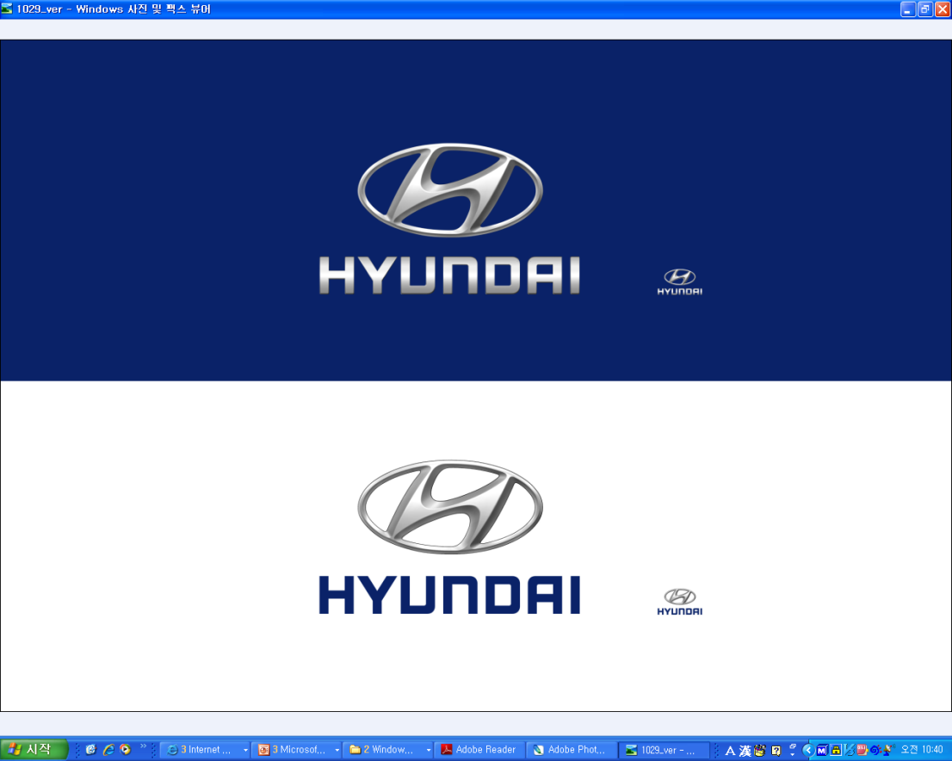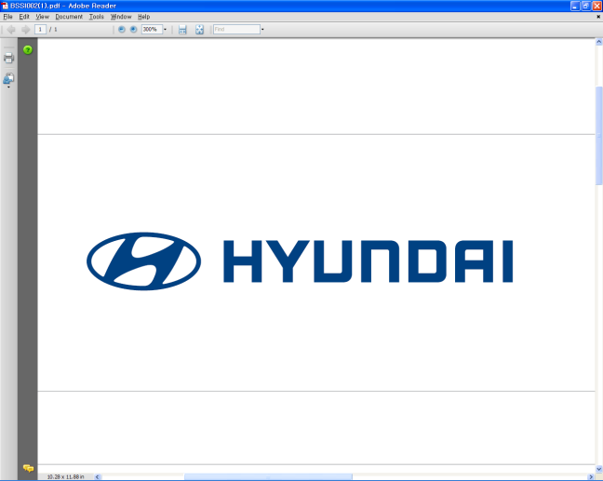  Nov. 13, 2011  Please send after noon (Seoul time) | Media Release  For further information contact the  Global Public Relations Team  Tel: +82+2—3464-2153 ~ 60  Fax: +82+2—3464-3497  globalpr@hyundai.com

Hyundai Motor Launches New Genesis Coupe

Face-lifted Genesis Coupe comes with sportier design and more power

* The vehicle in this press release refers to the Korean-specific model only. Names and specifications may differ in other regions.

Hyundai Motor Company, South Korea’s largest automaker, unveiled its redesigned premium sports coupe, the new Genesis Coupe, at one of Korea’s biggest motorsports competitions.

The new Genesis Coupe is a face-lift version of Hyundai’s first rear-wheel drive sports coupe, introduced in October 2008. As its sportier new look implies, the upgraded Genesis Coupe offers a more dynamic and powerful driving experience. The new coupe was launched on Nov. 12 at the Korea Speed Festival 2011 in Yeongam, Korea in front of about 5,000 driving enthusiasts.

The eye-catching wide grille completes a bold and sporty front look and enhances cooling performance. Additionally, sleeker head lamps, LED positioning lamps, an LED rear combination lamp and voluminous character lines reinforce Genesis Coupe’s high-performance sports car image.

Exclusive materials and metal accents create a sporty and sophisticated
high-tech interior, while the standard multi-gauge located on the center fascia gives the driver instant feedback for a more dynamic driving experience.

Stronger engine performance completes the new design. The new Genesis Coupe comes with two engines: the Lambda 3.8 GDi and the Theta 2.0 TCI. In particular, the Lambda 3.8 GDi engine significantly increases performance and efficiency by directly injecting fuel into the cylinder.

The new Genesis Coupe delivers maximum output of 350ps and maximum torque of 40.8kg.m. Compared to the Genesis Coupe’s previous engine – the Lambda 3.8 MPi – this represents an improvement of 47ps and 4.0kg.m.

For the Theta 2.0 TCI engine, a larger radiator intercooler for the high-performance turbocharger cools air more effectively and enhances driving responsiveness. The twin-scroll turbo allows for better performance and durability.

Compared to its predecessor, the Theta 2.0 TCi increases maximum output and maximum torque by 65ps and 8.0kg.m to 275ps and 38kg.m, respectively.

The more powerful engines are mated to an eight-speed automatic transmission, bringing smoother shifting and more dynamic driving performance to the Genesis Coupe.

In order to raise the emotional quality in the Lambda 3.8 GDi model, a sound generator is applied to replace the rough engine sound with a classy and sporty sound.

Hyundai Motor aims to sell more than 4,000 units in the Korean market next year.

About Hyundai Motor
Established in 1967, Hyundai Motor Co. has grown into the Hyundai Motor Group which has ranked as the world’s fifth-largest automaker since 2007 and includes more than two dozen auto-related subsidiaries and affiliates. Hyundai Motor, which has six manufacturing bases outside of South Korea, sold approximately 3.6 million vehicles globally in 2010. Hyundai vehicles are sold in 186 countries through some 5,300 dealerships and showrooms. Further information about Hyundai Motor and its products is available at www.hyundai.com.

