MEDIA RELEASE

KNOCK-OUT ROOM STAYS FOR PACQUIAO VS THURMAN
FIGHT AT PAN PACIFIC MANILA
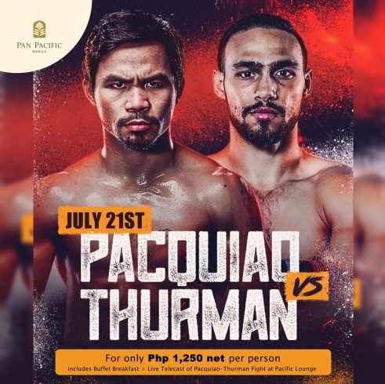
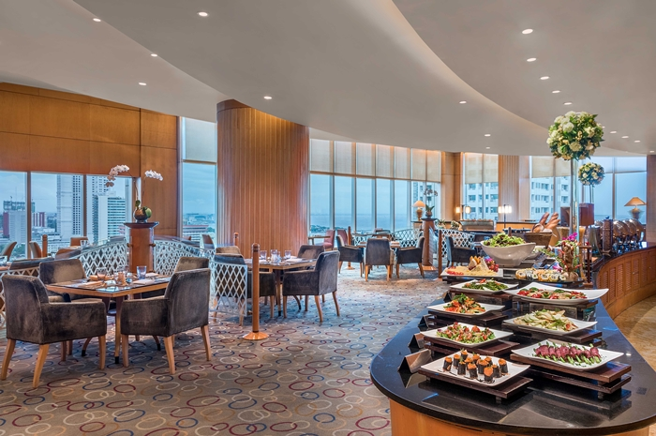

18 July 2019, Manila – The Pacquiao vs. Thurman boxing bout on Sunday, July 21, 2019, will be shown live on HD at Pan Pacific Manila’s Pacific Lounge from 8:30 AM to 11:30 AM. Admission is priced at P 1,250 net per person inclusive of a hearty international breakfast buffet and free-flowing fresh juice, iced tea, coffee, and tea.

A special fight package for local residents valid July 20 to 21 is available starting at P 5,550++ per night for Superior room accommodations inclusive of admission for two persons to the live fight coverage at the Pacific Lounge plus breakfast buffet fresh juice, iced tea, coffee, and tea.
Pacific Lounge is located on the 21st floor, Pan Pacific Manila, M. Adriatico cor. Gen Malvar Sts. Malate. For reservations, please contact (02) 318 0788 or email dining.ppmnl@panpacific.com. Price is subject to change without prior notice.

For more information on Pan Pacific Manila, please visit:
https://www.panpacific.com/en/hotels-resorts/philippines/manila

ENDS
Media Contact
Stephanie Cabrejas
Assistant Marketing Manager
Pan Pacific Manila
Email: stephanie.cabrejas@panpacific.com
Tel: +63 2 917 595 1479/ +63 2 318 0788

About Pan Pacific Manila
The first and finest Butler hotel in the Philippines – ranked among the recommended hotel at the 2017, 2018 and 2019 Forbes Travel Guide, named one of the best places to stay in the TripAdvisor Travellers Choice Award, and also recognised among the Philippines’ Leading Business Hotels at the World Travel Awards, is conveniently located at the heart of the historical and cultural district of Malate in the Manila Bay area. Pan Pacific Manila is a short drive to the city’s convention, exhibition and business centres and a walk away from shopping, food and entertainment establishments. A business hotel, designed to offer a comfortable abode to business and leisure travellers with its excellent facilities and service, the hotel has 236 all-executive rooms and suites and 7 spacious function rooms.

About Pan Pacific Hotels and Resorts
With hotels, resorts and serviced suites across Asia, Oceania and North America, Pan Pacific provides a safe harbour in an ever-changing world. Places with less to worry about because, when you stay with us, rest assured that all will be taken care of. For this is where you will find your balance.
About Pan Pacific Hotels Group
Pan Pacific Hotels Group is a wholly-owned hotel subsidiary of Singapore-listed UOL Group Limited, one of Asia’s most established hotel and property companies with an outstanding portfolio of investment and development properties.

Based in Singapore, Pan Pacific Hotels Group owns and/or managers more than 40 hotels, resorts and serviced suites including those under development in 24 cities across Asia, Oceania, North America and Europe.

Voted “Best Regional Hotel Chain” by readers in Asia in 2017 and 2018, Pan Pacific Hotels Group comprises two acclaimed brands: its signature brand, Pan Pacific and its deluxe brand, PARKROYAL.

Sincerity is the hallmark of Pan Pacific Hotels Group. The Group is known to its guest’s partners, associates and owners for its sincerity in people and the sense of confidence which alleviates the stresses of today’s complex world.

