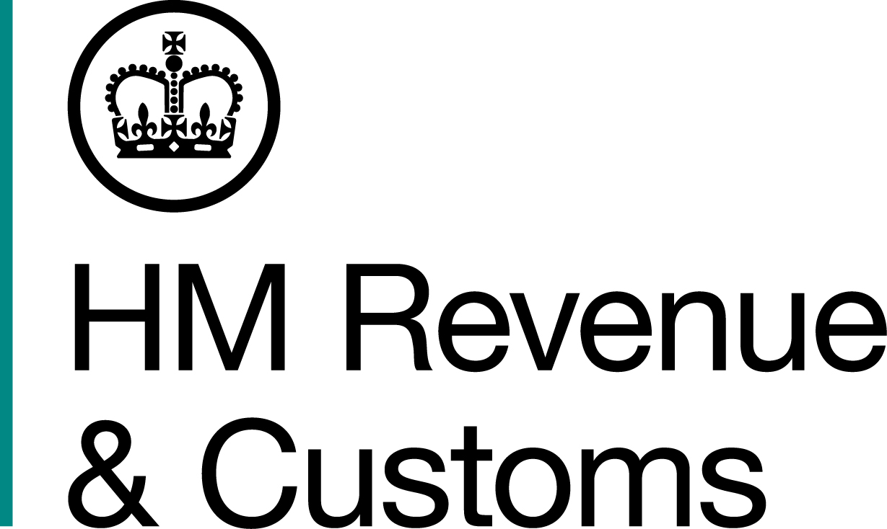
News Release

 | For the attention of News Desks |  | No of pages: 3
 | Date: | 12 07 2019 | Ref: | NW NR 08 19

Woman jailed for four years for £440,000 online tobacco scam

A woman from Bolton has been jailed – and her husband and mother given suspended prison sentences – for selling illegal cigarettes.

Married couple Paul, 49, and Vicky Whalley, 46, of Corner Brook in Bolton, along with her mother Lynn Abbey, 68, of The Spinney, Bolton, sold counterfeit cigarettes and rolling tobacco worth £440,000 in unpaid duty, an investigation by HM Revenue and Customs (HMRC) revealed.

The trio sold their illegal products through social media and three websites – dandandoo.com, vicvicvoo.com and greencups.co – where the items were advertised as t-shirts, cupcakes and plastic drinking cups bearing the logo of the tobacco.

They even kept on operating their illegal enterprise after being arrested and opened a new bank account to allow trade to continue.

Tim Atkins, Assistant Director, Fraud Investigation Service, HMRC, said:

“This family pocketed money that should have gone to our public services. Their attempts to hide their illegal operation behind cupcakes, drinking cups and t-shirts were utterly futile.

“Tobacco fraud cheats the public purse and undermines the honest majority of businesses who play by the rules. Anyone with information about illegal tobacco or any other tax fraud should report it to HMRC online or contact our Fraud Hotline on 0800 788 887.”

HMRC discovered the fraud during an operation across Greater Manchester targeting illegal tobacco and alcohol in June 2016, which saw the seizure of more than 560,000 cigarettes, 414kg of rolling tobacco and 6,280 litres of alcohol.

During the operation, investigators searched a self-storage unit in Egyptian Street, Bolton, which was rented in Vicky Whalley’s name. It contained 1,620 non-duty paid cigarettes and 12.35kg of non-duty paid rolling tobacco stored within laundry bags.

Investigators found the family sold 232,160 counterfeit branded cigarettes – including Mayfair, Richmond, Lambert & Butler, and Regal – as well as 34,479 pouches of counterfeit Amber Leaf, Golden Virginia and Cutter Choice rolling tobacco, between 2014 and 2018 across a vast UK and Northern Ireland customer base.

Orders were placed online and Lynn Abbey would use her home as a collection point for the courier service, with everything distributed by tracked mail.

Paul Whalley was employed by the National Offender Management Service in Bolton, Vicky Whalley worked as a catering assistant for Bolton Borough Council, and Lynn Abbey was a health care assistant at Bolton Hospital.

The three were convicted of fraudulently evading duty at Manchester Crown Court on 23 May. They were sentenced at the same court on 12 July 2019.

- Vicky Whalley was sentenced to four years in prison.
- Paul Whalley was sentenced to 18 months, suspended for two years; 240 hours unpaid community service and was ordered to undertake 20 days of rehab.
- Lynn Abbey was sentenced to 12 months, suspended for 18 months, and ordered to complete 120 hours of unpaid community service.

Notes to Editors

- Paul Jason Whalley, DOB 07/08/1969, of Corner Brook, Bolton. Between 31/07/2014 and 01/04/2018 at Bolton in relation to goods, namely cigarettes, was knowingly concerned in a fraudulent evasion of any duty chargeable on the goods Contrary to section 170(2) and (3) of the Customs and Excise Management Act 1979. Between 31/07/2014 and 01/04/2018 at Bolton in relation to goods, namely Tobacco, was knowingly concerned in a fraudulent evasion of any duty chargeable on the goods Contrary to section 170(2) and (3) of the Customs and Excise Management Act 1979.

- Vicky Marie Whalley, DOB 12/07/1973, of Corner Brook, Bolton. Between 31/07/2014 and 01/04/2018 at Bolton in relation to goods, namely cigarettes, was knowingly concerned in a fraudulent evasion of any duty chargeable on the goods Contrary to section 170(2) and (3) of the Customs and Excise Management Act 1979. Between 31/07/2014 and 01/04/2018 at Bolton in relation to goods, namely Tobacco, was knowingly concerned in a fraudulent evasion of any duty chargeable on the goods Contrary to section 170(2) and (3) of the Customs and Excise Management Act 1979.

- Lynn Abbey, DOB 01/04/1951, of The Spinney, Bolton. Between 31/07/2014 and 01/04/2018 at Bolton in relation to goods, namely cigarettes, was knowingly concerned in a fraudulent evasion of any duty chargeable on the goods Contrary to section 170(2) and (3) of the Customs and Excise Management Act 1979. Between 31/07/2014 and 01/04/2018 at Bolton in relation to goods, namely Tobacco, was knowingly concerned in a fraudulent evasion of any duty chargeable on the goods Contrary to section 170(2) and (3) of the Customs and Excise Management Act 1979.

- Follow HMRC Press Office on Twitter @HMRCpressoffice.
- HMRC's Flickr channel: www.flickr.com/hmrcgovuk.

Issued by HM Revenue & Customs Press Office

Press enquiries only please contact:

Lucy Collins
Tel: 07900 394 601
Email: lucy.collins@hmrc.gsi.gov.uk

Out of hours: Tel: 07860 359544

Website: www.gov.uk/hmrcs

