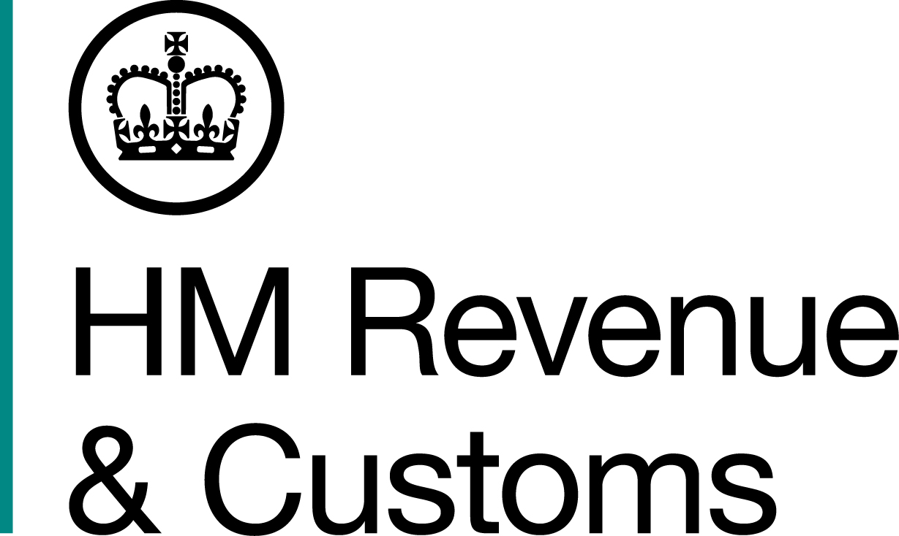
News Release

 | For the attention of News Desks |  | No of pages: 2
 | Date: | 05 July 2019 | Ref: | NTH 05 19

Jailed tobacco fraudster ordered to repay £494k
A jailed shopkeeper, who imported, stored and sold thousands of illegal cigarettes, has been ordered to repay more than £490,000 he made from his crimes, or spend more time in jail.
Karim Heabah, 29, of Jenkin Road, Sheffield, was jailed for three years in December 2017 for excise fraud offences after an investigation by HM Revenue & Customs (HMRC).
At a confiscation hearing today, 05 July 2019, at Sheffield Crown Court, Heabah was told he must repay £494,296 within three months, or spend a further four-and-a-half years behind bars and still owe the money.
Diccon Wood, Assistant Director, Fraud Investigation Service, HMRC, said:
“Selling illegal cigarettes creates an uneven playing field for legitimate businesses and is theft from the taxpayer. This is money which should be used to fund our vital public services and now Heabah must pay it back.
“The majority of tobacco retailers are law abiding, but we will continue pursue those who smuggle, store and profit from illegal tobacco. Our actions don’t stop once someone is convicted and we will always look to reclaim the stolen money.
“We encourage anyone with information about tobacco fraud to report it online, or call our Fraud Hotline on 0800 788 887.”
HMRC and Trading Standards made a number of tobacco seizures from Heabah’s shop, Baghdad Stores, on Page Hall Road, Sheffield, between 2011 and 2016. The largest haul consisted of more than 29,900 illegal cigarettes and 10.5 kilos of hand-rolling tobacco.
A number of parcels containing illicit tobacco goods, addressed to Heabah, were also seized by HMRC at delivery depots in Sheffield and Coventry in 2015.
HMRC officers found another batch of illicit tobacco goods at his shop just days before he was sent to prison.
Heabah was jailed for excise fraud at Sheffield Crown Court on 15 December 2017.
Notes to Editors
- Karim Heabah, DOB 30/06/2019, of Jenkin Road, Sheffield, was jailed for three years on 15 December 2017 for excise fraud.
- At a confiscation hearing on 05 July 2019, at Sheffield Crown Court, a judge ruled Heabah benefited from a Criminal Lifestyle under the Proceeds of Crime Act 2002 and was ordered to pay £494,296 within three months, or serve a further four-and-a-half years in prison and still owe the money.
- Information about any type of tax fraud can be reported to HMRC online at https://www.gov.uk/government/organisations/hm-revenue-customs/contact/customs-excise-and-vat-fraud-reporting
- Follow HMRC Press Office on Twitter @HMRCpressoffice

Issued by HM Revenue & Customs Press Office

Press enquiries only please contact:

Jon Sibley
Tel: 03000 552871
Email: jonathon.sibley@hmrc.gsi.gov.uk

Or

Ed Casson
Tel: 03000 524697
Email: ed.casson@hmrc.gsi.gov.uk

Out of hours
Tel: 07860 359544
Website www.gov.uk/hmrc

