PRESS RELEASE | MAY 2020

Haglöfs announces Maria Granberg
as their new ambassador

Haglöfs has signed Swedish adventure athlete Maria Granberg as their new ambassador. Maria brings a strong background in mountaineering with the accomplishment of being the fourth Swedish woman to summit Mount Everest in May 2016.

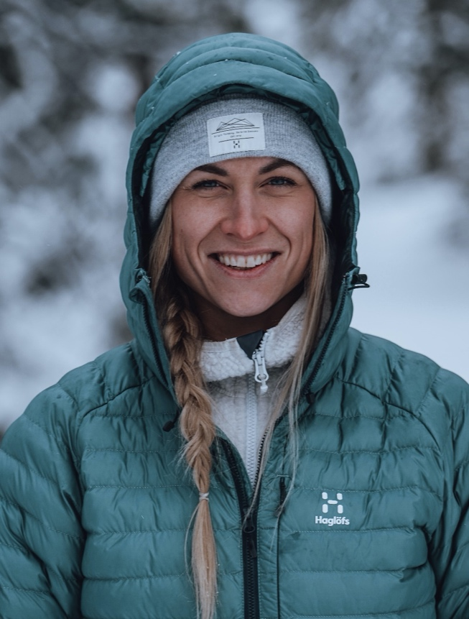

We are extremely happy and proud that Maria is now a part of Haglöfs as our new Brand Ambassador. With Maria comes not only extensive knowledge and experience in mountaineering, but also a mindset that aligns with our vision as brand. She inspires us and will continue to solidify Haglöfs in the mountaineering community and build on our reputation as a progressive performance brand. We have no doubt that this will be an exciting partnership. We’re looking forward to being part of, and to support her upcoming adventures’. Haglöfs Marketing Director, Victor Adler.
In addition to her adventures, Maria is also a mental performance coach, behavioral scientist and public speaker. Born and raised in a small mining village called Persberg (Värmland, Sweden) she was always curious about exploring her limits and went on to compete in various sports until her mid-twenties.

After many years studying psychology and mental training, she lectures for companies, events and schools where she shares her experiences in the mountains and the ways everyone can live a more vibrant life.

Her first real experience at high altitude was realized in 2010 while living and working as a volunteer in Tanzania. A non-technical yet challenging experience on Mt. Kilimanjaro was the moment when she completely fell in love with high altitude mountaineering.

‘It’s been a long learning process, and still is, but I quickly became addicted to the struggle of climbing at high altitude. There’s something particular with that experience, the combination of being in an environment that constantly challenges you while simultaneously showing you how little you need to be happy. The journey of acquiring the skills necessary to become a well-rounded mountain athlete is never ending which naturally becomes a kind of bottomless source of inspiration. It fueled me to choose the field of psychology, alongside mountaineering, and I eventually realized that it all aligned pretty perfectly. It didn’t force me to choose but rather enabled me to pursue them both, exploring life in the mountains and helping other athletes explore theirs.” Maria Granberg

Today Maria lives in Åre, in the north of Sweden – where she trains and has her base camp. She’s a diverse mountain athlete, constantly brewing ideas and projects she’d like to attempt. One specific goal she has carried with her for quite some time is to climb an 8000+ peak without oxygen. Her hope is to share her endeavors with more women, expanding the female presence in high altitude mountaineering.

Follow Maria and her adventures here: https://www.instagram.com/granbergadventureathlete/

For more information, please contact:
Lisa Grübb
PR & Sponsorship Specialist
lisa.grubb@haglofs.se
+46 76 677 67 84

