FOR IMMEDIATE RELEASE

***Becoming - An Exhibition by Vincent Chua***

*Featuring artworks of Chinese ink on ‘Xuan’ paper, a solo exhibition in collaboration with ArtSE, a social enterprise by Goshen Art Gallery*

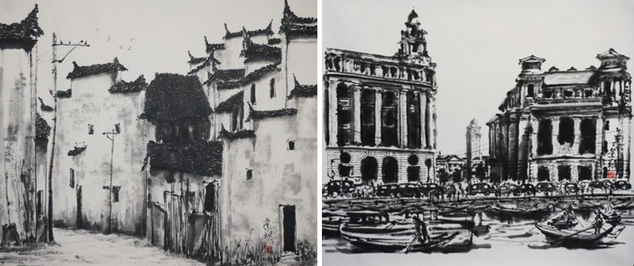

16 July 2019, Singapore – Pan Pacific Singapore and Goshen Art Gallery present ***"Becoming - An Exhibition by Vincent Chua"***, a stand-alone exhibition by established artist Vincent Chua.

In this exhibition, Vincent Chua will be debuting 27 extraordinary pieces that depict an equilibrium of Western realism and Chinese interpretation. Through a combination of Western techniques of creating volume and depth in shading, incorporation of Chinese ink and Chinese “Xuan” paper creating differing effects, the skilful manipulation of the Chinese brush and dilution of the ink, he is able to create his signature art pieces.

Born in 1959, Vincent Chua is a renowned Singaporean artist who has clearly been influenced by his artist brother, the late Mr Chua Ek Kay. Vincent’s works have been featured internationally in China, India, Korea and Malaysia and he has garnered several awards for his works, including the Dr. Tan Tsze Chor Award in the Open Chinese Ink Category in 2014, and “*Excellence Art Award*” for the World Artists Invitation Art Exhibition in 2011. Apart from his remarkable achievements, Vincent Chua is an active participant in the Singapore local art scene, and has had his works featured in the annual National Day and Teochew Art Exhibition, organised by the Ngee Ann Cultural Centre.

A portion of proceeds goes to ArtSE - a social enterprise which focuses on cultivating an all-inclusive community by empowering seniors, low income, special needs and persons-with-disabilities through visual arts or art related activities. As a social impact business, we endeavour to reinvest all returns towards ArtSE operations and complementary social causes."

Visitors are welcome to view the spectacular creations at this complimentary art exhibition. ***Becoming - An Exhibition by Vincent Chua*** will be on showcase 11:00am to 8:00pm daily from 31 July to 28 October 2019 at the Public Art Space on Level 2 of Pan Pacific Singapore. For artwork enquiries, please contact Jack Yu from Goshen Art Gallery at info@goshenartgallery.com.

**Name of Exhibition:** Becoming - An Exhibition by Vincent Chua (蔡逸翔 -水墨绪缘)

**Artist:** Vincent Chua (蔡逸翔)

**Exhibition Duration:** 31 July to 28 October 2019

**Opening Hours:** 11:00am to 8:00pm daily

**Venue:** Public Art Space (Level 2) at Pan Pacific Singapore

**Address:** Pan Pacific Singapore, 7 Raffles Boulevard, Marina Square, Singapore 039595

[**Download images here**](https://www.dropbox.com/sh/so6sapjrj4xqouh/AABtpoiezqMKv7Kn9EMqlYUoa?dl=0)

**ENDS**

**Media Contact**

Annie Choy

Director of Marketing Communications

DID: (65) 6826 8079

E-mail: [annie.choy@panpacific.com](mailto:annie.choy@panpacific.com)

Junjia Luo

Marketing Communications

DID: (65) 6826 8058

E-mail: [luo.junjia@panpacific.com](mailto:luo.junjia@panpacific.com)

*Pan Pacific Singapore Facebook:* [*https://www.facebook.com/panpacificsingapore*](https://www.facebook.com/panpacificsingapore)

*Twitter:* [*https://twitter.com/panpacificsgp*](https://twitter.com/panpacificsgp)

*Instagram:* [*http://instagram.com/panpacificsingapore*](http://instagram.com/panpacificsingapore)

**About Goshen Art Gallery**

Goshen Art Gallery is an international art gallery that offers exquisite art works from Asia to the rest of the world. The gallery has in its collection over 8000 pieces of artworks by renowned local and international artists. Bridging cultures, philosophies, beliefs and imagination through fine paintings, sculptures and art installations, our strength is in curating art exhibitions, art commissioning, interior art consultancy, art leasing and corporate art programs.

**About Public Art Space**

Public Art Space, 220 square metres of dedicated space on level to of the hotel overlooking the Atrium, is dedicated to showcasing collections by international and local artists with regularly rotating exhibitions. The decision to create Public Art Space is based on the hotel’s commitment to the local community; particularly supporting local Arts in the most accessible way possible and making it available for public enjoyment.

**Pan Pacific Hotels Group**

Pan Pacific Hotels Group is a wholly-owned hotel subsidiary of Singapore-listed UOL Group Limited, one of Asia’s most established hotel and property companies with an outstanding portfolio of investment and development properties.

Based in Singapore, Pan Pacific Hotels Group owns and/or manages 40 hotels, resorts and serviced suites with more than 12,000 rooms including those under development in Asia, Oceania, North America and Europe.

Voted “Best Regional Hotel Chain” by readers in Asia in 2017, Pan Pacific Hotels Group comprises two acclaimed brands: its signature brand, Pan Pacific and its deluxe brand, PARKROYAL.

Sincerity is the hallmark of Pan Pacific Hotels Group. The Group is known to its guests, partners, associates and owners for its sincerity in people and the sense of confidence which alleviates the stresses of today’s complex world.

**Pan Pacific Hotels and Resorts**

With hotels, resorts and serviced suites across Asia, Oceania and North America, Pan Pacific provides a safe harbour in an ever-changing world. Places with less to worry about because, when you stay with us, rest assured that all will be taken care of. For this is where you will find your balance.