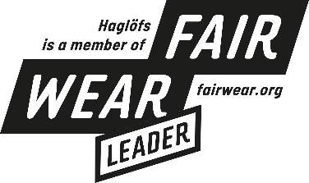
PRESS RELEASE | JUNE 2021

Haglöfs is taking action to ensure fair treatment of everyone involved in making their products

At Haglöfs, being a global citizen and taking responsibility for their supply chain is a high priority. The work Haglöfs carried out to reduce the vulnerability of workers amid the challenges of 2020 resulted in them achieving Fair Wear Leader status.

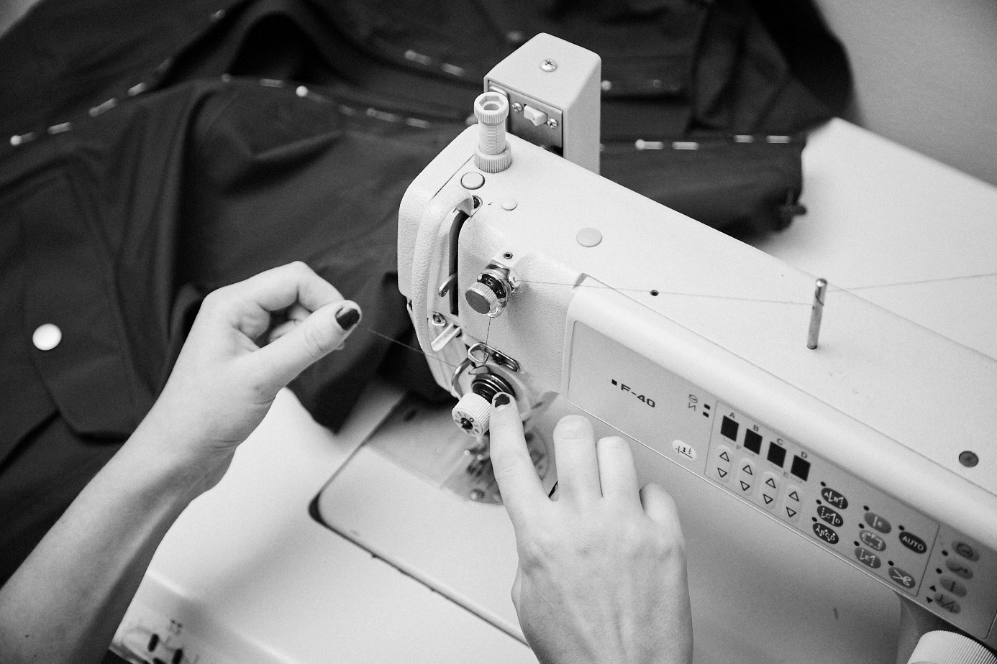

The textile industry provides employment and development opportunities to millions of workers around the world. Unfortunately, labor and human rights are not universally applied. Haglöfs takes active responsibility for their supply chain working to reduce the vulnerability of workers and ensure they are treated fairly. As members of the non-profit Fair Wear, Haglöfs has achieved Leader status for work carried out in the challenging year of 2020.

Fair Wear is a non-proﬁt organization that works with brands, factories, trade unions, NGOs and governments to improve working conditions for garment workers. They support brands with audits, training, a worker helpline, and local expertise in labor and human rights issues as well as by providing a forum for member brands to collaborate within shared factories to accelerate improvements.

Haglöfs’ membership of Fair Wear underpins their social responsibility initiatives in their clothing, footwear, and hardware factories.

“At Haglöfs, dedicated people work every day, all around the world, to make products that inspire people to get out there,” said Fredrik Ohlsson, CEO at Haglöfs. “It is fundamental that all the people involved are treated fairly in the process including those in our supply chain. Through our partnership with Fair Wear, and together with our peers in the outdoor industry, we must keep acting as responsible global citizens and push to reduce the vulnerability of workers in the clothing industry supply chain.”

2020 was an especially difficult year for textile industry workers

In 2020, as orders collapsed across the industry, the livelihoods of the tens of thousands of workers who help bring products to life every day was put at serious risk. An especially vulnerable time for those without the luxury of a social safety net.

"During the year, it became clearer than ever before how interconnected we are and the importance of partnership and cooperation in confronting uncertainty,” said Fredrik Ohlsson. “As our retail partners fought to save their businesses, we sought ways to support them, while at the same time cooperating with our suppliers to minimize the potential damage of reduced orders ”

While Haglöfs had to reduce and delay orders in 2020, they paid for orders already made or in progress and worked closely with suppliers to take their individual circumstances into account.

Haglöfs’ annual brand performance check by Fair Wear
In addition to supporting brands to accelerate labor condition improvements, Fair Wear provides an external veriﬁcation of brands’ performance by evaluating their processes and systems.

The work carried out in the difficult year of 2020 resulted in Haglöfs achieving Fair Wear Leader status. The report summary states:

“Haglöfs has shown advanced results on performance indicators and has made exceptional progress. With a benchmarking score of 84, once again places Haglöfs in the Leader category. Although the monitoring threshold does not determine the category this year, Haglöfs has fulfilled the monitoring requirements at suppliers providing 97% of its production volume.”

Read the complete 2020 Fair Wear Brand Performance Check report on Haglöfs here.

Find out more about Haglöfs’ progress and download the Sustainability Report 2020 here.

About Fair Wear Foundation
We are the Fair Wear Foundation. Together with garment brands and other industry players, we work on better labor conditions for the people who make our clothes. The men and women working in clothing factories often are employed under dangerous and abusive conditions for poverty wages. That is why we’re pushing towards a new normal, where workers feel safe and respected and receive a salary that is enough to provide for their families. Fair Wear brands show that there is a better way to make clothes, a way that puts the people who make them front and center. We’re determined to make this the new normal.

Read more: https://www.fairwear.org

For more information, please contact:
Sara Skogsberg Cuadras
Corporate & CSR Communications Manager
sara.skogsberg-cuadras@haglofs.se

HAGLÖFS | SINCE 1914

We come from Sweden, a country of extreme weather and extensive landscape. A place where the outdoors isn’t just a far-off place, it’s in the fabric of our culture and community. We are committed to creating gear that will support anyone, anywhere in their own outdoor adventure. We were founded in 1914 by Wiktor Haglöf, a visionary with a dream and a toolbox. Our story has evolved from humble beginnings, and we’ve ventured into new territory, creating technical designs that set a new standard in craftsmanship.

At Haglöfs, we are Outsiders by Nature. We draw outside the lines, think outside the box, and live outside our comfort zones. We encourage exploration both physically and mentally through embracing the outdoors. We believe that everyone can experience the outdoors, and do all we can to ensure that it will still be there for future generations to explore.

