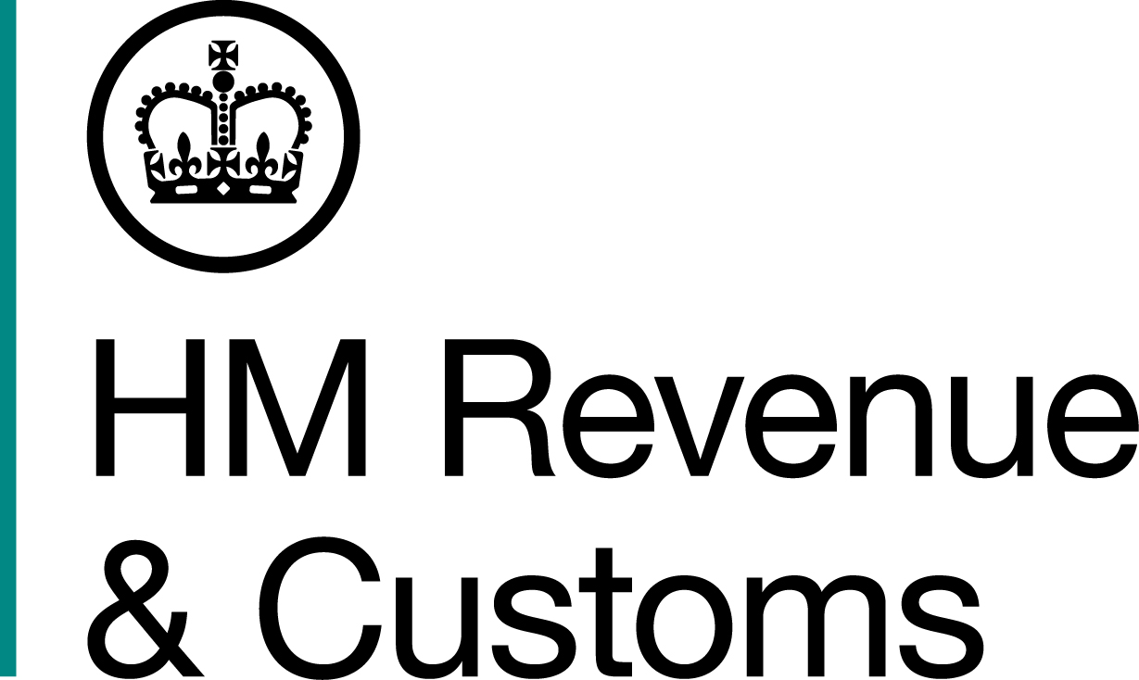
News Release

 | For the attention of News Desks |  | No of pages: 2
 | Date: | 27 November 2018 | Ref: | WA 4 20 18

HMRC writes to Welsh rates of Income Tax payers

HM Revenue and Customs (HMRC) has written to two million customers in Wales ahead of the introduction of the new Welsh Rates of Income Tax (WRIT) in April next year.

Income Tax will continue to be collected from pay and pensions through PAYE and Self Assessment in the same way it is now. But from 6 April, the Welsh Government will set its own Income Tax rates and WRIT taxpayers will receive a new tax code, starting with C for Cymru.

Angela MacDonald, Director General for HMRC Customer Services, said:

“We want to help people pay the right tax so we’re writing to customers to let them know that they’ll now be paying WRIT.

“Customers don’t need to do anything right now but should make sure to keep HMRC informed if their details change in the future.”

For more information on how to update your details online, please go to www.gov.uk/tell-hmrc-change-of-details.
Notes to Editors

- Welsh Rates of Income Tax will be implemented from 6 April 2019. People who pay Income Tax and have a main residence in Wales will need to pay the Welsh Rates of Income Tax regardless of where they work.
- For more information on the Welsh rates of Income tax go to https://www.gov.uk/welsh-income-tax
- All customers have received letters, including those who earn below the Income Tax Threshold or receive a pension.

- For more information about the Welsh Government’s draft budget and process for setting the rates visit https://gov.wales/funding/fiscal-reform/welsh-taxes/?lang=en
- Follow HMRC Press Office on Twitter @HMRCpressoffice.
- HMRC's Flickr channel: www.flickr.com/hmrcgovuk

Issued by HM Revenue & Customs Press Office

Press enquiries only please contact:

Stephen Cassidy
Tel: 03000 511593
Email: Stephen.cassidy@hmrc.gsi.gov.uk

Out of hours: Tel: 07860 359544
Website www.gov.uk/hmrc

