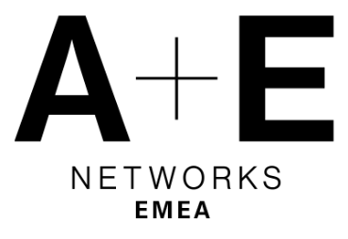

A+E NETWORKS EMEA APPOINTS MARIANNA KRITIKOS

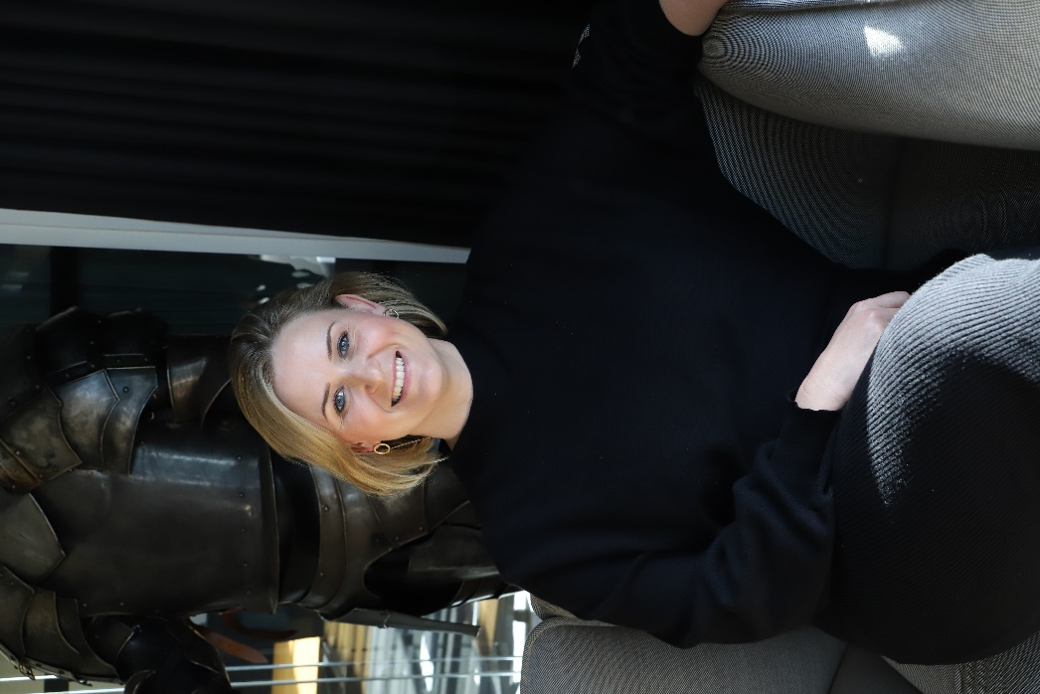
TO NEW VP COMMERCIAL ROLE

London, Tuesday 23rd of May: Marianna Kritikos has been appointed A+E Networks EMEA’s Vice President of Commercial Advertising and Partnerships. Following her strong performance and in-territory growth under her leadership, Marianna will also assume the role of Regional Director for Nordics & Benelux, where she will have responsibility for revenue growth in these regions.

Previously Director of On-Air Strategy (UK and International) and Director of Commercial Operations (Nordics and Benelux), Kritikos brings strategic, commercial, and operational leadership. She joined A+E Networks EMEA in 2013 and has previously held Sky and Time Warner roles.

Based in London and reporting to Adrian Pilkington, COO of EMEA and GM of Northern Europe, the Middle East, and Africa, Kritikos will lead A+E Networks EMEA’s London-based sales team, with a remit to drive digital and sponsorship and airtime revenues across its channel brands in the UK, Nordics, Benelux, Central and East Europe, Africa, and the Middle East.

On Kritikos’ new role, Pilkington commented: “Marianna has a wealth of commercial and operational experience and is an extremely successful and respected leader within our business. Her previous experience at Sky gives her a great understanding of our most important partnership. We’re excited to see her excel as our business evolves.”
Kritikos will manage relationships with A+E Networks EMEA sales houses across multiple territories, including Sky Media, RTL, and Viaplay. She will also take responsibility for pan-regional ad sales campaigns.

Upon being appointed, Marianna Kritikos said: “I’m excited to be taking on this new role at a time of growth for A+E Networks EMEA. I look forward to unlocking opportunities that innovate, build and drive adoption of new advertising solutions for partners.”

Kritikos begins her role effective immediately.

- ENDS -

For more information, please contact:
Joanna Fellows at A+E Networks EMEA | Joanna.Fellows@aenetworks.co.uk

A+E Networks EMEA
At A+E Networks EMEA, we share stories that matter everywhere, anywhere. A leader in factual entertainment, our compelling, award-winning content connects with millions across the UK, Nordics, Benelux, Germany, Italy, Spain, Central and Eastern Europe, the Middle East, and Africa. Our portfolio of premium brands – The HISTORY® Channel, Crime+Investigation®, BLAZE®, and COSMO - inspire and excite viewers with hit franchises (Forged in Fire), must-see dramas (Vikings), and original commissions (The Hunt for Baltic Gold and Ross Kemp: Shipwreck Treasure Hunters). For more information, visit www.aenetworks.tv.

