**PRESS RELEASE**

**Pan Pacific Singapore Attains 10,000 Guest Reviews on TripAdvisor®**

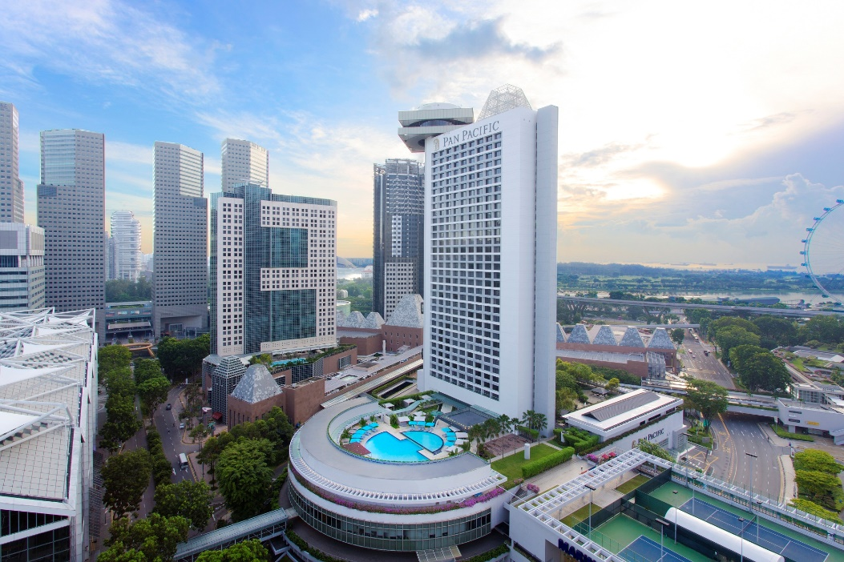

**Singapore, 19 August 2019** – Pan Pacific Singapore is proud to announce that it has reached its 10,000th guest review on TripAdvisor® - the world’s largest travel site. This comes after 15 years since the hotel was first listed on TripAdvisor®.

Dedicated to serving guests from around the globe with gracious and dependable hospitality, Pan Pacific Singapore is currently ranked 11th out of 340 Hotels in Singapore. It has been honoured with the TripAdvisor® Certificate of Excellence every year since 2012 and has earned its place in the TripAdvisor® Travellers’ Choice Award since 2013. Alongside its growing TripAdvisor® presence, Pan Pacific Singapore is also the proud winner of Forbes Travel Guide Four-Star Award 2019, making the list as one of only nine hotels in the Four-Star category and among the 12 hotels in the Four and Five-Star categories in Singapore. It is also placed in the fifth spot in Cvent Top Asia Pacific Meeting Hotels 2019 list.

Consistently garnering great reviews from travellers, the hotel has been described on TripAdvisor® as “phenomenal,” “impressive,” and “highly recommended.” The infographic below, produced with data generated by TripAdvisor®, will provide greater insights into the reviewers’ profiles and commonly enjoyed hotel services and amenities:

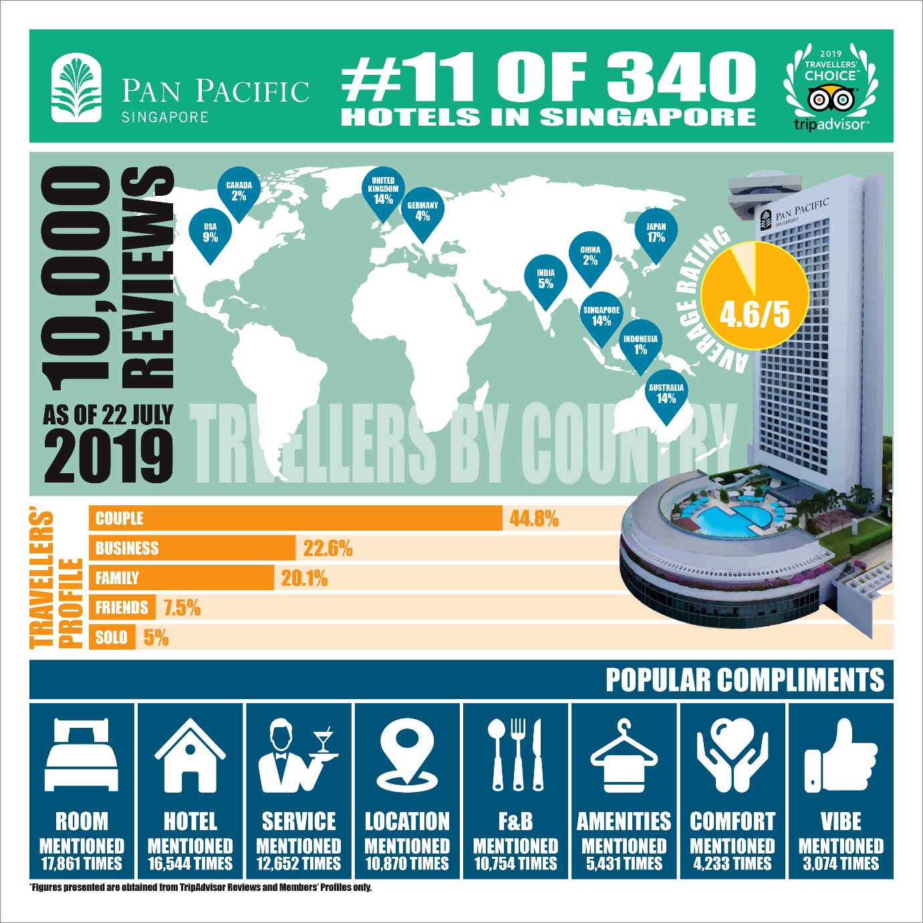

In celebration of this achievement, the hotel invited its guests to a poolside cocktail reception replete with sumptuous gourmet creations and fine champagne on 14 August 2019. Bright green TripAdvisor® balloons lined the walkway to the event venue where guests are greeted by a gigantic display of numeric gold foiled balloons forming the number “10,000”. Addressing the crowd, Mr. Kurt O. Wehinger, General Manager at Pan Pacific Singapore, took the opportunity to thank and recognise the effort and hard work of an incredibly dedicated group of associates who have been frequently highlighted for their extraordinary service on TripAdvisor®. The speech was followed by a cake cutting ceremony with a cake specially baked by the hotel’s in-house pastry team. Guests attending the cocktail session also stood a chance to win lucky draw prizes including a complimentary stay and dining vouchers that evening.

Thrilled to have written another chapter in the hotel’s legacy, Mr. Kurt O. Wehinger said, “Thank you to everyone who has shared their Pan Pacific Singapore experience with the world. Feedback is the number one barometer in measuring guest satisfaction and ranking among the most highly-rated hotels in Singapore reaffirms the hard work we put in every day to create memorable hotel experiences. Reading the incredible reviews have been absolutely humbling and motivating. It is no secret that we aspire to be the best in class and the overwhelming comments are what drives us to continue striving towards our goal.”

It seems only appropriate then to end with the 10,000th TripAdvisor review written by Kerri R. on 21 July 2019, which adds a great milestone to the hotel’s history:

“Extremely hospitable, friendly and polite welcome to the motel (sic). All of the staff go out of their way to assist you for a relaxing, comfortable and pleasant stay. Excellent view from my room. Fantastic service in the restaurants.”

High-resolution hotel images and infographic can be downloaded [here](https://www.dropbox.com/sh/acrp2e9xxzzjys9/AAD3GIsWVolrjCXK9-ZG8541a?dl=0).

**ENDS**

**Media Contact**

Janice Tan

Marketing Communications Manager

Pan Pacific Singapore

Email: [janice.tan@panpacific.com](mailto:janice.tan@panpacific.com)

Tel: +65 6826 8092

Annie Choy

Director of Marketing Communications

Pan Pacific Singapore

Email: [annie.choy@panpacific.com](mailto:annie.choy@panpacific.com)

Tel: +65 6826 8079

**About Pan Pacific Singapore**

Located in the heart of Marina Bay and with easy access to world-class shopping, Suntec Singapore International Convention and Exhibition Centre and the Central Business District, Pan Pacific Singapore offers 790 contemporary rooms and suites that are ideal for business or leisure. Savour epicurean delights at our award-winning restaurants and bars or rejuvenate at our swimming pool and spa. Pan Pacific Singapore is proud to be named Asia’s Leading Business Hotel by the World Travel Awards from 2006 to 2012, World’s Leading Business Hotel by the World Travel Awards from 2007 to 2010 and 2012, and World’s Leading City Hotel by the World Travel Awards in 2011. The hotel was also recently named a “Four-Star Hotel” by Forbes Travel Guide 2019 and Top 25 Hotels in Singapore in Tripadvisor’s 2019 Traveller’s Choice Awards.

**About Pan Pacific Hotels and Resorts**

With hotels, resorts and serviced suites across Asia, Oceania and North America, Pan Pacific provides a safe harbour in an ever-changing world. Places with less worry about because, when you stay with us, rest assured that all will be taken care of. For this is where you will find your balance.

**About Pan Pacific Hotels Group**

Pan Pacific Hotels Group is a wholly-owned hotel subsidiary of Singapore-listed UOL Group Limited, one of Asia’s most established hotel and property companies with an outstanding portfolio of investment and development properties.

Based in Singapore, Pan Pacific Hotels Group owns and/or manages more than 40 hotels, resorts and serviced suites including those under development across 24 cities in Asia, Oceania, North America and Europe.

Voted “Best Regional Hotel Chain” by readers in Asia in 2017 and 2018, Pan Pacific Hotels Group comprises two acclaimed brands: its signature brand, Pan Pacific and its deluxe brand, PARKROYAL.

Sincerity is the hallmark of Pan Pacific Hotels Group. The Group is known to its guests, partners, associates and owners for its sincerity in people and the sense of confidence which alleviates the stresses of today’s complex world.