

News Release January 25rd, 2019
Yanmar Co., Ltd.

Yanmar Establishes New Industrial Engine Plant in India

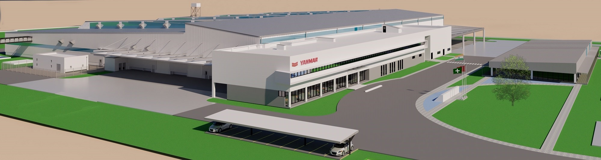
The new manufacturing facility will produce industrial diesel engines

Chennai, India (January 25, 2019) – Yanmar has announced plans to establish a manufacturing plant in Chennai, India to produce industrial diesel engines. Yanmar Engine Manufacturing India Pvt. Ltd. will operate the plant from its expected commencement in 2020.

Located at the ORIGINS industrial park in north Chennai, the plant will manufacture industrial diesel engines with annual production capacity of 80 thousand units.
“With today’s announcement of this, our first manufacturing facility in India, Yanmar has taken its investment in the country to the next level and demonstrated our long-term commitment to the sub-continent,” said Yanmar Engine Manufacturing India Project Head, Hajime Hirai. “We expect that this plant will fuel Yanmar’s future growth and directly contribute up to 400 quality jobs to the community.”

The choice of site reflects the high skill levels of the Chennai workforce, a developed component supply chain and robust infrastructure including port and rail facilities.
“This new facility will manufacture high quality engines utilizing the latest Japanese production technologies,” said Yanmar Engine Manufacturing Director, Varun Khanna. “These quality engines will allow us meet the growing demand of Indian and overseas markets.”

At a glance:
Company | Yanmar Engine Manufacturing India Pvt. Ltd.
Location | ORIGINS industrial park
Plant capacity | 80,000 units at full capacity
Production start | 2020

[About Yanmar]
With beginnings in Osaka, Japan, in 1912, Yanmar was the first to succeed in making a compact diesel engine of a practical size in 1933. Then, with industrial diesel engines as the cornerstone of its enterprise, Yanmar has continued to expand its product range, services, and expertise to deliver total solutions as an industrial equipment manufacturer. As a provider of small and large engines, agricultural machinery and facilities, construction equipment, energy systems, marine equipment, machine tools, and components, Yanmar’s global business operations span seven domains.

Note: Information contained in the news release is valid at the time of publication and may differ from the most recently available information.

【Inquiries】
Public Relations Group,
Brand Communication Division
Yanmar Co., Ltd.
E-mail: newsroom@yanmar.com

