Pressinformation
More variety: the hansgrohe Metropol line provides the most comprehensive range of mixers
A Distinctive Style for Premium Bathroom Design
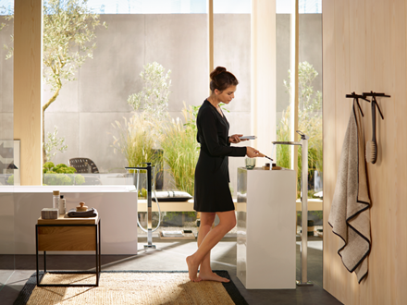
hansgroheMetropol_People01
Copyright: hansgrohe / Hansgrohe SE
The mixers of the new Metropol collection merge geometric precision with distinctive design.

Stockholm, April 2018. The new hansgrohe Metropol range of mixers makes a striking appearance with its consistently geometric design language. In collaboration with its partner of many years, Phoenix Design, the brand hansgrohe has developed its most comprehensive range of mixers to date; it not only features a choice of three types of handles, but is also the first range to include a floor-standing washbasin mixer for use with free-standing washbasins. Striking design is the distinctive and defining feature of the new Metropol mixers: precise geometric contours, spheres and rectangles blend with expansive surfaces, casting delicate reflections of light. The cubic shape of the base conveys an elegant modernist aesthetic. Handle and spout harmoniously complement each other thanks to their parallel alignment. The mixers are Type Approved in Sweden and ready for sale.
ComfortZone for greater freedom of movement
The basin mixers come in four different tap heights, providing space for individual needs, whether for washing hands, shaving or filling receptacles. Moreover, the hansgrohe Metropol 100 basin mixer is available in two versions; with either a 160 or 190 millimetre spout length for a variety of uses at the washbasin. Models with a high swivel spout, for example, are perfect for washing hair. With an overall height of 120 centimetres, the new floor-standing Metropol basin mixer is not only a visually striking highlight in the bathroom, but can also be easily positioned, making it a flexible complement to free-standing washbasins. For a stylish overall ambience, the comprehensive Metropol range also includes shower and bathtub mixers for exposed or concealed installation. A floor-standing model is a fitting and attractive solution for free-standing bathtubs.
A variety of handles and control options
With the Allegroh range, hansgrohe was the first to launch the loop handle in the 1980s. For the Metropol mixers, the designers introduced a new take on the success story. In addition to mixers with a flat lever handle, hansgrohe offers customers a choice of models with a slender loop handle. A third version is the mixer handle with integrated Select technology. It combines minimalist design with the intuitively easy Select control: the flow of water can be turned on and off at the simple touch of a button. If you have soapy hands, for instance, you can press the button using the back of your hand or your lower arm and your mixer stays dry and clean. The technology is purely mechanical and works by means of a specially designed cartridge. This added convenience requires neither electricity nor additional devices in the base cabinet. Water temperature is selected by turning the handle.

hansgrohe är premiummärket för duschar, duschsystem, badrum och kökskranar i den internationella Hansgrohe Group. Med prisbelönta produkter formar hansgrohe vattnet i köket och badrummet. Här använder människor tid som är särskilt viktigt för dem - och upplever betydelsefulla ögonblick med vatten. hansgrohe utvecklar framtida lösningar till dessa förnöjsamma stunder, som kombinerar utmärkt design, kvalitet, hållbarhet och intelligenta funktioner för bästa komfort. hansgrohe gör vatten till en fantastisk upplevelse.
hansgrohe. Meet the beauty of water.
 |  | Läs mer om märket hansgrohe på:  www.facebook.com/hansgrohe www.twitter.com/hansgrohe_pr

 | Sanitetsbranchens designfrämste  I den aktuella Rankingen från det Internationale Forum Design (iF) av de bästa verksamheter i världen när det handlar om design, ligger Hansgrohe SE på en 6:e plats av ca 2000 verksamheter. Med 1040 poäng mer än andra verksamheter är armatur- och duschspecialisten från Schiltach före verksamheter som Audi, BMW och Apple och toppar ännu en gång design-hitlistan för sanitetsbranschen.  www.hansgrohe.se/design

Ytterligare information: | Hansgrohe AB  Tlf. 031-21 66 00  info@hansgrohe.se  www.hansgrohe.se

Picture Overview
hansgrohe Metropol
Copyright all images: hansgrohe / Hansgrohe SE
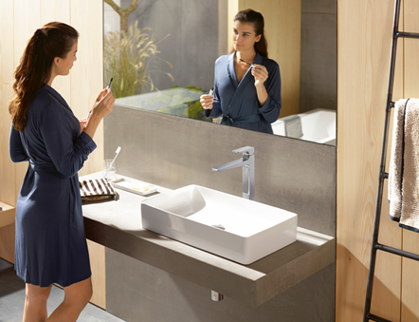 | 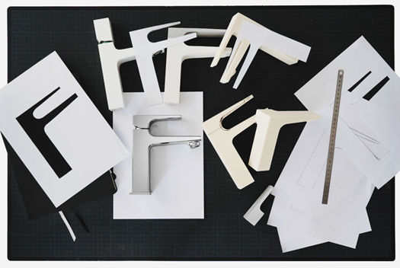
hansgroheMetropol_People02 | hansgroheMetropol_Design
In addition to mixers with a flat lever handle, hansgrohe offers customers a choice of models with a slender loop handle. The new hansgrohe Metropol range of mixers makes a striking appearance with its consistently geometric design language. In collaboration with its partner of many years, Phoenix Design, the brand hansgrohe has developed its most comprehensive range of mixers to date.

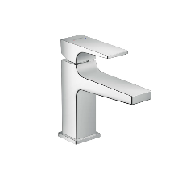 | 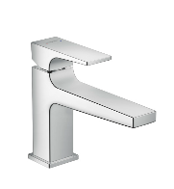 | 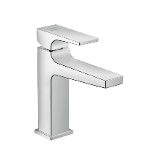 | 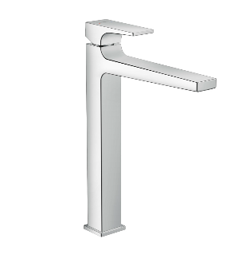
hansgroheMetropol_  Washbasin100 | hansgroheMetropol_  Washbasin100long | hansgroheMetropol_  Washbasin110 | hansgroheMetropol_  Washbasin260

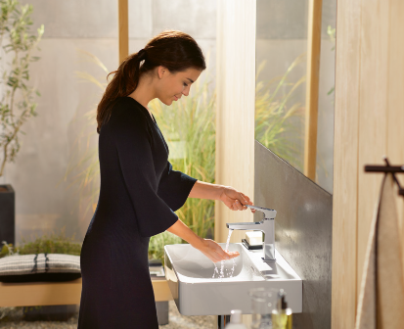 | 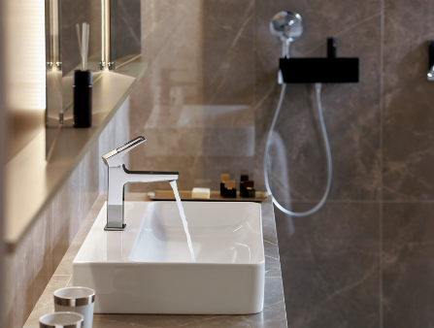
hansgroheMetropol_People03 | hansgroheMetropol_AmbienceHotel01

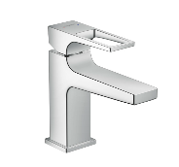 | 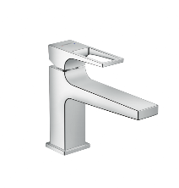 | 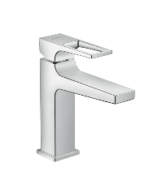 | 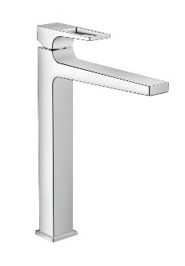
hansgroheMetropol_  WashbasinLever100 | hansgroheMetropol_  WashbasinLever100long | hansgroheMetropol_  WashbasinLever110 | hansgroheMetropol_  WashbasinLever260

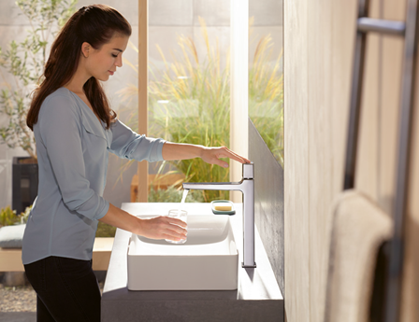 | 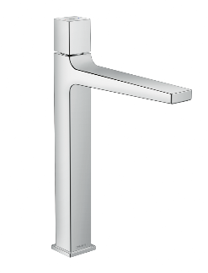 | 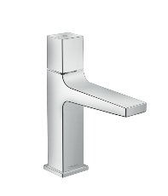
hansgroheMetropol_People04 | hansgroheMetropolSelect_Washbasin260 | hansgroheMetropolSelect_Washbasin110
Another version is the mixer handle with integrated Select technology. It combines minimalist design with the intuitively easy Select control: the flow of water can be turned on and off at the simple touch of a button. If you have soapy hands, for instance, you can press the button using the back of your hand or your lower arm and your mixer stays dry and clean.

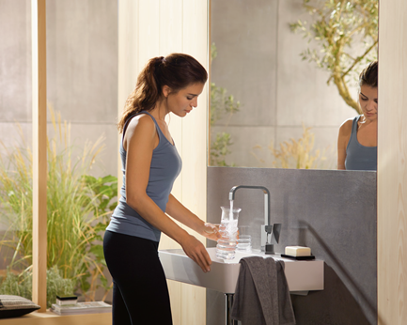 | 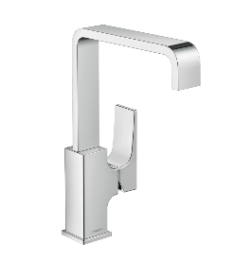 | 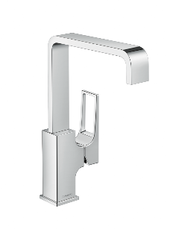
hansgroheMetropol_People05 | hansgroheMetropol_SwivelSpout | hansgroheMetropol_SwivelSpoutLever
Models with a high swivel spout are perfect for washing hair or filling high vases, for example.

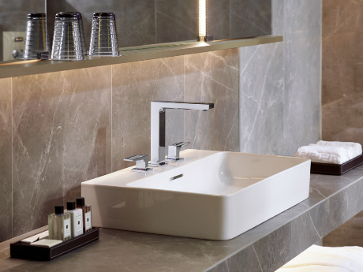 | 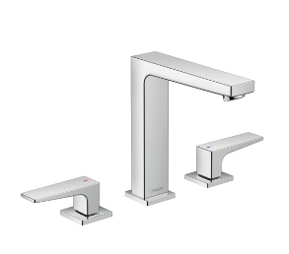 | 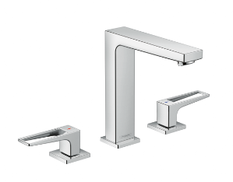
hansgroheMetropol_  AmbienceHotel02 | hansgroheMetropol_  ThreeHole160 | hansgroheMetropol_  ThreeHole160Lever
The hansgrohe Metropol three-hole washbasin mixer is an elegant solution available in two versions with either a 160 or 190 millimetre spout length, both available with a flat or a loop handle.

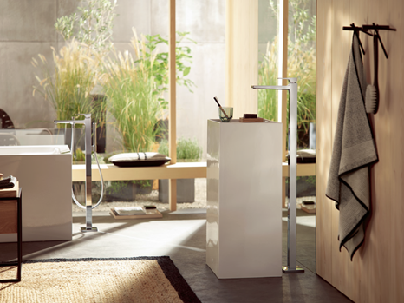 | 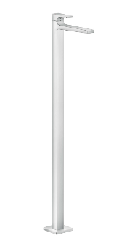
hansgroheMetropol_AmbienceLiving01 | hansgroheMetropol_WashbasinMixerFloor
With an overall height of 120 centimetres, the new floor-standing Metropol basin mixer is not only a visually striking highlight in the bathroom, but can also be easily positioned, making it a flexible complement to free-standing washbasins.

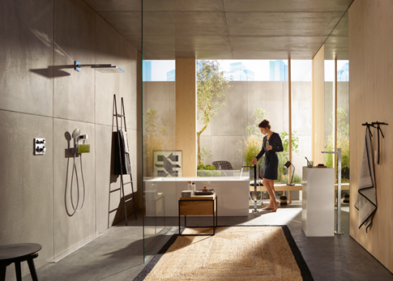
hansgroheMetropol_AmbienceLiving01

Picture link: http://www.mynewsdesk.com/se/hansgrohe
Copyright: We must draw your attention to the fact that we have only limited usage rights for the images provided, all further rights however belong to the respective photographers. These images may therefore only be published free of charge if they clearly and expressly serve to portray or advertise the performances, products or projects of Hansgrohe SE and/or its brands (AXOR, hansgrohe). Any other form of publication requires the approval of the respective copyright owner and remuneration must be made in agreement with said copyright owner.

