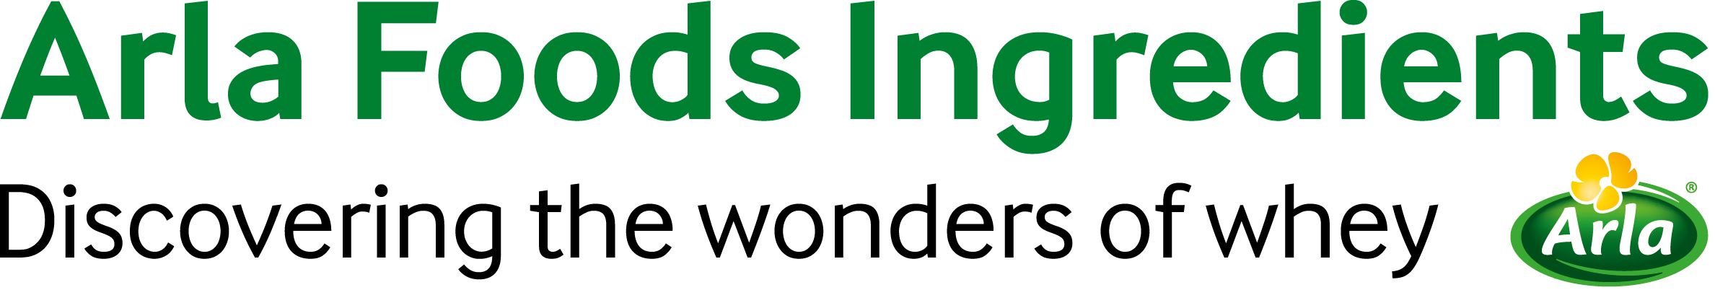
2 August 2017
PRESS RELEASE
New Pure Dairy campaign raises the bar
for dairy ingredients

Arla Foods Ingredients has launched a new campaign called ‘Pure Dairy’ to highlight how its range of Nutrilac® dairy ingredients satisfies growing consumer demand for natural products with ultra-clean labels.

Research shows that more than one third of shoppers in the EU (35%) are proactively avoiding food and drink products that contain artificial additives or preservatives, while the same proportion say they regularly check the ingredients list on pack. Furthermore, 34% of EU consumers say they would never buy food that contains genetically modified ingredients.

In the UK, meanwhile, Mintel research has found more than 70% of consumers are interested in avoiding foods with E-numbers, while over 80% of US consumers are seeking more natural foods. Among consumers in France, Italy, Spain and Poland, almost 30% prefer to buy dairy drinks that are non-GMO.

The new Pure Dairy campaign underlines how Arla Foods Ingredients’ portfolio of natural solutions for dairy products are made from whey proteins extracted from milk that is produced by grass-fed cows, hormone-free, non-GMO and free of antibiotic and pesticide traces.

To illustrate how processors and brands can tap into Pure Dairy, Arla Foods Ingredients has created a new high-protein drinking yoghurt concept product that contains just five ingredients – Nutrilac® YO-8075, sugar, cream, skimmed milk and fruit preparation. Total protein content is 9.5%, with just 95 calories per 100g and only 1.37% fat. The drink is the perfect template for formulating Pure Dairy products that will resonate with consumers.

Torben Jensen, Senior Category Manager for Fresh Dairy Products at Arla Foods Ingredients, said: “Many consumers today look twice when choosing which dairy products to buy from the local store. While yoghurts, cheese and dairy desserts are still seen as naturally healthy, they may contain additives or other components that people want to avoid.
Our Pure Dairy campaign highlights that our dairy ingredients address all of the concerns that shoppers have. So if you’re a dairy manufacturer looking to hold consumer attention, a squeaky-clean label with all-natural ingredients is the way to go.”

Arla Foods Ingredients’ Nutrilac® solutions for dairy products deliver multiple functionalities, including customised texture, creaminess, stability and in some cases higher yield, all without the need for non-dairy additives. They offer reduced syneresis, a mild and clean taste, and a pleasant and easily drinkable viscosity. They are suitable for use in applications such as drinking and stirred yoghurts, cream and cottage cheeses, low-fat traditional cheese, and quark desserts.

ENDS

For more information, please contact:
Steve Harman, Ingredient Communications
Tel: +44 (0)7494 307911| Email: steve@ingredientcommunications.com

About Arla Foods Ingredients
Arla Foods Ingredients is a global leader in value-added whey solutions. We discover and deliver ingredients derived from whey, supporting the food industry with the development and efficient processing of more natural, functional and nutritious foods. We serve global markets within early life nutrition, medical nutrition, sport nutrition, health foods and other foods and beverage products.

Five reasons to choose us:
- We have R&D in our DNA
- We offer superior quality
- We are your trusted business partner
- We support sustainability
- We ensure security of supply

Arla Foods Ingredients is a 100% owned subsidiary of Arla Foods. Our head office is in Denmark.

RSS Feed
Visit our website at http://www.mynewsdesk.com/arla-foods-ingredients and sign up to our News RSS feed for all the latest developments – updated regularly.

Twitter
Follow us on twitter for all the latest updates @ArlaIngredients

LinkedIn
http://www.linkedin.com/company/arla-foods-ingredients

Facebook
https://www.facebook.com/arlaingredients

Mintel consumer survey, Consumer Attitudes towards Free-From Products, 2015-2017

