PRADA og LG præsenterer eksklusivt samarbejde
– Resultatet af samarbejdet bliver en tredje PRADA-telefon fra LG - en elegant, klassisk og stilren telefon lanceres i løbet af 2012.

I dag fornyede PRADA og LG sit eksklusive partnerskab inden for smartphones. Partnerskabet bygger på det fremgangsrige samarbejde fra tidligere, og sammen har de to virksomheder nu udviklet PRADA phone by LG 3.0, en smartphone, der lanceres i begyndelsen af 2012. Samarbejdet mellem LG og PRADA blev indledt i 2006 og har siden resulteret i to premium-mobiler, der blev introduceret i henholdsvis 2007 og 2008. PRADA Phone by LG 1.0 var verdens første mobiltelefon med Touch Screen og 2.0 gav en innovativ mobiloplevelse gennem en unik Link-teknik, som gjorde det muligt at se indgående opkald, SMS, samtalehistorik med mere.

Mere information om PRADA Phone by LG 3.0 afsløres den 15. december.

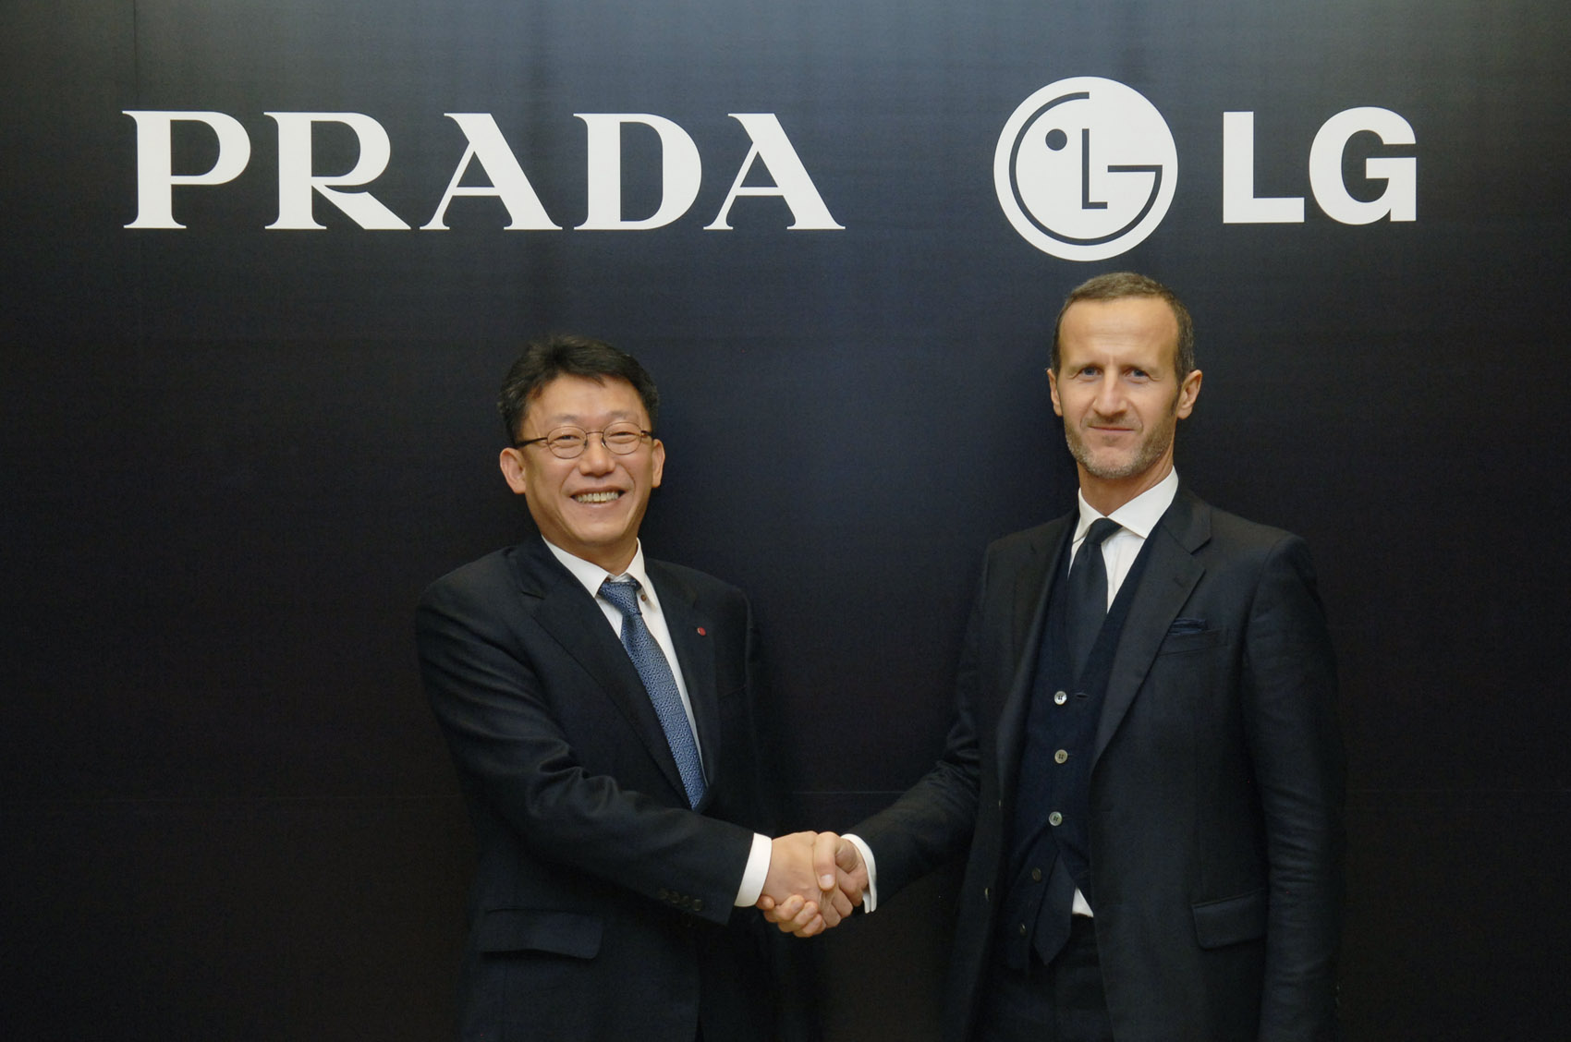
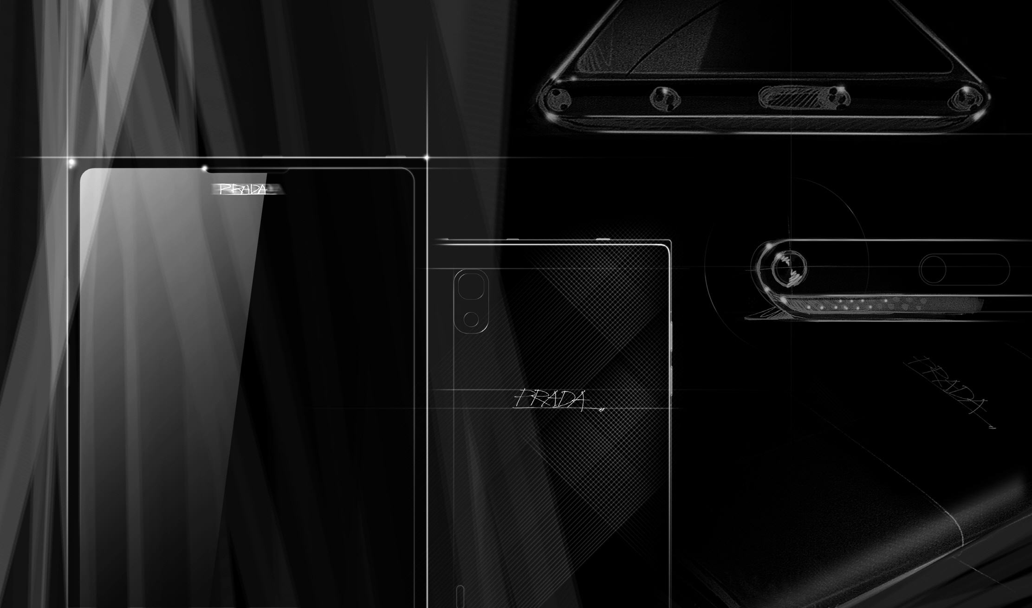

For mere information, se den fulde pressemeddelelse på engelsk nedenfor.

For billeder følg venligst links:
http://www.mynewsdesk.com/se/pressroom/lg_electronics_nordic_ab__/image/view/teaser-image-of-prada-phone-by-lg-3-0-103511
http://www.mynewsdesk.com/se/pressroom/lg_electronics_nordic_ab__/image/view/prada-and-lg-sign-exclusive-agreement-103510

For yderligere information, kontakt venligst:

Susanne Persson
PR Manager
LG Electronics Nordic AB
Box 83, SE-164 94 Kista, Sverige
Tlf: +46 (0)8 566 415 23
Mobil: +46 (0)709 694 606
E-mail: susanne.persson@lge.com

PRADA AND LG SIGN EXCLUSIVE
AGREEMENT CEMENTING PARTNERSHIP

PRADA Phone by LG 3.0 to be launched in 2012

SEOUL, Nov. 24, 2011 – PRADA and LG Electronics (LG) today renewed their exclusive mobile phone partnership at a signing ceremony in Seoul, Korea. Building on this partnership’s previous success, the two companies will develop the PRADA phone by LG 3.0, for launch in early 2012.

Under this partnership, LG will be PRADA’s exclusive mobile phone partner. The collaboration, which began in 2006 and resulted in two premium phones being introduced in 2007 and 2008, focuses on key elements within the smartphone, including software and user interface down to its design and packaging.

“The partnership between Prada and LG has always been characterised by an innovative approach and uncompromised quality of style, design and breakthrough technology,” said Mr. Patrizio Bertelli, CEO of PRADA Group. “These values are common to both our brands, which have always anticipated, and often set, the trends in many fields. We were therefore delighted to cooperate again with LG in the development of the latest creation of the mobile communication industry.”

“Our working relationship with PRADA is unique in its longevity and success, something no other phone company and fashion brand have been able to replicate,” said Dr. Jong-seok Park, President and CEO of LG Electronics Mobile Communications Company. “Having successfully launched two PRADA phones by LG, we look forward to collaborating further to develop premium handsets representing the most sophisticated style.”

The PRADA phone by LG 1.0, a pioneer in the fashion-house mobile phone space, was an unqualified success, selling over one million units. This premium handset combined high-end technology with a design embodying superior style. As evidence of its place in design history, the PRADA phone by LG 1.0 is part of the permanent collection in New York City’s Museum of Modern Art (MoMA) and the Museum of Contemporary Art (MOCA) in Shanghai.

The PRADA phones by LG were revolutionary in the technology they offered to users. The PRADA phone by LG 1.0 was the world’s first touchscreen mobile phone, and the 2.0 provided an innovative mobile experience through its unique watch with Link technology, which allowed for easy access to caller ID, SMS text messages, call history, call block and two-way alarm notification.

# # #

About PRADA
PRADA S.p.A. – HKSE stock code 1913 - is one of the world’s leaders in the luxury goods sector, operating actively with the Prada, Miu Miu, Church’s and Car Shoe brands to produce and market high-quality handbags, leather goods, footwear, clothing and accessories. Furthermore, the Group operates in the eyewear and fragrances sectors on the basis of license agreements. Its products are distributed in more than 70 countries around the world through 345 directly operated stores (DOS) as of 31 July 2011 and a network of selected luxury department stores, multi-brand stores and franchisees.

About LG Electronics, Inc.
LG Electronics, Inc. (KSE: 066570.KS) is a global leader and technology innovator in consumer electronics, mobile communications and home appliances, employing more than 93,000 people working in over 120 operations around the world. With 2010 global sales of KRW 55.8 trillion (USD 48.2 billion), LG comprises four business units – Home Entertainment, Mobile Communications, Home Appliance, and Air Conditioning & Energy Solutions. LG is one of the world’s leading producers of flat panel TVs, mobile devices, air conditioners, washing machines and refrigerators. LG has signed a long-term agreement to become both a Global Partner and a Technology Partner of Formula 1™. As part of this top-level association, LG acquires exclusive designations and marketing rights as the official consumer electronics, mobile phone and data processor of this global sporting event. For more information, please visit www.LGnewsroom.com.

About LG Electronics Mobile Communications Company
The LG Electronics Mobile Communications Company is a leading global mobile communications and information company. With its cutting-edge technology and innovative design capabilities, LG creates handsets that provide an optimized mobile experience to customers around the world. LG is pursuing convergence technology and mobile computing products, while continuing its leadership role in mobile communication with stylish designs and smart technology. For more information, please visit www.lg.com.

