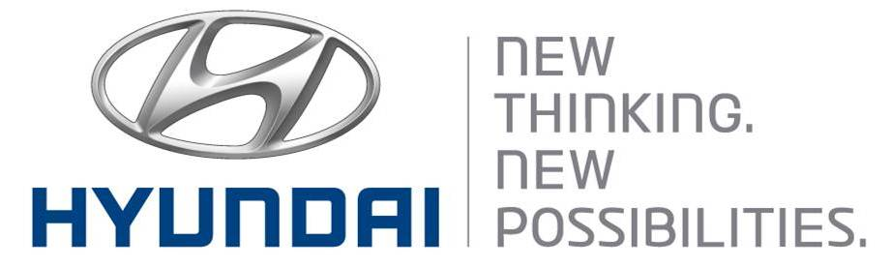  May 12, 2011  Embargoed until 03:00 p.m. CET  (10:00 p.m. Seoul Time) on May 12 | Media Release  For further information contact the  Global Public Relations Team  Tel: +82+2—3464-2153 ~ 60  Fax: +82+2—3464-3497  globalpr@hyundai.com

Hyundai Holds FCEV Test Drive in Northern Europe

- Mayors of Nordic capital cities experience Hyundai’s advanced FCEV technologies
- Hyundai signs MOU with the city of Copenhagen and H2 Logic
- Hyundai’s ix35 FCEV boasts same convenience as traditional ICE

Hyundai Motor Company offered the mayors of four Nordic cities an opportunity to test drive its Fuel Cell Electric Vehicles (FCEVs), to experience the automaker’s most advanced eco-friendly technologies.

Hyundai provided two units of its latest ix35 FCEV for the test drive, which was held at the City Hall of Copenhagen, Denmark, on May 12. The test drive was attended by mayors of the capital cities of Norway, Sweden, Denmark and Iceland. After the event, H2 Logic A/S, a leading developer of hydrogen & fuel cell technology in Denmark, and the City of Copenhagen, plan to operate test drives of the vehicles at selected public events in Northern European cities.

“Today’s test drive of our eco-friendly vehicles in Copenhagen is all the more meaningful since the City of Copenhagen is dedicated to achieving zero emissions in transportation,” said Vice Chairman Woong-Chul Yang, head of Hyundai’s R&D Center. “The MOU signed with the City of Copenhagen and H2 Logic will lay the foundation to commercialize Fuel Cell Electric Vehicles in Europe.”

The test drive demonstrated Hyundai’s advanced eco-friendly technology and provided further momentum to its leading role in the European FCEV market. Before the test drive, the hydrogen-powered SUV traveled 340 km on a single refueling, the first for an electric car, from the city of Holstebro in West Denmark to Copenhagen in the East.

The ix35 FCEV, which emits only water vapor, boasts the same convenience as today’s vehicles powered by traditional internal combustion engines by offering a driving range comparable to gasoline on a single refueling, as well as a maximum speed of 160 km/h and zero-to-100km/h time of 12.8 seconds.

Prior to the test drive, Hyundai Motor Group signed a memorandum of understanding (MOU) with the City of Copenhagen, H2 Logic and Hydrogen Link, an association working to advance the use of electricity for transportation, based on hydrogen and fuel cells in Denmark. The agreement aims to cooperate on establishing the related infrastructure for FCEVs and on supplying vehicles.

The Danish government is making all-out efforts to promote the use of green cars by exempting registration tax for environmentally friendly vehicles, which amounts to 180 percent of the price for vehicles with internal combustion engines.

“The MOU signing with Hyundai Motor Group and the test driving in the Nordic countries is an opportune moment for us to have our fast 70MPa hydrogen refueling technology tested an validated by car manufacturers” commented Mr. Jacob Krogsgaard, director of H2 Logic. “Also the potential future availability of fuel cell vehicles from Hyundai in Northern European countries provides a strong basis for hydrogen refueling infrastructure deployment.”

This January, Hyundai Motor Group signed an MOU with four Northern European countries to operate a test fleet of FCEVs. In February, it signed an MOU with the Clean Energy Partnership (CEP) in Germany to help promote FCEVs and showcase the company’s competitiveness in eco-friendly vehicles.

Established in 1967, Hyundai Motor Co. has grown into the Hyundai Motor Group which has ranked as the world’s fifth-largest automaker since 2007 and includes more than two dozen auto-related subsidiaries and affiliates. Hyundai Motor, which has six manufacturing bases outside of South Korea, sold approximately 3.6 million vehicles globally in 2010. Hyundai vehicles are sold in 186 countries through some 5,300 dealerships and showrooms. Further information about Hyundai Motor and its products is available at www.hyundai.com.

