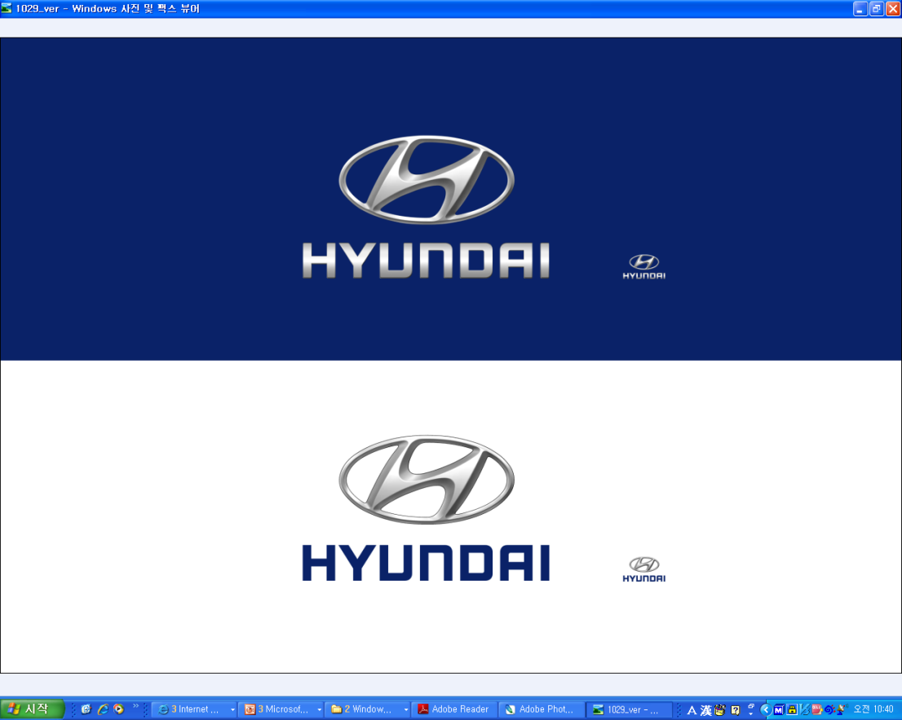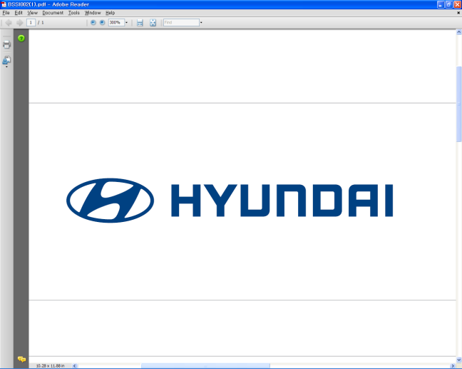  Apr. 26, 2012 | Media Release  For further information contact the  Global Public Relations Team  Tel: +82+2—3464-2153 ~ 60  Fax: +82+2—3464-3497  globalpr@hyundai.com

Hyundai Announces 2012 First Quarter Earnings

- Hyundai sells 1,072,679 units worldwide in the first quarter
- Sales revenue and net profit stand at 20.2 trillion won and 2.5 trillion won
- Continuous efforts of ‘value-pricing’ lead higher profitability

Hyundai Motor Company, South Korea’s largest automaker, sold 1,072,679 units (domestic: 154,800 / overseas: 917,879) worldwide in the first quarter of 2012, up 16.7 percent from the same period a year earlier, to continue its upward sales momentum.

In spite of global business uncertainties, Hyundai Motor’s continuing efforts in "value-pricing" -- or raising car prices to match their value -- paid off to result in increasing profitability.

While Hyundai Motor’s net profit rose 30.6 percent to 2.45 trillion won (including non-controlling interest) in the first quarter, compared to a year earlier, its operating profit jumped 24.9 percent to 2.28 trillion won. Due to a rise in sales volume and improved product mix, sales revenues increased 10.6 percent to 20.16 trillion won, as well. (Auto business: 17.25 trillion won / Finance and others: 2.92 trillion won)

In the Korean domestic market, sales were down by 7.1 percent to 154,800 units because of dropping consumer confidence caused by recent economic difficulties. In contrast, in overseas markets, Hyundai Motor’s sales increased 22.0 percent to 917,879 units. (export: 328,771 / overseas plants: 589,108)

Hyundai’s brand value is significantly enhanced through its persistent quality management, which also drives sales volumes.

As a result of qualitative growth based on enhanced brand awareness, Hyundai scored at an all-time high in the 2012 Vehicle Dependability Study, conducted by J.D. Power and Associates. Enhanced brand value led to significant jumps in both sales and profit, especially in the overseas markets.

Hyundai Motor expects the auto industry to remain uncertain throughout the remainder of 2012. Although the U.S. market shows signs of recovery, the European markets still face the potential of economic crisis.

In the emerging markets, competition will increase to win slowing demand in China and India. Stronger governmental policies to protect the local auto industry are expected in Brazil and Russia, as well.

Under such tough circumstances, Hyundai Motor will continue to seek qualitative growth, focusing on better profitability, rather than hasty sales volume expansion.

In addition to selling Elantra (Avante) and Sonata in the global market, Hyundai will reinforce sales of local strategic models -- such as i30 in Europe, Solaris in Russia and Eon and i10 in India -- to raise brand awareness in the global market.

Hyundai Motor will increase capacity in emerging markets with the completion of a third plant in China and a plant in Brazil -- its seventh plant outside of Korea -- in the second half of this year.

About Hyundai Motor

Established in 1967, Hyundai Motor Co. has grown into the Hyundai Motor Group, with more than two dozen auto-related subsidiaries and affiliates. Hyundai Motor -- which has six manufacturing bases outside of South Korea including the U.S., China, India, Russia, Turkey and the Czech Republic -- sold 4.06 million vehicles globally in 2011. Hyundai Motor, which employs over 80,000 worldwide, offers a full line-up of products including small to large passenger vehicles, SUVs and commercial vehicles. Further information about Hyundai Motor and its products is available at www.hyundai.com.

