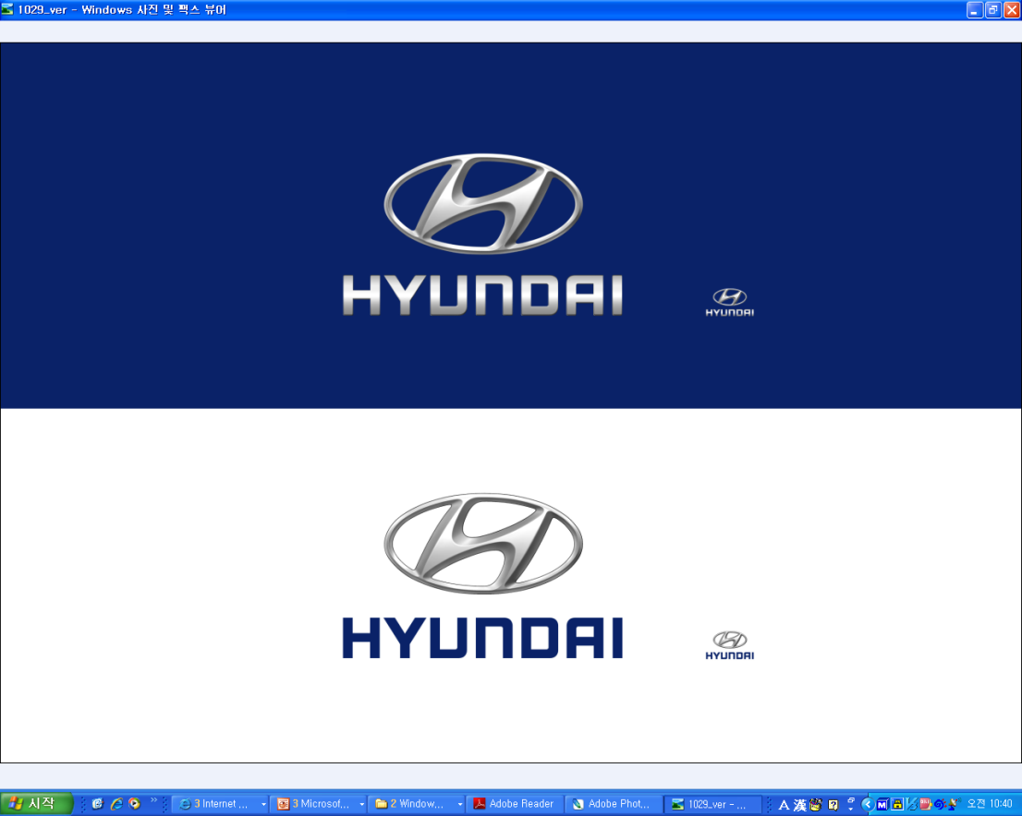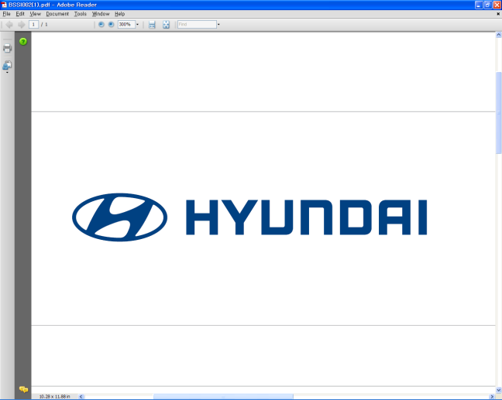  Jan. 5, 2011 | Media Release  For further information contact the  Global Public Relations Team  Tel: +82+2—3464-2153 ~ 60  Fax: +82+2—3464-3497  globalpr@hyundai.com

Hyundai Introduces Blue Link®,
Future In-Vehicle Technologies at 2011 CES
- Offers voice-activated distraction-free Web browsing, texting, e-mailing
- ‘Eco-Coach’ tracks driver’s performance, urges greener operation;
roadside assistance, vehicle recovery featured
- Hyundai displays advanced Web, safety, touch-feedback concepts

Hyundai Motor Company, South Korea’s largest automaker, introduced its new global telematics brand Blue Link® and other independently developed in-vehicle technologies at the 2011 Consumer Electronics Show (CES), presenting its advanced vehicle information technology systems to the world.

Blue Link®, which makes its world debut in the U.S. market, is a telematics system unique to Hyundai models that offer consumers seamless connection between the office, home, smart phone and automobile with fast and reliable IT technology. Drivers increasingly want to stay in touch with the world around them and Blue Link delivers, with safe, distraction-free features. As consumers shift their lifestyles, Hyundai will concentrate on providing more services focused on customers instead of vehicles.
In addition to turn-by-turn navigation ability, a restaurant finder and more than 30 other features, Blue Link will let Hyundai owners start their car remotely, will call emergency services if the driver cannot, will share vehicle location on social-network sites and will let drivers browse the Web, text and e-mail in a non-distracting manner. Blue Link will even let parents monitor how far and how fast their teens are driving when they borrow the Hyundai.

“Automobiles are evolving rapidly, equipped with not only the latest powertrain technologies, but with advanced electronics, IT and software to satisfy drivers’ emotional needs,” said Woong-Chul Yang, President at Hyundai Motor’s R&D Center. “Hyundai will focus on securing state-of-the-art IT and automobile convergence technologies to become an industry leader.”

Blue Link will be available in the U.S. starting with the Sonata and Veloster three-door utility coupe later this year and will gradually be offered in other regions.

The 2011 CES, held at the Las Vegas Convention Center from January 6~9, is known as the world's largest consumer technology trade show. Thousands of leading IT, electronics and related companies showcase their cutting-edge technologies. Hyundai Motor is one of only four automakers to participate in this year’s show.

At Hyundai’s booth, the company displayed its all-new Sonata Hybrid equipped with Blue Link®, as well as its concept car Nuvis (HCD 11), giving visitors a sneak preview of Hyundai’s next-generation technology and car designs.

Hyundai also displayed six concept in-car technologies: The Smart Connectivity System, which allows drivers to connect their smart phones and tablet PCs with the vehicle; the Motion Sensor Moustick, which recognizes the driver’s hand movements through sensors to control the car’s audio and navigation system; Intelligent Haptic System, a control system inspired by popular consumer technology; Dynamic Cluster, an LCD gauge and information system that is driver-customizable; Car Browser System and Web Platform, a fully functional Internet terminal; and Multifunctional Safety Vision System, a four-camera, 360-degree view around the vehicle.

Many of these technologies were developed at the Automotive IT Innovation Center (AIIC), which was established near Seoul in 2008 by the Hyundai Motor Group, Microsoft Corp. and Korea’s National IT Technology Promotion Agency (NIPA) to develop IT products and services for automotive application.

Hyundai plans to strengthen its research and development in automotive IT technology through cooperative organizations such as the AIIC to raise its future brand competitiveness.

<Reference Material>
1. Smart Connectivity System
Bridges the gap between your mobile technology and vehicle technology

The ‘Smart Connectivity System’ uses a Wi-Fi function in a vehicle and mobile communication network for sharing and for real-time synchronization of content between mobile devices, such as smart phones and tablet PCs, and a vehicle.

In addition to simply connecting and playing back content, this system improves information sharing and connectivity between external devices and a vehicle to allow users to utilize information more easily and conveniently.

Major Features:
- A widget that displays information on weather, news, stock market and planning in real time
- Real-time synchronization of personal information and images between a smart phone and vehicle via wireless LAN
- SNS (Social Networking Service) linked with Twitter for real-time uploading of messages and images
- LBS (Location-Based Service) linked with Google Maps to display destinations and route guidance information
- Entertainment function for playback of music and videos from a smart phone via real-time streaming

2. Motion Sensor Moustick
Part computer mouse. Part joystick. Part telepathic. The Motion Sensor Moustick introduces a new way for drivers to communicate with their vehicles.

Beyond a simple button-based operating interface, the world’s first ‘Motion Sensor Moustick,’ a new mouse-type human-machine interface device, allows users to control various functions in a more user-friendly and convenient way. Its haptic scroll-wheel allows for faster and more intuitive operation of vehicle functions.

In addition to direct operation, the approach of a driver’s hand toward the controls of the Moustick or the driver’s motion a certain distance from the device enables the use of menus, change of media channels and display or removal of system status. The device also provides the fun of interacting with a vehicle.

3. Intelligent haptic system
iPod-inspired controller minimizes driver distraction while managing critical vehicle functions

The ‘Intelligent Haptic System’ is applied to major controllers to help control vehicle functions with tactual feedback and LED-based visual feedback. This is a next-generation intelligent control system that improves the concentration of the driver to enhance safety.

The Intelligent Haptic System consists of 1) the Lumino Haptic Console Switch, a driver seat’s main controller with haptic and lumino functions, 2) the Haptic Steering Wheel Switch, a haptic function switch on the steering wheel, and 3) the Haptic Touch Screen, an LCD touch screen with dashboard switches on it.

The Lumino Haptic Console Switch is the vehicle’s main controller and allows the driver to concentrate on driving while controlling all the major functions with tactual feedback for the entire hand. Also, LEDs around the switch provide visual feedback (lumino function) with various menu tree-based colors for a driver.

With the Haptic Steering Wheel Switch, the user can use his/her thumb to control air conditioning, phone, media and other functions just like they do with the iPod.

The Haptic Touch Screen is a resistive touch screen, which uses pressure by a finger on the LCD screen and provides icons for dashboard switches.

4. Dynamic Cluster
The next generation LCD cluster - ‘Dynamic Cluster’ gives a safer and more effective driving experience

The ‘Dynamic Cluster’ is a next-generation LCD cluster that switches into different modes based on driving conditions and the driver’s intentions. Unlike the existing cluster on which the locations of information are fixed, the Dynamic Cluster switches into different screen modes such as navigation mode, economic driving mode or sports driving mode.

In addition, while switching between screen modes, the cluster maintains information consistency between these modes through visual effects to improve the information recognition capability of a driver and enable more safe and effective driving.

Major Features:
- Graphic Cluster: A variety of different cluster styles can be displayed based on the driver’s preferences and driving conditions.
- Themes: The smart-mode theme provides various on-screen services; eco-mode provides information to help drive economically and in an eco-friendly manner; and sporty-mode gives the driver a dynamic driving experience.
- Dynamic Transition: Gives a fun visual experience via dynamic transitions between different screens.
- High Productivity: Easy and fast creation of new cluster displays based on easy-to-use authoring tools and a GUI component framework specialized for cluster displays.

5. Multifunctional Safety Vision System
Four cameras and a 360-degree view eliminate blind spots and protect against collisions

The ‘Multifunctional Safety Vision System’ protects the safety of a driver via the visual recognition function of a vehicle camera.

This system uses a camera to calculate the distance while driving from the vehicle ahead and gives the driver a collision warning to avoid a possible accident. In addition, the system consists of the Front Collision Warning System (FCWS), which gives the driver a lane departure warning when he/she is about to leave his/her lane, and the Advanced Around View Safety System (AAVS), which recognizes driving conditions 360 degrees around a vehicle during high-speed driving.

6. Car Browser System and Web Platform
Brings the web directly to your in-vehicle display

The ‘Car Browser System and Web Platform’ is composed of the Car Browser System, optimized for Internet surfing and checking E-mail in a vehicle, and the Car Web Platform, a development platform to help develop content necessary for a vehicle.

The Car Browser System uses a touch-based, jog-type human-machine interface (HMI) that maximizes user-friendliness with graphic settings optimized for the in-vehicle screen. The Car Web Platform uses web-based widget runtime to allow users to download and update content more easily, which satisfies consumers’ demand for more diverse content. This platform adopts international standard technologies for better compatibility.

Major Features:
1.) Car Browser System
– Web Surfing, E-mail , RSS (Text to Speech Support)
– UX Feature (Favorites, Zoom In/Out, Panning, Login Manager, Virtual Keypad)
2.) Car Web Platform
– Simple-to-Build Extended Car Widget Service
- Car Widget Service: Weather, News, Navigation, Gas Finder, Mode Change, Car Diagnosis
Service

Established in 1967, Hyundai Motor Co. has grown into the Hyundai Motor Group which has ranked as the world’s fifth-largest automaker since 2007 and includes more than two dozen auto-related subsidiaries and affiliates. Hyundai Motor, which has six manufacturing bases outside of South Korea, sold approximately 3.6 million vehicles globally in 2010. Hyundai vehicles are sold in 186 countries through some 5,300 dealerships and showrooms. Further information about Hyundai Motor and its products is available at www.hyundai.com.

