


News Release December 16, 2020
Yanmar Holdings Co., Ltd

Yanmar Develops New 1.6L/2.1L Industrial Diesel Engines
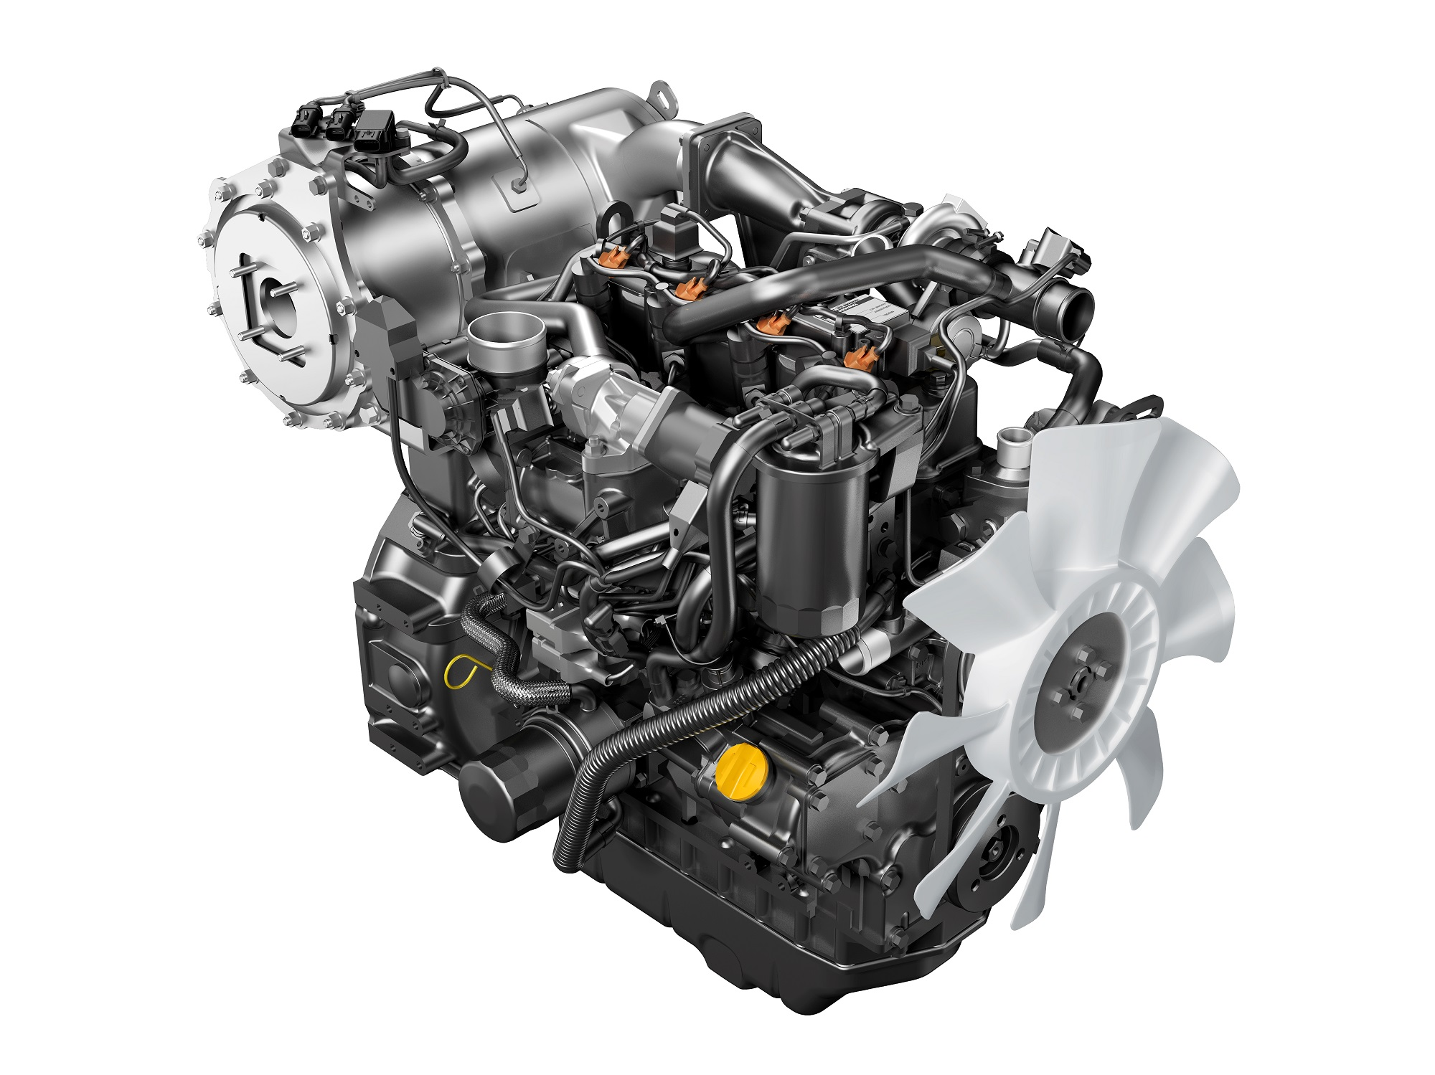
Vertical Water-cooled Diesel Engine 4TN86CHT

Yanmar has developed two models of high-powered industrial diesel engines (3TN86CHT/4TN86CHT) that comply with EU StageV and U.S. EPA/CARB Tier 4 emission regulations.

The newly developed engine pursues even higher power density^{※1} by integrating the latest diesel engine technology born from Yanmar’s extensive engine development experience. In addition to complying with strict emission regulations, the new engine is compact, allowing it to easily be fitted to customers’ machinery and has lower fuel consumption and noise.

Yanmar has added a clean, high-powered new models to its current popular line-up of vertical water-cooled diesel engines for industrial use and will continue to provide power sources for industrial machinery that meet customers' requirements.

■Product information
Model name： Vertical Water-cooled Diesel Engine 3TN86CHT/4TN86CHT
Mass production schedule： 3TN86CHT October, 2020
4TN86CHT April, 2021

■Main specifications
Model | 3TN86CHT | 4TN86CHT
Emission Compliance | U.S. EPA/CARB Tier4 / EU StageⅤ
Combustion | Direct Injection（DI）
Fuel Injection | Common Rail
Engine Type | Vertical, Water-cooled, 4-cycle diesel
Aspiration | T/C with CAC (Charge air cooler)
EGR | Cooled EGR
After Treatment Systems（ATS） | DOC^{※2} + DPF^{※3}
No. of Cylinders | 3 | 4
Bore x Stroke ［mm］ | 86×90 | 86×90
Displacement ［L］ | 1.57 | 2.09
Rated Output ［kW/min⁻¹］ | 40.1/2,600 | 55.4/2,600
Max. Torque ［Nm/min⁻¹］ | 197/1,690 | 263/1,690
Dry Weight ［kg］  （ATS installed on flywheel housing） | 200 | 247
Dimensions (L x W x H ) ［mm］  （ATS installed on flywheel housing） | 775×541×762 | 911×546×760

■Main advantages
(1) High power density
To increase power output, a new turbocharger matching design has been implemented, along with higher strength in various engine parts. As a result, 3TN86CHT and 4TN86CHT have 20% and 14% more power output, respectively, than TNV models of the same displacement with intercooled turbo in the current line-up.

(2) Compact engine configuration
The compact outline of the engine was designed in consideration of engine bay dimensions, making it easier for customers to install it on their work equipment. In addition, increasing the output of the exhaust gas after-treatment system without making it larger contributes to improved operator’s visibility and comfort.

(3) Proprietary exhaust gas after-treatment system to offer you seamless working in the field
The new engine is equipped with our proprietary DPF system for capturing PM. This system, which has been well received in the market, keeps you working at high altitudes and at low temperatures, and under all work conditions, from light to heavy loads. In addition, the DPF cleaning service has a long interval of 6,000 hours.
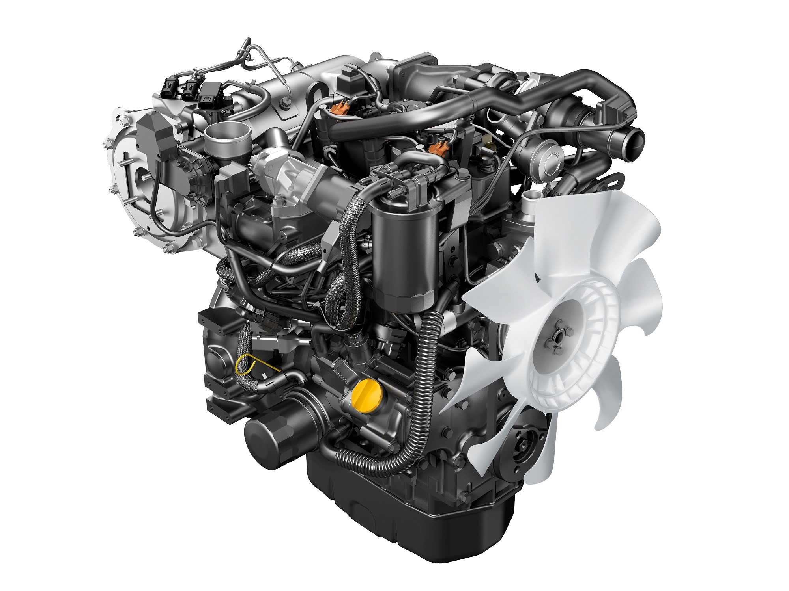
＜Vertical Water-cooled Diesel Engine「3TN86CHT」＞

※1 Power density：Power output per displacement
※2 DOC：Diesel Oxidation Catalyst, A catalyst to convert CO and hydrocarbons from diesel exhaust into CO² and water.
※3 DPF：Diesel Particulate Filter, A filter device designed to remove particulate matter (PM) from diesel exhaust.
※4 PM：Particulate matter. Refers to suspended particulate matter such as soot,etc.

About Yanmar
With beginnings in Osaka, Japan in 1912, Yanmar was the first ever to succeed in making a compact diesel engine of a practical size in 1933. Moving on, with industrial diesel engines as the cornerstone of the enterprise, Yanmar has continued to expand its product range, services, and expertise to deliver total solutions as an industrial equipment manufacturer. As a provider of small and large engines, agricultural machinerys and facilities, construction equipment, energy systems, marine, machine tools, and components — Yanmar’s global business operations span seven domains.
On land, at sea, and in the city, Yanmar’s Mission of “providing sustainable solutions focused on the challenges customers face, in food production and harnessing power, thereby enriching people’s lives for all our tomorrows,” stands testament to Yanmar’s determination to providing us with “A Sustainable Future.” For more information, visit Yanmar Co., Ltd. at its global website at https://www.yanmar.com/global/about/.

