# PRESS RELEASE

**Pan Pacific Hotels Group Launches Global Instagram Contests**

**#FindYourBalance #EveryDayIsPARKROYALDay**

*14 October 2019, Singapore* – Pan Pacific Hotels Group launches two global Instagram contests for its brands: Pan Pacific #FindYourBalance and PARKROYAL #EveryDayisPARKROYAL Day. The contests underline authenticity as they leverage user-generated content to showcase guests’ experiences of the brands while staying or dining at the properties.

Participants of both contests can win attractive prizes including a 10-night stay at any three PARKROYAL destinations, and weekly giveaways of a two-night stay at any Pan Pacific destination. To drive engagement, the most-voted entry for Pan Pacific will also win a four-night stay in any destination – spanning Singapore, Beijing, Melbourne, and Canada.

#EveryDayIsPARKROYALDay

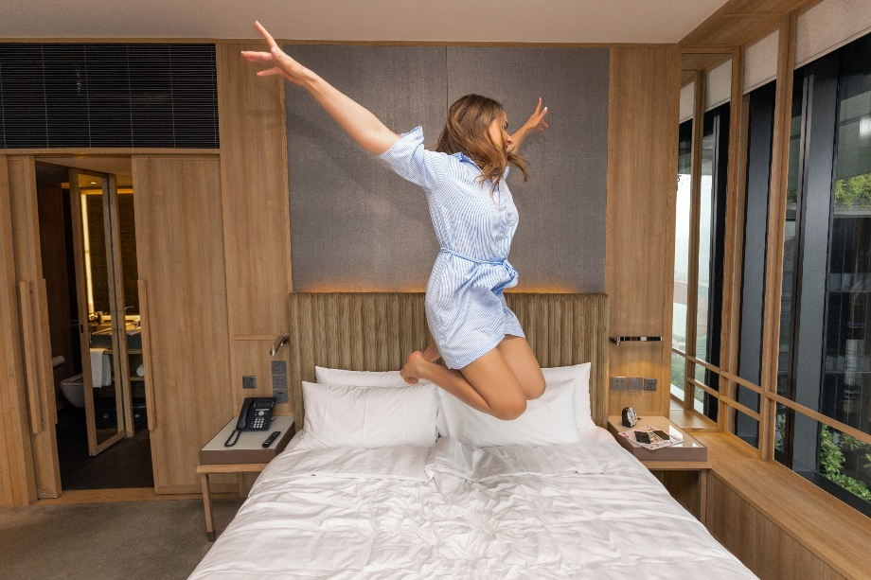

PARKROYAL Collection on Pickering. Photo credit: @lufotolab

**#EveryDayIsPARKROYALDay** runs from 14 October to 10 November 2019. Daily updates related to the PARKROYAL brand will be posted on the brand’s Instagram page **@PARKROYALHotels** to spark curiosity and inspiration for submissions to the contest.

PARKROYAL Hotels & Resorts, a rapidly growing brand with more than 20 hotels, resorts and serviced suites across the Asia-Pacific region, celebrates people and the joy in real connections. At PARKROYAL, you can find warm and inclusive people who have a passion for the well-being of others, and who exist to bring out the best of their guests and one another.

Participants stand to win the grand prize of a 10-night stay at any three PARKROYAL destinations by simply following @PARKROYALHotels on Instagram and leaving a comment on their favourite posts. The winner will be announced live on 11 November via Instagram Stories featuring a custom-made ball pit with all our followers’ Instagram handles printed on them to celebrate our moments of joy together.

#FindYourBalance

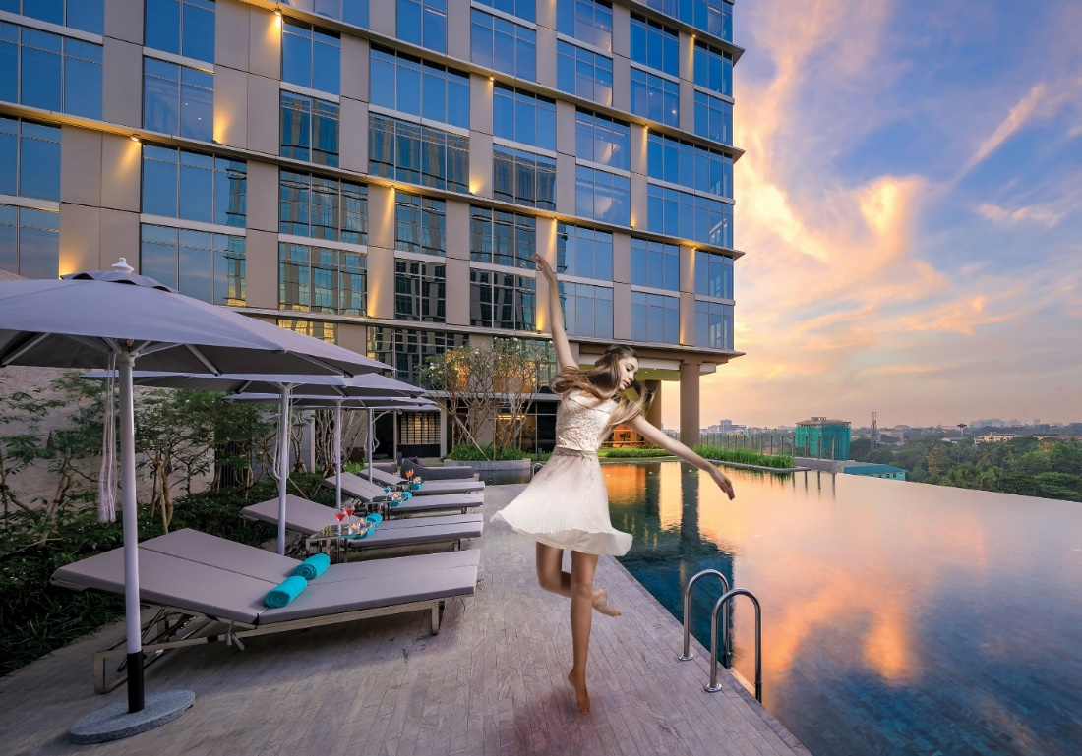

Pan Pacific Yangon

**#FindYourBalance** starts after #EveryDayIsPARKROYALDay, and runs from 4 November to 3 December 2019. Participants are invited to share images that tell us what “balance” means to them by following **@PanPacificHotels** and using the hashtags #FindYourBalance and #ShareYourMoments in their posts.

A series of original and inspiring photos of guests finding their balance at work or at play across Pan Pacific’s global portfolio of more than 20 hotels and serviced suites will be shared on @PanPacificHotels to get ideas flowing.

Each week, our panel of judges will select one winning entry. The winner will receive a two-night stay at a Pan Pacific destination of their choice. Plus, all entries will be uploaded to a microsite (contest.panpacific.com) for public voting. The entry that receives the most votes wins a four-night stay at any Pan Pacific destination of their choice. Voters too, stand to win a two-night stay at their selected destination.

Pan Pacific Hotels Group’s Chief Sales & Marketing Officer, Ms Cinn Tan, says, “At Pan Pacific or PARKROYAL, guests can depend on us to deliver sincere service that comes from the heart. Each guest’s experience is unique to them, yet they represent moments of joy and connection that collectively make up the PARKROYAL experience. With Pan Pacific, our guests capture snippets of how travel can be uncomplicated in everyday experiences as they leave it to our associates to take care of them in all areas. There’s no better way to bring our brands to life than through our guests’ personal stories and we’re excited about how these contests on Instagram will pan out!”

-ENDS-

# Media Contact

Cuili NG

Director, Brand & Corporate Communications Pan Pacific Hotels Group

Mobile: +65 9634 4425

Email: [ng.cuili@pphg.com](mailto:ng.cuili@pphg.com)

# About Pan Pacific Hotels Group

Pan Pacific Hotels Group is a wholly-owned hotel subsidiary of Singapore-listed UOL Group Limited, one of Asia’s most established hotel and property companies with an outstanding portfolio of investment and development properties.

Based in Singapore, Pan Pacific Hotels Group owns and/or manages more than 40 hotels, resorts and serviced suites including those under development in 24 cities across Asia, Oceania, North America and Europe.

Voted “Best Regional Hotel Chain” by readers in Asia-Pacific in 2018 and 2019, Pan Pacific Hotels Group comprises two acclaimed brands: its signature brand, Pan Pacific and its deluxe brand, PARKROYAL.

Sincerity is the hallmark of Pan Pacific Hotels Group. The Group is known to its guests, partners, associates and owners for its sincerity in people and the sense of confidence which alleviates the stresses of today’s complex world.

Visit us at [www.panpacific.com](http://www.panpacific.com/).

# Pan Pacific Hotels and Resorts

# With hotels, resorts and serviced suites across Asia, Oceania and North America, Pan Pacific provides a safe harbour in an ever-changing world. Places with less to worry about because, when you stay with us, rest assured that all will be taken care of. For this is where you will find your balance.

# PARKROYAL Hotels & Resorts

# A big city or cosy enclave – where there is a PARKROYAL hotel, resort or serviced suite, there is a celebration of people. Our passion for creating real connections and joyous moments can be felt when you enter any of our properties across Asia and Australia. After all, this is the place to bring out the best of you, by us.

Annex A – Campaign mechanics

**#EveryDayIsAPARKROYALDay (14 October to 14 November 2019)**

* Follow @PARKROYALHotels on Instagram
* Comment on your favourite #EveryDayIsPARKROYALDay post and tell us why it is your favourite day
* You can increase your chances of winning by commenting on as many #EveryDayIsPARKROYALDay post as you like

**#FindYourBalance (4 November to 3 December 2019)**

* Follow @PanPacificHotels on Instagram
* Upload a meaningful photo on Instagram and include a post caption on what Balance means to you
* Tag @PanPacificHotels and include the hashtags #FindYourBalance and #ShareYourMoments
* Your entry will be uploaded to <https://www.contest.panpacific.com> for voting