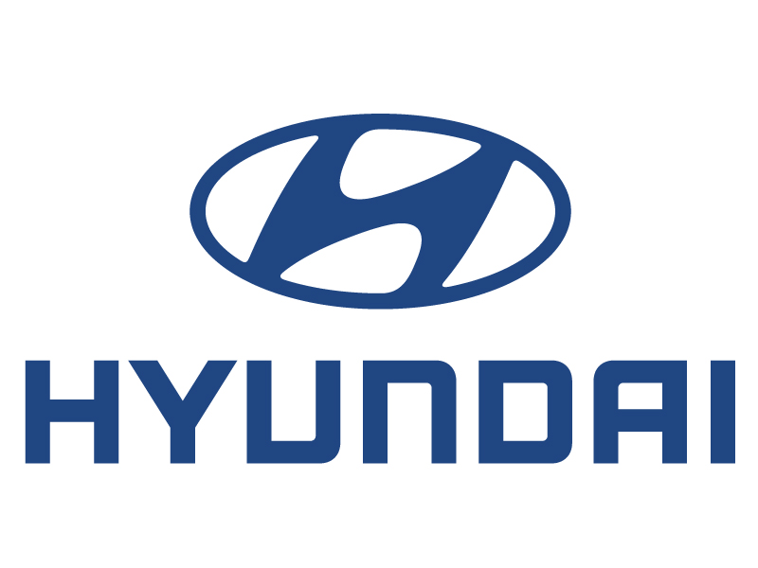
Hyundai Motor Manufacturing Czech
Průmyslová zóna Nošovice
739 51 Nižní Lhoty
TEL: +420-596-141-651, +420-606-759-790
pvanek@hyundai-motor.cz, www.hyundai-motor.cz
Press Release

Nošovice, 11th November 2011

Company HMMC won the National Quality Award 2011

President of the company Hyundai Motor Manufacturing Czech (HMMC) took over the National Award for Quality of the Czech Republic in its highest rank “Excellence” from hands of Milan Štěch, Chairman of the Senate of the Parliament of the Czech Republic at the Prague Castle on 10th November 2011.
National Award for Quality of the Czech Republic is the most important domestic appreciation of quality of a production process in its all stages. Hand over of the prestigious award exactly in a day of the 3rd anniversary of an official launch of a mass production in the plant in Nošovice is an important milestone and motivation for the company HMMC.

* * * * *

Kang Ho-don, President of HMMC, took over the National Award for Quality of the Czech Republic in its highest rank Excellence at the Spanish Hall of the Prague Castle last night. This grade of the award appreciates all stages of a production process as well as training and services provided, based on interviews and local inquiries and research directly in the plant.

Award of the most important Czech appreciation of quality to HMMC is the first award of this kind to an automobile maker in the country. Company Hyundai proved that there is an excellent quality management in the HMMC plant and that quality itself is a main condition of a success on the market. National Award for Quality means an increase of competitiveness, sales and also of Hyundai brand awareness.

„We really do appreciate the National Award for Quality of the Czech Republic”, said Kang Ho-don, President of HMMC and he continued: „The award is not only an appreciation of our work up to now but especially it is our obligation for future years because you can be successful in a tough competition today only if you offer a high quality product with high quality services.”

„HMMC deserves this award fully,” said Milan Štěch, Chairman of the Senate. “I wish the award helped the company to increase the profile to be perceived as a synonym of reliability, perfect approach to the customers and high quality, which are key factors at the market. We have one Hyundai i30 at home and we are very happy and content with it.”

Representatives of HMMC took over the National Award of Quality of the Czech Republic exactly in a day of the 3rd anniversary of an official launch of a mass production in the plant in Nošovice. In three years, over 530 thousand cars rolled off the line and they were exported to 48 countries in Europe, Near East and North Africa. Currently, everything is focused on the Hyundai i30 model of a new generation, mass production of which will be launched in mid January next year in the HMMC plant.

Petr Vaněk
PR Director

