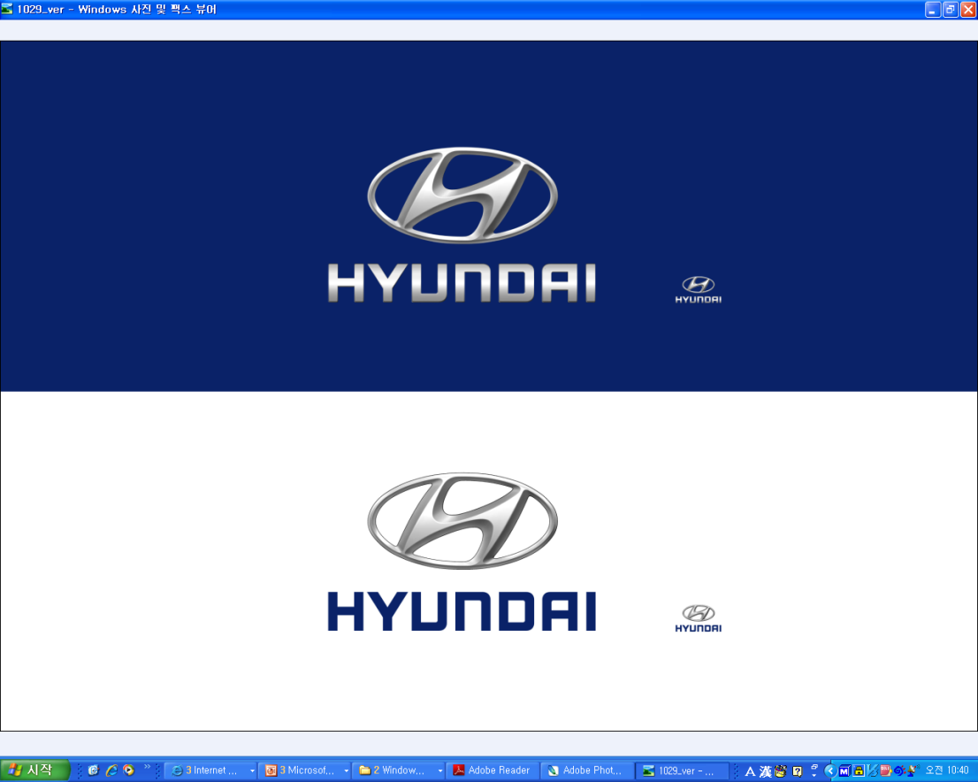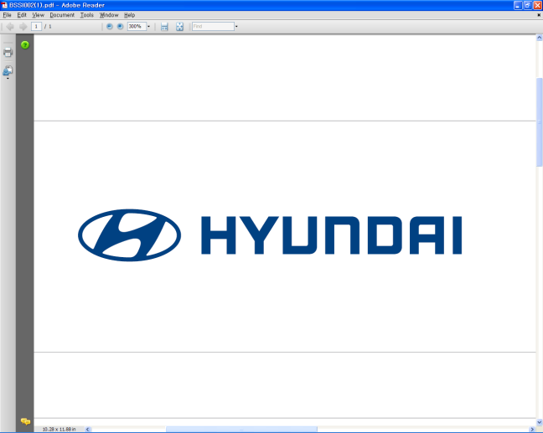  FEB. 17, 2012 | Media Release  For further information contact the  Global Public Relations Team  Tel: +82+2—3464-2153 ~ 60  Fax: +82+2—3464-3497  globalpr@hyundai.com

Hyundai Provides Vehicles For Ski Flying Championships

- Vehicles will be used by officials, staff during FIS Ski Flying World Championships in Norway
- Hyundai to provide i40 wagon, ix35 SUV

Hyundai Motor, one of the world’s largest and fastest-growing automakers, will deliver several vehicles today as part of its official sponsorship of the 2012 FIS Ski Flying World Championships in Vikersund, Norway, which begin February 23.

Hyundai will provide 10 units of its new i40 wagon, a D-segment wagon designed in Europe for Europeans; and 14 units of its popular ix35 SUV (badged as Tucson in some markets), which has won Car Of the Year awards in several European nations.

“We’re happy to showcase two of our most European vehicles during the FIS Ski Flying World Championships,” said S.T. Kim, Senior Executive Vice President and COO of Hyundai Motor Co. “The i40 wagon and ix35 SUV have been embraced by Europeans. Their exciting design reflects the dynamic spirit of this event.”

Representing Hyundai Motor Norway AS at the vehicle handover event are Chief Executive Coordinator Young Jin Kim and General Manager, Sales Jan Erik Nordhagen. Representing the Vikersund 2012 Ski Flying World Championships is Vice President Halvor Hartz

Earlier this month, Hyundai announced a two-year sponsorship of ski jumping competitions around the world, as organized by the FIS (International Ski Federation), which sanctions a number of global skiing competitions, including ski jumping, nordic skiing, alpine skiing, freestyle skiing and snowboarding.

Ski flying is similar to ski jumping, but is preformed on the highest hills, producing the longest jumps possible. There are only five ski flying hills in the world and Vikersund is home to the largest. In 2011, Johan Remen Evensen executed a world-record jump of 246.5 meters at Vikersund.

About Hyundai Motor

Established in 1967, Hyundai Motor Co. has grown into the Hyundai Motor Group, with more than two dozen auto-related subsidiaries and affiliates. Hyundai Motor -- which has six manufacturing bases outside of South Korea including the U.S., China, India, Russia, Turkey and the Czech Republic -- sold 4.06 million vehicles globally in 2011. Hyundai Motor, which employs over 80,000 worldwide, offers a full line-up of products including small to large passenger vehicles, SUVs and commercial vehicles. Further information about Hyundai Motor and its products is available at www.hyundai.com.

