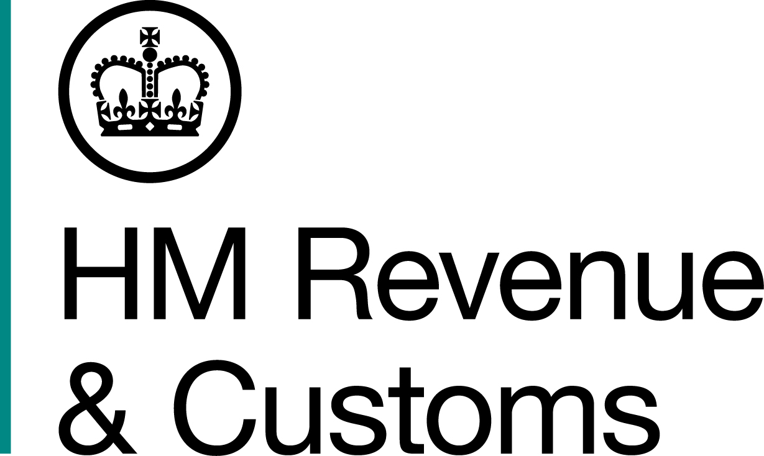
News Release

 | For the attention of News Desks |  | No of pages: 3
 | Date: | 12 04 2019 | Ref: | SO 02 19

Former Top Gear mechanic jailed for helping £1m tax fraudsters flee to Spain

A former Top Gear mechanic who helped father and son tax cheats escape from the UK has been jailed.

Stephen Howard, of Crafts End, Chilton, helped tax cheats Jamie Colwell and his father Brian flee to Spain before they could be sentenced for a £1 million VAT scam, a HM Revenue and Customs (HMRC) investigation found.

The pair have since been extradited back to the UK and are currently serving prison sentences totalling almost eight years.

Howard bought travel tickets for the pair and hired a van to drive Brian Colwell to a hideout in Spain. During this time £2,900 was deposited into Howard’s bank account.

Ticket receipts and a detailed travel itinerary were discovered during a search of Howard’s home. HMRC investigators pieced together the journey Howard helped the Colwells make by examining the receipts, bank statements, and evidence from mobile devices. This evidence proved Howard:

- Drove to France via the Eurotunnel in Jamie Colwell’s Porsche Cayenne before meeting up with Colwell and handing over the car
- Purchased a foot passenger ferry ticket from Portsmouth to Caen for Brian Colwell
- Rented a DAF box van and travelled via ferry from Portsmouth to Caen with Brian Colwell
- Drove the van, which was loaded with Jamie and Brian Colwell’s furniture, through France and Spain, to the Colwells’ Benidorm hideout.

Howard returned to the UK in the box van on January 14, 2018. On January 19 the Colwells failed to show in court and on January 22 they were sentenced in their absence.

Howard said he had worked for the Colwells in the past but denied knowing anything about their crimes or court appearances.

Howard, who helped to build and modify specialist racing cars on BBC1 show Top Gear, was convicted of perverting the course of justice at Winchester Crown Court on 14 March. He was sentenced today (Friday 12 April) at Salisbury Crown Court to 15 months in jail.

HMRC investigators used evidence from Howard’s phone to track the Colwells to a villa in Benidorm and they were arrested in May 2018.

The pair had been convicted for dishonestly claiming £965,897 in VAT repayments after they lied about spending £14 million on building new properties. The stolen money was spent on luxury purchases including a speedboat, expensive cars and renting a high-end property in Sandbanks, Dorset.

Following their extradition, Jamie Colwell was jailed for five years and three months, while his father Brian was jailed for two years and eight months. Both men were ordered to serve an extra six months for breaching bail.

Information about any type of tax fraud can be reported to HMRC online at https://www.gov.uk/report-an-unregistered-trader-or-business.

Notes to Editors

- Stephen Howard, DOB 16/05/1958, of Crafts End, Chilton, Didcot, OX11 0SB. He was convicted on one count of perverting the course of justice at Winchester Crown Court on 14 March 2019. Howard was sentenced to 15 months in jail at Salisbury Crown Court on 12 April 2019.
- The full press release on the Colwells sentencing in May 2018 is available here: https://www.mynewsdesk.com/uk/hm-revenue-customs-hmrc/pressreleases/flying-and-ferry-fleeing-fugitives-grounded-over-ps1m-vat-scam-2517846
- Follow HMRC Press Office on Twitter @HMRCpressoffice.
- HMRC's Flickr channel: www.flickr.com/hmrcgovuk.

Issued by HM Revenue & Customs Press Office

Press enquiries only please contact:

Ed Casson
Tel: 03000 524697
Email: ed.casson@hmrc.gsi.gov.uk

Or

Will Lyon
Tel: 03000 519451
Email: will.lyon@hmrc.gsi.gov.uk

Out of hours: Tel: 07860 359544

Website www.gov.uk/hmrc

